

UNIVERSIDADE FEDERAL DE SANTA CATARINA

CENTRO DE CIÊNCIAS BIOLÓGICAS

PROGRAMA DE PÓS-GRADUAÇÃO EM ECOLOGIA

Marcio Baldissera Cure

Estados funcionais da vegetação neotropical e a heterogeneidade das respostas fenológicas à sazonalidade da chuva

Florianópolis

2024

Marcio Baldissera Cure

Estados funcionais da vegetação neotropical e a heterogeneidade das respostas fenológicas à sazonalidade da chuva

Tese submetida ao Programa de Pós-Graduação em Ecologia da Universidade Federal de Santa Catarina como requisito parcial para a obtenção do título de Doutor em Ecologia.

Orientadora: Profa. Dra. Marina Hirota

Coorientador: Prof., Dr. Bernardo Monteiro Flores

Florianópolis

2024

|  |
| --- |
|  |
| Ficha catalográfica para trabalhos acadêmicos [Elemento obrigatório.]  [Insira neste espaço a ficha catalográfica para trabalhos acadêmicos.]  [A ficha é elaborada pelo(a) autor(a) no seguinte link:  <http://portalbu.ufsc.br/ficha>] |
|  |
|  |
|  |
|  |
|  |

Marcio Baldissera Cure

Estados funcionais da vegetação neotropical e a heterogeneidade das respostas fenológicas à sazonalidade da chuva

O presente trabalho em nível de Doutorado foi avaliado e aprovado, em 8 de Agosto de 2024, pela banca examinadora composta pelos seguintes membros:

[Não é necessária a assinatura dos membros]

Prof.(a) Ana Catarina Conte Jakovac, Dr.(a)

Instituição UFSC

Prof.(a) Guilherme Gerhardt Mazzochini, Dr.(a)

Instituição UFRJ

Prof.(a) Eduardo Luis Hettwer Giehl, Dr.(a)

Instituição UFSC

Certificamos que esta é a versão original e final do trabalho de conclusão que foi julgado adequado para obtenção do título de Doutor em Ecologia.

Insira neste espaço a

assinatura digital

\_\_\_\_\_\_\_\_\_\_\_\_\_\_\_\_\_\_\_\_\_\_\_\_\_\_\_

Coordenação do Programa de Pós-Graduação

Insira neste espaço a

assinatura digital

\_\_\_\_\_\_\_\_\_\_\_\_\_\_\_\_\_\_\_\_\_\_\_\_\_\_\_\_

Profa. Marina Hirota, Dra.

Orientadora

Florianópolis, 2024.

Ofereço esta tese à minha sobrinha Gaia Iglesias Cure e às futuras gerações. Que o futuro os reserve um planeta ecologicamente equilibrado e socialmente justo.

**AGRADECIMENTOS**

Neste momento, enquanto escrevo, passa um filme na minha cabeça, onde faço uma retrospectiva dos últimos anos. Isso me faz lembrar de todas (ou quase todas) as pessoas que contribuíram para a minha transformação e para a concretização desta tese. Sem elas, eu não teria chegado até aqui, pelo menos, não da mesma maneira. Portanto, não poderia deixar de mencioná-las. Esta é uma tarefa difícil, pois corro o risco de esquecer alguém. Isso me causa uma certa ansiedade, mesmo sabendo que a grande maioria não lerá esta tese e nem mesmo saberá que contribuiu. Ainda assim, é importante expressar minha gratidão a todos que fizeram parte desta jornada.

Em primeiro lugar, eu agradeço à minha família biológica. Meus pais, Nádia e Cesar, e meu irmão, Marcelo, nunca mediram esforços para me dar todo o apoio de que precisei. Não somente durante o longo e sinuoso percurso desta tese, mas durante todas as empreitadas que me meti no decorrer de minha existência. Obrigado, mãe e pai, por terem me proporcionado uma educação de qualidade, mesmo com todas as dificuldades e limitações impostas ao proletariado brasileiro, e por terem me incentivado a seguir o caminho dos estudos.

Em segundo lugar, agradeço à minha familia acadêmica, que me deu todo o apoio e que contribuiu (e continua contribuindo) para a minha formação como cientista e como pessoa. É difícil expressar com palavras o meu reconhecimento e agradecimento por toda a ajuda e apoio que a Marina, minha orientadora desde o mestrado, me deu. Ela conseguiu me motivar nos momentos de dúvida e me transmitiu esperança e paz nos momentos de dificuldade e de quase desespero. Da mesma forma, foi uma sorte ter cruzado com o Bernardo, meu coorientador. Nos conhecemos durante uma viagem para trabalho de campo no Parque Nacional da Chapada dos Veadeiros e a partir daí, num ambiente de camaradagem, surgiu nossa parceria de campos, pesquisas e cervejas. Assim como a Marina, ele é uma fonte infinita de ideias que quase fritaram a minha cabeça e/ou que me conduziram a *insigths*. Agradeço também ao Rafa (Oliveira), meu segundo “pai” acadêmico, uma máquina de gerar ideias e uma fonte transbordante de alegria. Ele foi fundamental com o seu olhar super especialista e preciso sobre o primeiro capítulo da tese e com discussões sobre a ecologia do Cerrado. Me sinto privilegiado por ter sido orientado por estes respeitados cientistas e professores, mas também por estes seres humanos iluminados.

Agradeço aos meus amigos, ou seja, à família que formei longe do meu pago, especialmente aos queridos amigos da Costa da Lagoa: André, Bruna, Ana Paula e Amanda, que me deram todo o apoio que os amigos costumam dar e ainda me tiraram de casa várias vezes depois de longos períodos de "hibernação". Eles me aproximaram da realidade fora da academia e me proporcionaram conversas filosóficas profundas e novas perspectivas. Nestes últimos dez anos, eles fizeram (e felizmente ainda fazem) parte da minha formação como ser humano e até mesmo como cientista. Quero agradecer ainda ao meu amigo André Giles, que também conheci em campo no PNCV. Conheci o André no primeiro ano de doutorado e desde então nossos laços se estreitam cada vez mais. O André me ensinou quase tudo o que eu sei sobre as plantas do Cerrado. Ele certamente é o melhor parceiro de campo que alguém pode ter. Também agradeço de coração à Débora, que me deu suporte para percorrer os períodos mais críticos dos últimos anos.

Também agradeço de todo o coração ao Felipe, fisioterapeuta e esposo da Marina, que curou a minha dor no ciático num dos momentos mais difíceis da tese e durante a pandemia de COVID 19. Agradeço ao Matheus Pamplona por ser a personificação do StackOverflow, sempre me ajudando a resolver problemas com códigos em R. Agradeço ao Caio Mattos por suas críticas precisas e pelo tempo dedicado à contribuição para esta tese. Também agradeço ao Guiga por todas as conversas esclarecedoras no café do CFH e por sua ajuda com as análises de dados. Agradeço também a parceria da Bia e da Deli, que me ajudaram a refletir sobre e encarar a realidade acadêmica atual. Nós nos conectamos rapidamente e formamos um trio de apoio mútuo com muitas reuniões divertidas, risos, choros e conversas.

Quero ainda agradecer ao FUNBIO e Instituto Humanize por financiarem as minhas saídas de campo e a compra de materiais para campo. Foram 4 expedições para o PNCV, com duração média de 30 dias cada uma. Duas na estação seca que fizeram sangrar o nariz e duas na estação chuvosa onde passávamos o dia molhados. Mesmo com as dificuldades, todos os momentos foram de extremo prazer. Foram muitas caminhadas na paisagem mágica do Cerado com conversas e companhias interessantes e muitos sabores que eu não poderia morrer sem sentir, como o araticum do Cerrado (*Annona crassiflora*). Estar em campo é a coisa que mais me faz feliz. Obrigado aos bravos colegas e amigos que me acompanharam e ajudaram em campo: Alexandre, Géssica, João, Débora, Carol, André, Caio, Mari, Bruna, Bernardo, Tina, Vic e Karine. Eles foram muito valentes e nobres por se embrenharem nas matas alagadas e na inóspita savana brasileira por amor à ciência e pela aventura.

Agradeço à Isabel Schmidt e ao Alexandre Sampaio pela camaradagem e por terem cedido sua casa de Alto Paraiso de Goiás, GO, para base da equipe em todas as nossas expedições. Eles facilitam a vida dos pesquisadores sem recursos por amor ao Cerrado. Agradeço à Caroline Camargo em nome do Instituto Chico Mendes de Conservação da Biodiversidade (ICMBio) por fornecer apoio para o campo. Agradeço ao seu Lauro Jurgeaitis por nos receber tantas vezes muito bem na sua RPPN e por ceder uma casa para passarmos alguns dias. Agradeço ao seu Ângelo Testa, proprietário de uma RPPN onde coletamos dados. Foi difícil a nossa aproximação, mas depois da confiança estabelecida, pude aprender muito com ele sobre o manejo tradicional do Cerrado. Agradeço à Secretaria do Estado de Meio Ambiente e Desenvolvimento Sustentável (SEMAD Goiás) por nos receberem e fornecerem alojamento na Estação Ecológica Chapada de Nova Roma, em Nova Roma, GO. Agradeço ao Romilson, funcionário da ESEC Nova Roma, que nos aproximou da comunidade e ajudou a encontrar as parcelas. Agradeço ao seu João e sua esposa dona Geni, que nos encontraram famintos numa estrada de chão no coração do Brasil (ao norte do PNCV) e nos levaram (na verdade arrastaram) para a sua casa às margens do Rio Negrinho (GO), perto do Povoado Capela, no município de Cavalcante, GO. Eles nos trataram como filhos. Ganhamos um almoço autêntico do interior de Goiás, uma boa conversa e muitos presentes. Agradeço a toda a comunidade de Nova Roma por nos receber de braços abertos, nos dar café, bolo, almoço, janta, cachaça, churrasco, conhecimento, sinceridade, confiança e alegria. Que gente feliz e amistosa! Sinto que o Brasil é lá.

Agradeço à FAPESC pela bolsa de estudos. Agradeço ao PPG Ecologia e aos seus professores e coordenadores por darem o seu apoio sempre que eu precisei. Agradeço aos funcionários e técnicos da UFSC, que, no anonimato, enchem as nossas barrigas e fazem a roda administrativa girar, em especial à SIPG (Secretaria Integrada das Pós Graduações) do CCB. Eles são atenciosos, dedicados e fazem um trabalho excelente. Todo o meu reconhecimento e agradecimento por seu trabalho.

Por fim, mas não menos importante, agradeço aos trabalhadores brasileiros que pagaram impostos para financiar os meus estudos. Espero poder retribuir, daqui em diante, através do meu trabalho, trazendo benefícios, mesmo que indiretos, à classe trabalhadora brasileira e às gerações futuras.

Muito obrigado à todos.

Há sempre alguma loucura no amor. E também há sempre algum fundamento na loucura. (Nietzsche, Assim falou Zaratustra, 2012, p. 58)

**RESUMO**

Florestas e savanas são bem conhecidas por caracterizarem estados alternativos estruturais em termos de cobertura do dossel, definidos parcialmente pelo regime de chuvas. Entretanto, em uma mesma paisagem, diferentes tipos de vegetação coexistem, como florestas, savanas e campos dominados pelo estrato herbáceo. Além disso, existem tipos de vegetação com a mesma estrutura, mas que apresentam funcionamento diferente, como é o caso das matas secas (decíduas) e das matas de galeria (sempre verdes) que coexistem, por exemplo, nas paisagens do Cerrado submetidas a um mesmo regime de chuvas. Esta tese busca caracterizar os estados funcionais da vegetação tropical do Brasil e relacioná-los à estrutura da vegetação e às variáveis ambientais em escala local e continental. Sendo assim, no Capítulo I, queremos entender como diferentes tipos de vegetação em uma paisagem do Cerrado, submetidos ao mesmo regime de chuva, respondem às variações sazonais da precipitação e como esta resposta depende das condições ambientais locais, como a disponibilidade de nutrientes e de água no solo. Neste sentido, o Capítulo I destaca a importância do acoplamento entre o verdor foliar (greenness) e a precipitação mensal como uma forma inovadora de diferenciar entre tipos de vegetação coexistentes no mesmo envelope climático. Este capítulo ressalta que variáveis funcionais em nível de ecossistema, como a dinâmica temporal das respostas da vegetação à precipitação, podem ser mais significativas do que variáveis estruturais simples, como área basal e altura de árvores, na caracterização de ecossistemas distintos na paisagem tropical. Além disso, os resultados indicam que tipos de vegetação aparentemente similares em estrutura podem apresentar funcionamentos e respostas contrastantes à variabilidade da precipitação, os quais são definidos pela disponibilidade de água e nutrientes no solo. Nossos resultados desafiam a noção de que tipos de vegetação coexistentes são necessariamente estados estáveis alternativos e de que a estrutura é um indicativo de funcionalidade. A partir daí, buscamos expandir espacialmente o entendimento da heterogeneidade das respostas fenológicas da vegetação para aprimorar modelos de dinâmica da vegetação e de fluxos de carbono. Estes modelos incorporam alta incerteza devido a dificuldade de caracterizar por meio de parâmetros os tipos funcionais da vegetação. Para isso, no Capítulo II, nós (1) testamos se a classificação fenológica de comunidades vegetais baseada em composição de espécies reflete os comportamentos espectrais baseados em dados de satélite ao longo dos biomas do Brasil tropical; e (2) testamos a hipótese de que a resposta da vegetação é dependente do regime de chuvas na escala continental. Sendo assim, o Capítulo II enfatiza a heterogeneidade da resposta fenológica da vegetação dentro dos biomas tropicais e sua dependência não apenas do bioma em que está estabelecida, mas também da composição de espécies e das condições ambientais em larga escala como a precipitação média anual e o déficit de pressão de vapor da atmosfera. Estes dois capítulos de resultados destacam a possibilidade de entender as respostas da vegetação à variação sazonal da precipitação em nível de ecossistema utilizando medições baseadas em satélites para extrapolar os processos em pequena escala para escalas mais amplas, interagindo com ciclos climáticos e biogeoquímicos. A extrapolação temporal e espacial dos nossos resultados contribui para a aprimoração dos modelos de vegetação para melhorar o seu desempenho na previsão da distribuição e dinâmica da vegetação tropical frente às mudanças climáticas.

**Palavras-chave**: vegetação tropical; fenologia; resiliência, sensoriamento remoto.

**ABSTRACT**

Forests and savannas are well known for characterizing alternative structural states in terms of canopy coverage, partially defined by rainfall regime. However, within the same landscape, different vegetation types coexist, such as forests, savannas, and herbaceous-dominated fields. Additionally, there are vegetation types with similar structures but differing functionally, such as coexisting dry forests (deciduous) and gallery forests (evergreen), for example, in Cerrado landscapes subjected to the same rainfall regime. This thesis aims to characterize the functional states of Brazilian tropical vegetation types and relate them to vegetation structure and environmental variables at local and continental scales. Thus, in Chapter I, we seek to understand how different vegetation types subjected to the same rainfall regime respond to seasonal variations in precipitation and how this response depends on local environmental conditions, such as soil nutrients and water availability. In this regard, Chapter I emphasizes the importance of the coupling between greenness and precipitation as an innovative way to differentiate between coexisting vegetation types within the same climatic envelope. This chapter highlights that ecosystem-level functional variables, such as temporal dynamics of vegetation responses to precipitation, may be more significant than simple structural variables in characterizing distinct ecosystems in the tropical landscape. Furthermore, the results indicate that vegetation types seemingly similar in structure may exhibit contrasting functionality and responses to precipitation variability defined by soil water and nutrient availability, challenging the notion that coexisting vegetation types are necessarily alternative stable states and that structure is indicative of functionality. From there, we aim to spatially expand the understanding of vegetation phenological response heterogeneity to improve vegetation dynamics and carbon flux models that incorporate high uncertainty due to the difficulty of characterizing vegetation functional types through parameters. To achieve this, in Chapter II, we (1) test whether the phenological classification of plant communities based on species composition reflects satellite-based spectral behaviors across tropical biomes of Brazil; and (2) test the hypothesis that vegetation response is dependent on rainfall regime at the continental scale. Thus, Chapter II emphasizes the heterogeneity of vegetation phenological response within tropical biomes and its dependence not only on the biome in which it is established but also on species composition and large-scale environmental conditions such as mean annual precipitation and atmospheric vapor pressure deficit. These two results chapters highlight the possibility of understanding vegetation responses to seasonal variation in precipitation at the ecosystem level using satellite-based measurements to upscale small-scale processes to broader scales, interacting with climatic and biogeochemical cycles. The temporal and spatial extrapolation of our results contribute to the improvement of vegetation models to enhance their performance in predicting the distribution and dynamics of tropical vegetation in the face of climate change.

**Keywords**: tropical vegetation; phenology; resilience, remote sensing.

**SUMÁRIO**

[1. INTRODUÇÃO 16](#__RefHeading___Toc7433_3394397590)

[1.1 CONTEXTUALIZAÇÃO 16](#__RefHeading___Toc7457_3394397590)

[1.2 CONSIDERAÇÕES SOBRE O CICLO DA ÁGUA NAS PLANTAS 19](#__RefHeading___Toc7477_3394397590)

[1.3 MECANISMOS DE REGULAÇÃO HÍDRICA 20](#__RefHeading___Toc7475_3394397590)

[1.4 FENOLOGIA FOLIAR 21](#__RefHeading___Toc7473_3394397590)

[1.5 O PAPEL DO SOLO NA DISPONIBILIDADE DE RECURSOS PARA AS PLANTAS 22](#__RefHeading___Toc7471_3394397590)

[1.6 OBJETIVO GERAL 24](#__RefHeading___Toc7469_3394397590)

[1.7 OBJETIVOS ESPECÍFICOS E ESTRUTURA DA TESE 25](#__RefHeading___Toc7467_3394397590)

[REFERÊNCIAS 26](#__RefHeading___Toc7465_3394397590)

[2. CAPÍTULO I 38](#__RefHeading___Toc7455_3394397590)

[2.1. VEGETATION-RAINFALL COUPLING AS AN INDICATOR OF ECOSYSTEM STATE IN A HETEROGENEOUS LANDSCAPE 38](#__RefHeading___Toc7463_3394397590)

[2.1.1 Introdução 42](#__RefHeading___Toc7479_3394397590)

[2.1.2 Materials and Methods 44](#__RefHeading___Toc7497_3394397590)

[*2.1.2.1 Study site* 44](#__RefHeading___Toc7525_3394397590)

[*2.1.2.2 Environmental conditions* 46](#__RefHeading___Toc7523_3394397590)

[2.1.2.2.1 Precipitation and fire frequency data 46](#__RefHeading___Toc7527_3394397590)

[2.1.2.2.2 Soil samples 47](#__RefHeading___Toc7549_3394397590)

[2.1.2.2.3 Topographic Wetness Index (TWI): water in the soil 48](#__RefHeading___Toc7547_3394397590)

[*2.1.2.3 Ecosystem state variables* 49](#__RefHeading___Toc7521_3394397590)

[2.1.2.3.1 Tree community structure and functional traits 49](#__RefHeading___Toc7545_3394397590)

[2.1.2.3.2 Satellite EVI2 data for vegetation greenness 51](#__RefHeading___Toc7543_3394397590)

[2.1.2.3.3 Coupling between precipitation and greenness 51](#__RefHeading___Toc7541_3394397590)

[2.1.3 Results 52](#__RefHeading___Toc7495_3394397590)

[*2.1.3.1 Heterogeneity in environmental conditions* 52](#__RefHeading___Toc7519_3394397590)

[*2.1.3.2 Ecosystem state variables* 55](#__RefHeading___Toc7517_3394397590)

[2.1.4 Discussion 59](#__RefHeading___Toc7493_3394397590)

[2.1.5 Conclusion 61](#__RefHeading___Toc7491_3394397590)

[86](#__RefHeading___Toc7445_3394397590)

[3. CAPÍTULO II 100](#__RefHeading___Toc7437_3394397590)

[3.2 UNRAVELING DISTINCT LEAF PHENOLOGIES IN TROPICAL VEGETATION TYPES 100](#__RefHeading___Toc7461_3394397590)

[3.2.1 Introduction 104](#__RefHeading___Toc7489_3394397590)

[3.2.2 Methods 106](#__RefHeading___Toc7487_3394397590)

[3.2.2.1 Sampled vegetation communities and greenness 107](#__RefHeading___Toc7515_3394397590)

[3.2.2.2 Is the floristic-based classification of the phenological types related with the greenness annual cycle? 109](#__RefHeading___Toc7513_3394397590)

[3.2.2.2.1 Metrics for characterizing the annual cycle of vegetation greenness 109](#__RefHeading___Toc7539_3394397590)

[3.2.2.2.2 Clusterization of the EVI2-based leaf flush regime 109](#__RefHeading___Toc7537_3394397590)

[3.2.2.2.3 Statistical analyses of the greenness metrics 110](#__RefHeading___Toc7535_3394397590)

[3.2.2.3 Is the response of vegetation types to rainfall seasonality dependent on the climatic regimes? 111](#__RefHeading___Toc7511_3394397590)

[3.2.2.3.1 Data on climatic variables 111](#__RefHeading___Toc7533_3394397590)

[3.2.2.3.2 Coupling between greenness and rainfall as a measure of vegetation response to rainfall 112](#__RefHeading___Toc7531_3394397590)

[3.2.2.3.3 Statistical analysis of the vegetation communities responses 113](#__RefHeading___Toc7529_3394397590)

[3.2.3 Results 114](#__RefHeading___Toc7485_3394397590)

[3.2.3.1 Annual cycle of vegetation greenness: semideciduous communities have more diverse dynamics 114](#__RefHeading___Toc7509_3394397590)

[3.2.3.2 Clustering annual cycle behavior: three leaf flush regimes divided into two clusters 116](#__RefHeading___Toc7507_3394397590)

[3.2.3.3 Coupling vegetation with rainfall: positive and negative correlations as contrasting responses 120](#__RefHeading___Toc7505_3394397590)

[3.2.3.4 Coupling vs climatic gradient: VPD, MSI and MAP as drivers of vegetation response to rainfall 123](#__RefHeading___Toc7503_3394397590)

[3.2.4 Discussion 127](#__RefHeading___Toc7483_3394397590)

[3.2.4.1 Vegetation-response heterogeneities within leaf flush regime groups 128](#__RefHeading___Toc7501_3394397590)

[3.2.4.2 Vegetation-response dependence on large-scale drivers 129](#__RefHeading___Toc7499_3394397590)

[3.2.4.3 Bridging scales: upscaling ecosystem dynamics 131](#__RefHeading___Toc7459_3394397590)

[References 133](#__RefHeading___Toc7481_3394397590)

[4 CONCLUSÃO 153](#__RefHeading___Toc7435_3394397590)

# **INTRODUÇÃO**

## CONTEXTUALIZAÇÃO

Os ecossistemas são sistemas dinâmicos complexos formados por elementos bióticos e abióticos, a partir dos quais emergem propriedades que lhes confere uma identidade (HOLLING, 1973; BEGON, TOWNSEND, HARPER, 2005). São formados por múltiplos elementos que interagem entre si, como por exemplo as espécies vegetais e animais vivendo em um determinado espaço. São considerados dinâmicos porque evoluem com o tempo (STROGATZ, 1994), como por exemplo, a mudança de biomassa de uma área. As propriedades emergentes podem ser descritas, por exemplo, em termos de acúmulo de biomassa, fluxo de água e nutrientes e respiração. Ademais, variações aleatórias, como eventos de fogo, fazem parte da dinâmica dos ecossistemas e podem contribuir para sua manutenção ou mudanças (MIRANDA, BUSTAMANTE & MIRANDA, 2002; HOFFMANN & MOREIRA, 2002). Entretanto, os sistemas dinâmicos e complexos possuem mecanismos de auto-organização que são regulados pelo balanço de mecanismos de retroalimentação (*feedbacks)* positivos e negativos provenientes das interações dos seus elementos (FLORES & STAAL, 2022). Enquanto os *feedbacks* positivos são responsáveis por sustentar uma determinada configuração, os *feedbacks* negativos são responsáveis por alterá-la. Por exemplo, eventos naturais, periódicos e breves de fogo no Cerrado costumam ocorrer no final da estação seca impulsionados por raios que chegam com as primeiras chuvas. Esses eventos de fogo controlam a biomassa da vegetação e consequentemente limitam a quantidade de combustível disponível em um próximo evento de fogo, garantindo, assim, que a composição da vegetação e as propriedades emergentes do ecossistema sejam mantidas (DURIGAN, 2020) mesmo em face de um evento mais extremo de incêndio (DANTAS et al., 2013).

Neste sentido, a resiliência ecológica (HOLLING, 1973, 1996) é um conceito que denota essa capacidade que os sistemas possuem de absorver impactos antes de mudarem para um estado alternativo de funcionamento devido à prevalência de *feedbacks* positivos, de manutenção. A resiliência é uma forma de olhar para a dinâmica de sistemas complexos e tem como princípio a existência de estados alternativos de funcionamento que podem ocorrer sob as mesmas condições ambientais. Estes estados alternativos são caracterizados por diferentes elementos, interações e mecanismos de *feedback* que podem resultar em uma nova identidade do sistema (SCHEFFER; CARPENTER, 2003). Florestas tropicais e savanas, por exemplo, foram sugeridas como estados alternativos, em parte, moldados por mudanças nos regimes de precipitação média anual (MAP) (HIROTA et al., 2011). Sendo assim, mudanças graduais na MAP podem potencialmente alterar o funcionamento dos ecossistemas, suas interações e propriedades emergentes, e podem levar a estados alternativos indesejados aos seres humanos. Além disso, é aceitável a possibilidade de uma mudança abrupta na atmosfera terrestre (BARNOSKY et al., 2012) e no sistema terrestre (STEFFEN et al., 2018) como consequência do efeito cascata de impactos pontuais.

A cobertura do dossel, comumente usada para indicar tipos de vegetação na região tropical, é determinada em larga escala pela precipitação média anual (MAP) (HIROTA et al., 2011). Entretanto, existe um intervalo de MAP, chamado de zona de bi-estabilidade em que pode ocorrer tanto vegetação de floresta como de savana. A existência de mais de um estado de estabilidade com as mesmas condições ambientais, em que a transição de um estado para outro ocorre de forma não linear e com sobreposição em relação à variável independente (i.e. MAP), implica na existência de histerese (SCHEFFER; CARPENTER, 2003). Ademais, o limite que separa estes dois estados de estabilidade é caracterizado por uma alta instabilidade (SCHEFFER et al., 2001). A mudança de um estado para outro (ou sua permanência no estado atual) é controlada pelo balanço entre *feedbacks* positivos e negativos. Existem diversos modelos para explicar a bistabilidade floresta-savana (e.g. BOND; WOODWARD; MIDGLEY, 2005; HIROTA et al., 2011; STAAL et al., 2016; WUYTS; CHAMPNEYS; HOUSE, 2017). Entretanto, há dificuldade em se diminuir a incerteza inerente aos sistemas complexos devido ao grande número de interações, *feedbacks*, variabilidade climática, heterogeneidade espacial, variabilidade individual (VAN NES; SCHEFFER, 2005), pela baixa disponibilidade de dados de campo, pelo erro associado às medições e pela sinergia das respostas combinadas.

Mudanças na vegetação natural do cerrado para pastos e outras culturas, por exemplo, podem levar à diminuição de MAP e da evapotranspiração (HOFFMANN; JACKSON, 2000; IPCC, 2014). Entretanto, a precipitação não diminuirá uniformemente ao longo do ano. Esta diminuição provavelmente ocorrerá de forma concentrada no início e no fim da estação úmida (HOFFMANN; JACKSON, 2000). No Cerrado e na savana dos llanos, no norte da América do Sul, existe uma “mini-estação seca” no meio da estação úmida que pode aumentar em duração e intensidade em resposta à perda da cobertura natural. Estas mudanças vão alterar os padrões sazonais do clima do Cerrado e refletir de duas maneiras na regeneração da vegetação. Em primeiro lugar, as plântulas são mais sensíveis ao estresse hídrico (i.e. falta de água) no período de chuvas e isto afeta o seu estabelecimento e sobrevivência (ENGELBRECHT et al., 2006). Segundo, pelo aumento da probabilidade e intensidade das queimadas que também impactam negativamente a cobertura arbórea. Estes efeitos negativos na cobertura vegetal retroalimentam as mudanças climáticas que, por sua vez, reforçam esses efeitos (HOFFMANN; JACKSON, 2000). Além disso, os modos de variabilidade climática têm papel importante na funcionalidade dos ecossistemas (LUCAS et al., 2017) e influenciam inclusive na resiliência da vegetação a eventos de seca (CIEMER et al., 2019; BARROS et al., 2019). Sendo assim, fica evidente o *feedback* entre clima e vegetação e o efeito de mudanças na sazonalidade nos padrões de distribuição dos atributos funcionais responsáveis pelas respostas fisiológicas ao estresse hídrico e consequentemente na distribuição da vegetação tropical.

Sabe-se que a resiliência é incrementada pela diversidade e redundância funcionais (BIGGS et al., 2012, MAZZOCHINI et al., 2024). Alta diversidade de atributos funcionais, e.g., em uma floresta da bacia Amazônica, implica em incremento da resiliência diante das mudanças climáticas (SAKSCHEWSKI et al., 2016). Atributos funcionais são características, por exemplo, morfológicas, fisiológicas e comportamentais, que descrevem um determinado organismo (TILMAN, 2001) e são adaptações às condições naturais locais (BRODRIBB, 2017). Em contrapartida, os atributos da vegetação influenciam na manutenção destas condições (SCHEFFER et al., 2005). Além disso, quanto maior a variação de atributos, mais eficiente é o aproveitamento dos recursos no ecossistema e maior é a sua produtividade (TILMAN, 2001; ZHENG et al., 2024). Sabe-se, ainda, que a diversidade funcional aumenta com o aumento na riqueza de espécies, uma vez que a variação dos atributos funcionais é maior em comunidades com mais espécies (TILMAN, 2001). Por conseguinte, a diversidade funcional incrementa a resiliência do funcionamento do ecossistema pela promoção de redundância e de variedade de respostas às mudanças ambientais (ELMQVIST et al., 2003). Sendo assim, a perda de atributos funcionais causada pelas mudanças de origem antrópica na biodiversidade, somadas às mudanças climáticas, diminuem a resiliência dos ecossistemas (CHAPIN III et al., 2000). Além disso, a interdependência de causas e efeitos amplificam/diminuem tais perturbações (STROGATZ, 2004), alteram o funcionamento da biosfera, refletem no sistema climático e atingem os seres humanos através de alterações na provisão dos serviços ecossistêmicos (MILLENNIUM ECOSYSTEM ASSESSMENT, 2005). Neste sentido, as mudanças climáticas futuras podem ser absorvidas por sistemas mais resilientes, formados por alta diversidade de atributos funcionais que tem um efeito positivo na biomassa (SAKSCHEWSKI et al., 2016), o que pode potencialmente contribuir para desacelerar as mudanças.

Sendo assim, o entendimento do funcionamento das plantas e da sua interação com a água e com os componentes climáticos e edáficos é fundamental para melhorar o conhecimento sobre a resiliência dos ecossistemas tropicais.

## CONSIDERAÇÕES SOBRE O CICLO DA ÁGUA NAS PLANTAS

A força motriz para a transpiração e para o movimento de água nas plantas é a diferença de potencial hídrico entre o solo e a atmosfera, assim como a quantidade de água no solo (LARCHER, 2000; TYREE, 1999). A coluna d’água no interior da planta está sob tensão, i.e. pressão do xilema (Px). Esta tensão se dá pela diferença de pressão entre a atmosfera e o xilema nas superfícies onde ocorre transpiração. Além do mais, esta tensão se propaga através da continuidade da coluna d’água de forma decrescente das folhas às raízes. Em outras palavras, a água flui do solo (maior pressão) para a atmosfera (menor pressão). Neste sentido, a diminuição da precipitação, juntamente com o aumento na temperatura levam ao declínio na umidade do solo e ao aumento da demanda evaporativa por parte da atmosfera caracterizada por elevado déficit de pressão de vapor (VPD). Sendo assim, sob estresse hídrico, há aumento na tensão na coluna d’água no interior do xilema (Px) que causa a diminuição do potencial hídrico do xilema (Ψx). Quando o Px está abaixo da pressão perfeita do vácuo, diz-se que a água está em uma condição metaestável, pois se houver uma ruptura na coluna d’água, esta permanecerá rompida até que o valor de Px esteja acima do estabelecido para o vácuo (TYREE, 1999). Esta ruptura causada por entrada de ar no xilema é conhecida como cavitação. Com a formação de bolhas de ar devido à cavitação, há a descontinuidade da coluna d’água e a interrupção do transporte de água pelo canal. Esse processo denomina-se embolismo (TYREE, 1999) e está relacionado com a diminuição da fotossíntese e com a mortalidade do organismo ou a perda de parte dele, como ramos e folhas (CARDOSO, BATZ & MCADAM, 2020; SHAO et al., 2022; WANG et al., 2023). Além disso, a morte induzida pela seca provavelmente não será por insuficiência de carbono para o metabolismo e sim por falha hidráulica (ROWLAND et al., 2015). Sendo assim, mudanças na temperatura e na precipitação estão ligadas à mortalidade de árvores em diversas regiões do planeta e as projeções para o futuro são de aumento desta mortalidade (ALLEN et al., 2010).

## MECANISMOS DE REGULAÇÃO HÍDRICA

O funcionamento da vegetação, como a fenologia, ou seja, o estudo dos padrões temporais de desenvolvimento das plantas, está intimamente relacionada com o ciclo da água e os mecanismos de regulação hídrica das espécies vegetais (BORCHERT, 1994; BORCHERT et al., 2002). As plantas precisam lidar com a variação sazonal na disponibilidade de água, desenvolvendo estratégias para absorver, transportar e perder água de forma eficiente. O funcionamento da vegetação é influenciado por diversos fatores ligados às adaptações das plantas adquiridas ao longo do tempo para viver e se reproduzir nas condições dadas em um determinado ambiente, em particular as variações sazonais, como as estações seca e chuvosa. Essas adaptações podem ser morfológicas, como por exemplo a altura das árvores, que influencia na condução de água através do xilema, considerando que os limites biofísicos que afetam negativamente o transporte de água nas plantas aumentam com a altura (PRENDIN et al., 2018). Também há mecanismos de regulação hídrica das plantas impulsionados por sinais químicos, como através do fechamento dos estômatos quando o Ψ atinge valores críticos antes de haver embolismo (BRODRIBB, 2017; CHOAT et al., 2018; O’BRIEN et al., 2017; TYREE, 1999).

Mecanismos de compensação (como evitação e tolerância) em resposta à seca podem ajudar a entender a coexistência de diferentes tipos de vegetação e suas respectivas respostas em áreas com condições ambientais similares (SANKARAN et al., 2019). Há uma relação de compensação entre taxa de crescimento e margem de segurança hidráulica (HSM) (OLIVEIRA et al., 2021), sugerindo que estratégias distintas podem surgir com base na disponibilidade de recursos. Por exemplo, uma estratégia lenta-segura (ou seja, baixo risco hidráulico em detrimento do crescimento) é observada em solos pobres em nutrientes, enquanto uma estratégia rápida-arriscada (ou seja, crescimento rápido com segurança hidráulica comprometida) prevalece em solos mais férteis (OLIVEIRA et al., 2021). A eficiência no uso da água e a condutância estomática são influenciadas pelas condições do solo, indicando que estratégias alternativas para lidar com a seca devem ser consideradas ao analisar as respostas do Produto Bruto de Fotossíntese (GPP, sigla em inglês para *Gross Primary Productivity*) às mudanças na precipitação, especialmente para compreender as transições de biomas na zona tropical (WANG et al., 2021). Sendo assim, as respostas fenológicas da vegetação, como brotamento, expansão, senescência e queda das folhas, são fortemente influenciadas pelos mecanismos de regulação hídrica das plantas (BORCHERT, 1994; BORCHERT et al., 2002).

## FENOLOGIA FOLIAR

A fenologia se refere aos ciclos biológicos impulsionados pela variação sazonal das condições ambientais. A fenologia foliar é um indicador da variação anual da produtividade primária (GAO et al., 2023) e da respiração da vegetação (PIAO et a., 2008), parcialmente dependentes do regime de chuvas (LIEBERMAN, 1982; SUEPA et al., 2016). Neste sentido, a fenologia é objeto de estudo importante para o entendimento de processos relacionados ao fluxo de carbono da vegetação (BALDOCCHI & WILSON, 2001) e para projeção de cenários futuros que levam em consideração diferentes tendências das mudanças ambientais (LIU et al., 2019; FU et al., 2020).

Ao longo do gradiente de precipitação e de sazonalidade das chuvas, da Caatinga para a Amazônia, passando pelo Cerrado, são encontradas diferentes comunidades vegetais caracterizadas em relação à sazonalidade do verdor foliar (DEXTER et al., 2018). Comunidades sempre verdes são aquelas em que a maioria das árvores não perde as folhas na estação seca e ocorrem com maior frequência no bioma Amazônia, onde há maior disponibilidade de água. Comunidades decíduas são aquelas em que a maioria das árvores perde as folhas na estação seca e costumam ocorrer na Caatinga, em solos férteis e onde há menor disponibilidade de água em função de uma sazonalidade bem pronunciada e com baixos valores de MAP. Existem também, as comunidades semidecíduas que predominam no Cerrado, compostas por um misto de espécies decíduas e sempre verdes, indicando uma maior variedade de estratégias dentro da comunidade. Os três tipos de comunidades classificadas em função da sazonalidade do verdor foliar podem ocorrer na mesma paisagem e sua distribuição depende de fatores ambientais em escala local (CURE et al., 2023).

O estudo da fenologia tem ganhado popularidade com a maior disponibilidade de dados de sensoriamento remoto por satélite, já que a coleta de dados em campo são custosos em termos de tempo e recursos (DRONOVA & MATTEO, 2022; ABDI et al., 2022). Entretanto, ainda há muito o que se fazer na área, como por exemplo atribuir significado ecológico aos padrões encontrados nos dados de satélite e fazer validações com dados *in situ* e com modelos climatológicos.

## O PAPEL DO SOLO NA DISPONIBILIDADE DE RECURSOS PARA AS PLANTAS

O solo desempenha um papel fundamental na disponibilidade de recursos hídricos e nutrientes que sustentam o desenvolvimento fenológico da vegetação (SARDANS & PEÑUELAS, 2013). Características do solo, como textura, estrutura, fertilidade e umidade, influenciam diretamente a capacidade das plantas de obter água e nutrientes essenciais para seu crescimento e fenologia (CHAPIN III et al., 1987; VITOUSEK & SANFORD, 1986). O solo é o substrato em que as plantas terrestres se estabelecem e se nutrem e suas características são determinantes na distribuição e funcionamento da vegetação (MAIRE et al., 2015; OLIVEIRA et al., 2021). O solo fornece os elementos básicos relacionados aos processos fisiológicos da planta e ao seu funcionamento, ao mesmo tempo em que também é um reservatório de água (TYREE, 1999; HILLEL, 2004). Além disso, as características do solo não são imutáveis, pois ele também sofre as consequências da sazonalidade do clima que afeta a atividade microbiana e a disponibilidade de água e nutrientes. Ademais, atividades antrópicas também podem levar a mudanças severas nas características do solo, como através da supressão da vegetação, fertilização e outras formas de manejo agrícola.

Os solos geralmente possuem diferentes proporções granulométricas e esta proporção influencia na disponibilidade hídrica e de nutrientes. Os solos podem ser classificados quanto ao tamanho das partículas que os compõem. De forma simplificada, segundo a NBR 6502/95, partículas de solo entre 0.06 e 2 mm são consideradas areia; partículas entre 0.002 e 0.06 mm, silte; e argila inclui partículas menores do que 0.002 mm. Solos formados por partículas menores possuem maior capacidade de troca catiônica e a maior superfície de contato favorece a adsorção de nutrientes e sua disponibilidade para as plantas. O tamanho das partículas de solo também influencia nas condições hidrológicas do solo (HILLEL, 2004). Solos com partículas maiores estão relacionadas a uma maior permeabilidade da água, resultando em menor disponibilidade hídrica nas camadas mais superficiais. Partículas menores retém mais água e são mais suscetíveis ao escoamento superficial e a alagamentos. A sazonalidade também influencia a hidrodinâmica do solo, pois a saturação do solo facilita o fluxo de água, enquanto em solos não saturados a água flui mais devagar. Dessa forma, características do solo são responsáveis pelas funções ecossistêmicas via efeitos na biodiversidade e na distribuição de seus atributos econômicos e hidráulicos (WANG et al., 2021).

A topografia também tem papel importante na estrutura, composição e funcionamento da vegetação (JUCKER et al., 2018), uma vez que está relacionada ao potencial de áreas relativamente mais baixas em uma microbacia hidrográfica possuírem maior disponibilidade de água devido à gravidade (MATTOS et al., 2023). Por exemplo, é geralmente nestes locais que ocorrem com mais frequência as florestas sempre verdes do bioma Cerrado, dependentes de uma maior disponibilidade de água (CURE et al., 2023).

## OBJETIVO GERAL

Sendo assim, a fenologia da vegetação, ou seja, o estudo dos padrões temporais de desenvolvimento das plantas, desempenha um papel fundamental na compreensão do funcionamento dos ecossistemas tropicais. Essa informação é crucial para entender os fluxos de carbono da vegetação e projetar cenários futuros diante de mudanças ambientais. Particularmente na região tropical brasileira, a vegetação apresenta uma grande diversidade de fisionomias, desde florestas densas até savanas abertas, que respondem de maneira distinta às variações sazonais do clima. Apesar da importância desses estudos fenológicos, nenhuma pesquisa até o momento conseguiu caracterizar de forma abrangente os diferentes estados funcionais da vegetação tropical brasileira, tanto em escala local quanto continental. Essa lacuna de conhecimento limita nossa compreensão sobre os mecanismos que sustentam a resiliência desses ecossistemas complexos.

Diante dessa lacuna, nossa hipótese é de que uma maior heterogeneidade espacial e temporal da vegetação implica em maior resiliência, uma vez que a comunidade estaria melhor preparada para lidar com as condições ambientais (HOLLING, 1973) quando apresenta, por exemplo, maior diversidade, e.g. de atributos funcionais, otimizando os fluxos de massa e energia (TILMAN et al., 1997; YE et al., 2019). Assim, o **objetivo geral** desta tese é entender a resiliência da vegetação tropical brasileira em um contexto de mudanças, com base na caracterização dos estados funcionais da vegetação e sua resposta fenológica à variação sazonal da chuva, considerando fatores ambientais em escala local, como nutrientes e água no solo.

Com base na análise da resposta da vegetação obtida de dados de satélite, em atributos funcionais/estruturais e de variáveis ambientais, esperamos contribuir com o entendimento dos processos ecossistêmicos relacionados à resposta das comunidades vegetais à sazonalidade da chuva em áreas de floresta, savana e de transição floresta-savana. Nossos resultados podem ajudar a entender, uma vez que não está claro na literatura científica, as diferentes configurações relacionadas com a distribuição da vegetação e suas respostas às variações sazonais da chuva e às mudanças futuras no regime climático. Essa compreensão integrada dos estados funcionais da vegetação é essencial para subsidiar estratégias de manejo e conservação dos ecossistemas tropicais.

## OBJETIVOS ESPECÍFICOS E ESTRUTURA DA TESE

A tese está estruturada em dois capítulos de resultados, cada um abrangendo uma escala espacial e explorando o funcionamento e a resposta dos ecossistemas.

A resiliência ecológica parte do princípio da existência de estados alternativos de funcionamento dos ecossistemas (HOLLING et al., 1973). Estados alternativos podem ocorrer sob as mesmas condições ambientais, mas são caracterizados por diferentes elementos e interações e, consequentemente, por diferentes propriedades emergentes. Florestas e savanas são consideradas estados alternativos estruturais em que a precipitação média anual determina parcialmente a probabilidade de ocorrência de cada tipo de vegetação (HIROTA et al., 2011). Estudos sugerem que a funcionalidade da vegetação, usando como *proxy* a altura das árvores, seja correspondente à sua estrutura em termos de cobertura de dossel (XU et al., 2015; XU et al., 2016; XU et al., 2018). Entretanto, a altura das árvores também é um atributo estrutural e não indica necessariamente diferentes tipos de vegetação arbórea, como por exemplo matas secas e matas de galeria. Se a resposta da vegetação em termos da variação do verdor foliar com a chuva sazonal for considerada uma variável de estado, então é possível testar a existência de estados alternativos funcionais sob uma perspectiva diferente. Para entender o papel da chuva no funcionamento da vegetação, o **Capítulo I** analisa como matas secas, matas de galeria e savanas sob o mesmo regime de precipitação respondem às variações sazonais, e se estas fisionomias vegetais podem ser estados alternativos funcionais em relação às condições ambientais, como a fertilidade do solo, em escala mais fina. Mostramos que embora estes tipos de vegetação possuam funcionamento distinto com diferentes respostas às oscilações na chuva, elas provavelmente não são estados alternativos uma vez que não ocorrem sob as mesmas condições edáficas e hidrológicas.

Então, partindo do Capítulo I, sabemos que os diferentes tipos de vegetação em escala da paisagem possuem funcionalidade diferente e que as respostas às variações na precipitação dependem das condições de solo, como disponibilidade de nutrientes e disponibilidade de água. Ademais, também é sabido que na região tropical, conforme a precipitação média anual aumenta, aumenta a frequência/probabilidade de se encontrar florestas, e que savanas ocorrem com maior frequência/probabilidade em locais cuja precipitação média anual é intermediária (HIROTA et al., 2011). Além disso, a sazonalidade também tem papel importante na resiliência da vegetação numa escala continental (CIEMER et al., 2019). Sendo assim, o **Capítulo II** testa se as respostas fenológicas (i.e. acoplamento verdor-chuva e ciclo anual do verdor foliar) da vegetação dependem do regime de precipitação (média de chuva acumulada e sazonalidade da chuva, MAP e MSI), da temperatura média anual (MAT) e do déficit de pressão de vapor da atmosfera (VPD) na região tropical brasileira. Em outras palavras, testamos se na escala continental a resposta de florestas e savanas, entre tipos decíduos, sempre verdes e de semidecíduos em relação à variação sazonal da chuva são influenciados pelo regime climático de larga escala.

## REFERÊNCIAS

Abdi, A. M., Brandt, M., Abel, C., & Fensholt, R. (2022). Satellite Remote Sensing of Savannas: Current Status and Emerging Opportunities. *Journal of Remote Sensing*, *2022*. <https://doi.org/10.34133/2022/9835284>

Allen, C. D., Macalady, A. K., Chenchouni, H., Bachelet, D., McDowell, N., Vennetier, M., Kitzberger, T., Rigling, A., Breshears, D. D., Hogg, E. H. (Ted), Gonzalez, P., Fensham, R., Zhang, Z., Castro, J., Demidova, N., Lim, J. H., Allard, G., Running, S. W., Semerci, A., & Cobb, N. (2010). A global overview of drought and heat-induced tree mortality reveals emerging climate change risks for forests. *Forest Ecology and Management*, *259*(4), 660–684. <https://doi.org/10.1016/j.foreco.2009.09.001>

Baldocchi, D. D., & Wilson, K. B. (2001). Modeling CO2 and water vapor exchange of a temperate broadleaved forest across hourly to decadal time scales. *Ecological Modelling*, *142*(1-2), 155-184. <https://doi.org/10.1016/S0304-3800(01)00287-3>

Barnosky, A. D., Hadly, E. A., Bascompte, J., Berlow, E. L., Brown, J. H., Fortelius, M., Getz, W. M., Harte, J., Hastings, A., Marquet, P. A., Martinez, N. D., Mooers, A., Roopnarine, P., Vermeij, G., Williams, J. W., Gillespie, R., Kitzes, J., Marshall, C., Matzke, N., . . . Smith, A. B. (2012). Approaching a state shift in Earth’s biosphere. *Nature*, *486*(7401), 52-58. <https://doi.org/10.1038/nature11018>

Barros, F. de v., Bittencourt, P. R. L., Brum, M., Restrepo-Coupe, N., Pereira, L., Teodoro, G. S., Saleska, S. R., Borma, L. S., Christoffersen, B. O., Penha, D., Alves, L. F., Lima, A. J. N., Carneiro, V. M. C., Gentine, P., Lee, J. E., Aragão, L. E. O. C., Ivanov, V., Leal, L. S. M., Araujo, A. C., & Oliveira, R. S. (2019). Hydraulic traits explain differential responses of Amazonian forests to the 2015 El Niño-induced drought. *New Phytologist*, *223*(3), 1253–1266. <https://doi.org/10.1111/nph.15909>

Begon, M., Townsend, C. R., & Harper, J. L. (2005). Ecology: From Individuals to Ecosystems, 4th Edition. *Blackwell Publishing*.

Biggs, R., Schlüter, M., Biggs, D., Bohensky, E. L., Burnsilver, S., Cundill, G., Dakos, V., Daw, T. M., Evans, L. S., Kotschy, K., Leitch, A. M., Meek, C., Quinlan, A., Raudsepp-Hearne, C., Robards, M. D., Schoon, M. L., Schultz, L., & West, P. C. (2012). Toward principles for enhancing the resilience of ecosystem services. In *Annual Review of Environment and Resources* (Vol. 37). <https://doi.org/10.1146/annurev-environ-051211-123836>

Bond, W. J., Woodward, F. I., & Midgley, G. F. (2005). The global distribution of ecosystems in a world without fire. *New Phytologist*, *165*(2), 525–538. <https://doi.org/10.1111/j.1469-8137.2004.01252.x>

Borchert, R. (1994). Soil and Stem Water Storage Determine Phenology and Distribution of Tropical Dry Forest Trees. *Ecology*, *75*(5), 1437-1449. https://doi.org/10.2307/1937467Brodribb, T. J. (2017). Progressing from ‘functional’ to mechanistic traits. *New Phytologist*, *215*(1), 9–11. <https://doi.org/10.1111/nph.14620>

Borchert, R., Rivera, G., & Hagnauer, W. (2002). Modification of Vegetative Phenology in a Tropical Semi-deciduous Forest by Abnormal Drought and Rain1. *Biotropica*, *34*(1), 27-39. <https://doi.org/10.1111/j.1744-7429.2002.tb00239.x>

Cardoso, A. A., Batz, T. A., & McAdam, S. A. (2020). Xylem Embolism Resistance Determines Leaf Mortality during Drought in Persea americana. *Plant Physiology*, *182*(1), 547-554. <https://doi.org/10.1104/pp.19.00585>

Ciemer, C., Boers, N., Hirota, M., Kurths, J., Müller-Hansen, F., Oliveira, R. S., & Winkelmann, R. (2019). Higher resilience to climatic disturbances in tropical vegetation exposed to more variable rainfall. *Nature Geoscience*, *12*(3), 174–179. <https://doi.org/10.1038/s41561-019-0312-z>

Chapin III, F. S., Bloom, A. J., Field, C. B., & Waring, R. H. (1987). Plant Responses to Multiple Environmental Factors: Physiological ecology provides tools for studying how interacting environmental resources control plant growth. *BioScience*, *37*(1), 49-57. <https://doi.org/10.2307/1310177>

Chapin III, F. S., Zavaleta, E. S., Eviner, V. T., Naylor, R. L., Vitousek, P. M., Reynolds, H. L., Hooper, D. U., Lavorel, S., Sala, O. E., Hobbie, S. E., Mack, M. C., & Díaz, S. (2000). Consequences of changing biodiversity. *Nature*, *405*(6783), 234-242. <https://doi.org/10.1038/35012241>

Choat, B., Brodribb, T. J., Brodersen, C. R., Duursma, R. A., López, R., & Medlyn, B. E. (2018). Triggers of tree mortality under drought. *Nature*, *558*(7711), 531-539. <https://doi.org/10.1038/s41586-018-0240-x>

Cure, M. B., Flores, B. M., Mattos, C. R. C., Oliveira, R. S., & Hirota, M. (2023). Vegetation-rainfall coupling as an indicator of ecosystem state in a heterogeneous landscape. *Ecological Indicators*, *157*, 111268. <https://doi.org/https://doi.org/10.1016/j.ecolind.2023.111268>

Dantas, V. de L., Batalha, M. A., & Pausas, J. G. (2013). Fire drives functional thresholds on the savanna–forest transition. *Ecology*, *94*(11), 2454–2463. <https://doi.org/10.1890/12-1629.1>

Dronova, I., & Taddeo, S. (2022). Remote sensing of phenology: Towards the comprehensive indicators of plant community dynamics from species to regional scales. *Journal of Ecology*. <https://doi.org/10.1111/1365-2745.13897>

Durigan, G. (2020). Zero-fire: Not possible nor desirable in the Cerrado of Brazil. *Flora*, *268*, 151612. <https://doi.org/10.1016/j.flora.2020.151612>

Elmqvist, T., Folke, C., Nyström, M., Peterson, G., Bengtsson, J., Walker, B., & Norberg, J. (2003). Response diversity, ecosystem change, and resilience. *Frontiers in Ecology and the Environment*, *1*(9), 488-494. [https://doi.org/10.1890/1540-9295(2003)001[0488:RDECAR]2.0.CO;2](https://doi.org/10.1890/1540-9295(2003)001%5B0488:RDECAR%5D2.0.CO;2)

Engelbrecht, B. M., Dalling, J. W., Pearson, T. R., Wolf, R. L., Gálvez, D. A., Koehler, T., Tyree, M. T., & Kursar, T. A. (2006). Short dry spells in the wet season increase mortality of tropical pioneer seedlings. *Oecologia*, *148*(2), 258–269. <https://doi.org/10.1007/s00442-006-0368-5>

Flores, B. M., & Staal, A. (2022). Feedback in tropical forests of the Anthropocene. *Global Change Biology*. <https://doi.org/10.1111/GCB.16293>

Fu, Y., Li, X., Zhou, X. *et al.* (2020). Progress in plant phenology modeling under global climate change. *Sci. China Earth Sci.* **63**, 1237–1247. <https://doi.org/10.1007/s11430-019-9622-2>

Gao, X., McGregor, I. R., Gray, J. M., Friedl, M. A., & Moon, M. (2023). Observations of Satellite Land Surface Phenology Indicate That Maximum Leaf Greenness Is More Associated With Global Vegetation Productivity Than Growing Season Length. *Global Biogeochemical Cycles*, *37*(3), e2022GB007462. <https://doi.org/10.1029/2022GB007462>

Hillel, D. (2004). *Introduction to environmental soil physics*. Elsevier Academic Press.

Hirota, M., Holmgren, M., van Nes, E. H., & Scheffer, M. (2011). Global resilience of tropical forest and savanna to critical transitions. *Science*, *334*(6053), 232–235. <https://doi.org/10.1126/science.1210657>

Hoffmann, W. A., & Jackson, R. B. (2000). Vegetation-climate feedbacks in the conversion of tropical savanna to Grassland. *Journal of Climate*, *13*(9), 1593–1602. <https://doi.org/10.1175/1520-0442(2000)013><1593:VCFITC>2.0.CO;2

Hoffmann, William A. and Moreira, Adriana G.. "9. The Role of Fire in Population Dynamics of Woody Plants". *The Cerrados of Brazil: Ecology and Natural History of a Neotropical Savanna*, edited by Paulo S. Oliveira and Robert J. Marquis, New York Chichester, West Sussex: Columbia University Press, 2002, pp. 159-177.<https://doi.org/10.7312/oliv12042-008>

Holling, C. S. (1973). Resilience and stability of ecological systems. *Annual Review of Ecology and Systematics*, *4*, 1–23. <http://www.jstor.org/stable/2096802>

Holling, C.S. (1996) Engineering Resilience versus Ecological Resilience. In: Engineering within Ecological Constraints, National Academies Press, Washington DC, 31-44. <https://doi.org/10.17226/4919>

Jucker, T., Bongalov, B., P. Burslem, F. R., Nilus, R., Dalponte, M., Lewis, S. L., Phillips, O. L., Qie, L., & Coomes, D. A. (2018). Topography shapes the structure, composition and function of tropical forest landscapes. *Ecology Letters*, *21*(7), 989-1000. <https://doi.org/10.1111/ele.12964>

Lieberman, D. (1982). Seasonality and Phenology in a Dry Tropical Forest in Ghana. *Journal of Ecology*, *70*(3). <https://doi.org/10.2307/2260105>

Liu, Q., Piao, S., Fu, Y. H., Gao, M., Peñuelas, J., & Janssens, I. A. (2019). Climatic Warming Increases Spatial Synchrony in Spring Vegetation Phenology Across the Northern Hemisphere. *Geophysical Research Letters*, *46*(3), 1641-1650. <https://doi.org/10.1029/2018GL081370>

Lucas, C., Ceroni, M., Baeza, S., Muñoz, A. A., & Brazeiro, A. (2017). Sensitivity of subtropical forest and savanna productivity to climate variability in South America, Uruguay on JSTOR. *Journal of Vegetation Science*, 192. <https://doi.org/44215489>

Maire, V., Wright, I. J., Prentice, I. C., Batjes, N. H., Bhaskar, R., Cornwell, W. K., Ellsworth, D., Niinemets, Ü., Ordonez, A., Reich, P. B., & Santiago, L. S. (2015). Global effects of soil and climate on leaf photosynthetic traits and rates. *Global Ecology and Biogeography*, *24*(6), 706-717. <https://doi.org/10.1111/geb.12296>

Mattos, C. R. C., Mazzochini, G. G., Rius, B. F., Penha, D., Giacomin, L. L., Flores, B. M., Silva, M. C., Xavier, R. O., Nehemy, M. F., Petroni, A. R., Silva, J. S. G. M., Schlickmann, M. B., Rocha, M., Rodrigues, G., Costa, S. S., Barros, F. v, Tavares, J. v, Furtado, M. N., Verona, L. S., … Hirota, M. (2023). Rainfall and topographic position determine tree embolism resistance in Amazônia and Cerrado sites. *Environmental Research Letters*, *18*(11), 114009. <https://doi.org/10.1088/1748-9326/ad0064>

Mazzochini, G. G., Rowland, L., Lira-Martins, D., Barros, V., Flores, B. M., Hirota, M., Pennington, R. T., & Oliveira, R. S. (2024). Spectral asynchrony as a measure of ecosystem response diversity. *Global Change Biology*, *30*(2), e17174. <https://doi.org/10.1111/gcb.17174>

Miranda, H., Bustamante, M. & Miranda, A. (2002). 4. The Fire Factor. In P. Oliveira & R. Marquis (Ed.), *The Cerrados of Brazil: Ecology and Natural History of a Neotropical Savanna* (pp. 51-68). New York Chichester, West Sussex: Columbia University Press.<https://doi.org/10.7312/oliv12042-003>

O’Brien, M.J., Engelbrecht, B. M., Joswig, J., Pereyra, G., Schuldt, B., Jansen, S., Kattge, J., Landhäusser, S. M., Levick, S. R., Preisler, Y., Väänänen, P., & Macinnis-Ng, C. (2017). A synthesis of tree functional traits related to drought-induced mortality in forests across climatic zones. *Journal of Applied Ecology*, *54*(6), 1669-1686. <https://doi.org/10.1111/1365-2664.12874>

Oliveira, R. S., Eller, C. B., Barros, F. de v., Hirota, M., Brum, M., & Bittencourt, P. (2021). Linking plant hydraulics and the fast‐slow continuum to understand resilience to drought in tropical ecosystems. *New Phytologist*. <https://doi.org/10.1111/nph.17266>

Piao, S., Ciais, P., Friedlingstein, P., Peylin, P., Reichstein, M., Luyssaert, S., Margolis, H., Fang, J., Barr, A., Chen, A., Grelle, A., Hollinger, D. Y., Laurila, T., Lindroth, A., Richardson, A. D., & Vesala, T. (2008). Net carbon dioxide losses of northern ecosystems in response to autumn warming. *Nature*, *451*(7174), 49-52. <https://doi.org/10.1038/nature06444>

Prendin, A. L., Mayr, S., Beikircher, B., Von Arx, G., & Petit, G. (2018). Xylem anatomical adjustments prioritize hydraulic efficiency over safety as Norway spruce trees grow taller. *Tree Physiology*, *38*(8), 1088-1097. <https://doi.org/10.1093/treephys/tpy065>

Rowland, L., da Costa, A. C. L., Galbraith, D. R., Oliveira, R. S., Binks, O. J., Oliveira, A. A. R., Pullen, A. M., Doughty, C. E., Metcalfe, D. B., Vasconcelos, S. S., Ferreira, L. v., Malhi, Y., Grace, J., Mencuccini, M., & Meir, P. (2015). Death from drought in tropical forests is triggered by hydraulics not carbon starvation. *Nature*, *528*(7580), 119–122. <https://doi.org/10.1038/nature15539>

Sankaran, M. (2019). Droughts and the ecological future of tropical savanna vegetation. *Journal of Ecology*, *107*(4), 1531–1549. <https://doi.org/10.1111/1365-2745.13195>

Sakschewski, B., Von Bloh, W., Boit, A., Poorter, L., Heinke, J., Joshi, J., & Thonicke, K. (2016). Resilience of Amazon forests emerges from plant trait diversity. *Nature Climate Change*, *6*(11), 1032-1036. <https://doi.org/10.1038/nclimate3109>

Sardans, J., & Peñuelas, J. (2013). Plant-soil interactions in Mediterranean forest and shrublands: impacts of climatic change. *Plant and Soil*, *365*(1–2), 1–33. <https://doi.org/10.1007/s11104-013-1591-6>

Scheffer, M., & Carpenter, S. R. (2003). Catastrophic regime shifts in ecosystems: linking theory to observation. *Trends in Ecology & Evolution*, *18*(12), 648–656. <https://doi.org/10.1016/J.TREE.2003.09.002>

Scheffer, M., Holmgren, M., Brovkin, V., & Claussen, M. (2005). Synergy between small- And large-scale feedbacks of vegetation on the water cycle. *Global Change Biology*, *11*(7), 1003–1012. <https://doi.org/10.1111/j.1365-2486.2005.00962.x>

Scheffer, M., Carpenter, S. R., Dakos, V., & van Nes, E. (2015). Generic indicators of ecological resilience: inferring the chance of a critical transition. *Annual Review of Ecology, Evolution, and Systematics*, *46*, 145–167. <https://doi.org/10.1146/annurev-ecolsys-112414-054242>

Shao, J., Zhou, X., Zhang, P., Zhai, D., Yuan, T., Li, Z., He, Y., & McDowell, N. G. (2023). Embolism resistance explains mortality and recovery of five subtropical evergreen broadleaf trees to persistent drought. Ecology, 104(2), e3877. <https://doi.org/10.1002/ecy.3877>

Smith, T., & Boers, N. (2023). Reliability of vegetation resilience estimates depends on biomass density. *Nature Ecology & Evolution*, *7*(11), 1799-1808. <https://doi.org/10.1038/s41559-023-02194-7>

Souza, (1984). The Role of Disturbance in Natural Communities. *Annual Review* [*of Ecology, Evolution, and Systematics*](https://www.annualreviews.org/content/journals/ecolsys). 15:353-391. <https://doi.org/10.1146/annurev.es.15.110184.002033>

Staal, A., Dekker, S. C., Xu, C., & van Nes, E. H. (2016). Bistability, Spatial Interaction, and the Distribution of Tropical Forests and Savannas. *Ecosystems*, *19*(6), 1080–1091. <https://doi.org/10.1007/s10021-016-0011-1>

Staver, A. C., Archibald, S., & Levin, S. A. (2011). The global extent and determinants of savanna and forest as alternative biome states. *Science*, *230–232*(334). <https://doi.org/10.1126/science.1210465>

Steffen, W., Rockström, J., Richardson, K., Lenton, T. M., Folke, C., Liverman, D., Summerhayes, C. P., Barnosky, A. D., Cornell, S. E., Crucifix, M., Donges, J. F., Fetzer, I., Lade, S. J., Scheffer, M., Winkelmann, R., & Schellnhuber, H. J. (2018). Trajectories of the Earth System in the Anthropocene. *Proceedings of the National Academy of Sciences*, *115*(33), 8252-8259. <https://doi.org/10.1073/pnas.1810141115>

Strogatz, S. H. Non-linear dynamics and chaos: with applications to physics, biology, chemistry, and engineering. (1994)

Suepa, T., Qi, J., Lawawirojwong, S., & Messina, J. P. (2016). Understanding spatio-temporal variation of vegetation phenology and rainfall seasonality in the monsoon Southeast Asia. *Environmental Research*, *147*, 621-629. <https://doi.org/10.1016/j.envres.2016.02.005>

Tilman, D., Lehman, C. L., Thomson, K. T., Carroll, I. T., Hector, A., Srivastava, D. S., Loreau, M., & Weis, J. J. (1997). Plant diversity and ecosystem productivity: theoretical considerations. *Proceedings of the National Academy of Sciences of the United States of America*, *94*(5), 1857–1861. <https://doi.org/10.1073/pnas.94.5.1857>

Van Nes, E. H., Scheffer, M. (2005). Implications of spatial heterogeneity for catastrophic regime shifts in ecosystems. *Ecology*, *86*(7), 1797-1807. <https://doi.org/10.1890/04-0550>

Vitousek, P. M., & Sanford, R. L. (1986). Nutrient cycling in moist tropical forest. *Annual Review of Ecology and Systematics*, *17*(1), 137–167. <https://doi.org/10.1146/annurev.es.17.110186.001033>

Wang, J., Wen, X., Lyu, S., & Guo, Q. (2021). Soil properties mediate ecosystem intrinsic water use efficiency and stomatal conductance via taxonomic diversity and leaf economic spectrum. *Science of The Total Environment*, *783*, 146968. <https://doi.org/10.1016/j.scitotenv.2021.146968>

Wang, Y., Song, H., Chen, Y., Fu, P., Zhang, J., Cao, K., & Zhu, S. (2023). Hydraulic determinants of drought-induced tree mortality and changes in tree abundance between two tropical forests with different water availability. *Agricultural and Forest Meteorology*, *331*, 109329. <https://doi.org/10.1016/j.agrformet.2023.109329>

Wuyts, B., Champneys, A. R., & House, J. I. (2017). Amazonian forest-savanna bistability and human impact. *Nature Communications*, *8*(1), 1-12. <https://doi.org/10.1038/ncomms15519>

Xu, C., Vergnon, R., Cornelissen, J. H. C., Hantson, S., Holmgren, M., van Nes, E. H., & Scheffer, M. (2015). Temperate forest and open landscapes are distinct alternative states as reflected in canopy height and tree cover. *Trends in Ecology and Evolution*, *30*(9), 501–502. <https://doi.org/10.1016/j.tree.2015.07.002>

Xu, C., Hantson, S., Holmgren, M., Staal, A., & Scheffer, M. (2016). Remotely sensed canopy height reveals three pantropical ecosystem states. *Ecology*. <https://doi.org/10.1002/ecy.1470>

Xu, P., Zhou, T., Yi, C., Fang, W., Hendrey, G., & Zhao, X. (2018). Forest drought resistance distinguished by canopy height. *Environmental Research Letters*, *13*. <https://doi.org/10.1088/1748-9326/AACADD>

Zheng, L., Barry, K. E., R., N., Craven, D., Reich, P. B., Verheyen, K., Eisenhauer, N., Barsoum, N., Bauhus, J., Bruelheide, H., Dolezal, J., Auge, H., Fagundes, M. V., Ferlian, O., Fiedler, S., Forrester, D. I., Ganade, G., Gebauer, T., Haase, J., . . . Hautier, Y. (2024). Effects of plant diversity on productivity strengthen over time due to trait-dependent shifts in species overyielding. *Nature Communications*, *15*(1), 1-14. <https://doi.org/10.1038/s41467-024-46355-z>

# **2. CAPÍTULO I**

## 2.1. VEGETATION-RAINFALL COUPLING AS AN INDICATOR OF ECOSYSTEM STATE IN A HETEROGENEOUS LANDSCAPE

Cure, M. B., Flores, B. M., Mattos, C. R., Oliveira, R. S., & Hirota, M. (2023). Vegetation-rainfall coupling as an indicator of ecosystem state in a heterogeneous landscape. *Ecological Indicators*, *157*, 111268. <https://doi.org/10.1016/j.ecolind.2023.111268>

**GRAPHICAL ABSTRACT**

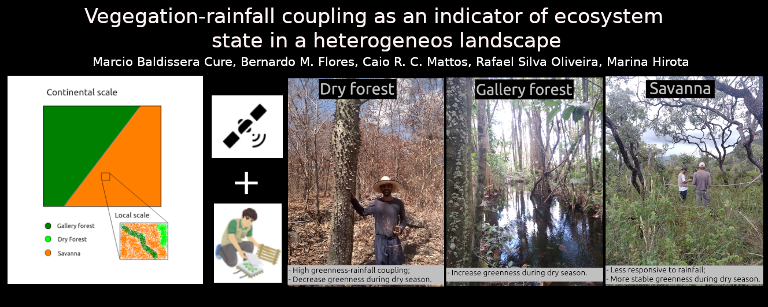

**HIGHLIGHTS**

* Distinct vegetation types coexist in tropical landscapes;
* Coexisting vegetation types respond differently to seasonal variation in rainfall;
* Structurally similar ecosystems (dry and gallery forests) are functionally distinct;
* Responses are partially determined by soil nutrients and water availability;
* Coupling between rainfall and greenness may shed light on future vegetation shifts.

**ABSTRACT**

Coexisting vegetation types in tropical landscapes can respond in contrasting ways to rainfall, despite being in the same climatic envelope. Understanding such heterogeneity in vegetation-rainfall interactions is key for predicting how ecosystems might respond to future environmental changes. Here we test whether temporal coupling between vegetation greenness and rainfall is a good indicator of ecosystem state in the landscape. For this, we study a well-preserved landscape of the Brazilian Cerrado that is formed by mosaics of contrasting ecosystems, including savannas, dry forests and gallery forests. First, we correlate the time-series of rainfall and vegetation greenness to quantify their coupling for each vegetation type. We then compare vegetation-rainfall coupling with other state variables, such as local-scale vegetation structural and functional traits, as well as differences in environmental conditions in which these vegetation types exist. Coexisting vegetation types are set in contrasting local-scale environmental conditions and have distinct responsiveness to rainfall. Commonly used structural and functional state variables, such as tree cover and tree height, do not depict such marked differences between the vegetation types, particularly for gallery and dry forests. Dry forests have the strongest coupling and decrease their greenness during dry seasons, reflecting vegetation deciduousness on nutrient-richer soils. In contrast, gallery forests increase their greenness during the dry season, when direct radiation peaks, likely due to perennial access to groundwater. Savannas are less responsive to rainfall and have a more stable greenness throughout the year. Our findings suggest that heterogeneity in local abiotic conditions contribute to determining both vegetation distribution and ecosystem states in these tropical savanna landscapes. Changes in these conditions as a result of climate and land-use changes will likely alter the distribution of vegetation types in the future. Our functional metric may thus be useful for assessing future responses of tropical ecosystems to changes in precipitation.

Keywords: cerrado; tropical vegetation; phenology; seasonality; remote sensing; ecosystem function.

### **2.1.1 Introdução**

While precipitation plays a significant role in determining vegetation distribution at the continental or regional scale (Hirota et al., 2011; Staver et al., 2011; Maksic et al., 2022; Hély et al., 2006), landscape-scale factors, i.e. abiotic conditions, such as soil fertility (Lopes & Fox, 1977), topography (Elias et al., 2019) and fire regimes (Simon & Pennington, 2012), also contribute to determine fine scale heterogeneity in the distribution of different forests and savannas (Lehmann et al., 2014; Veenendaal et al., 2015; Bueno et al., 2018). In the Brazilian Cerrado, fine scale abiotic conditions structure vegetation mosaics with sharp boundaries, with gallery forests often occurring along the wet riparian zones and dry forests, usually dominated by deciduous tree species, on fertile soil patches (Bueno et al., 2018; Dexter et al., 2018; Pennington et al., 2018; Lira-Martins et al., 2022). Despite this high heterogeneity, large-scale studies have long considered the whole Cerrado biome to be composed uniquely by savannas when using precipitation as the only predictor of vegetation distribution (e.g. Hirota et al., 2011), neglecting the concurrent role of local factors such as hydrology (e.g., Mattos et al., 2023).

For example, across the tropics, these studies consider different vegetation types, such as forests and savannas, as representing distinct ecosystem states within a range of annual rainfall totals (1000-2500mm; Staver et al., 2011) and rainfall seasonality (less than 7 months; Staver et al., 2011). Vegetation structure, specifically tree cover, has been used as state variable to differentiate these two ecosystem types (Hirota et al., 2011; Staver et al., 2011): savannas are characterized by sparse tree cover, typically ranging from 5% to 60%, whereas forests exhibit a closed canopy with ~ 80% tree cover (Hirota et al., 2011). However, it is noteworthy that using a simple structural threshold as tree cover can mask functionally different vegetation types, such as deciduous and evergreen forests (Lohbeck et al., 2013; Bueno et al., 2018; Dexter et al. 2018). While they both exhibit similar tree cover percentage when leaves are present, leaf coverage varies markedly through the year in dry forests, affecting ecosystem-level processes such as evapotranspiration and carbon assimilation (Eamus, 1999).

In this sense, the use of ecosystem functions as state variables that integrate the essence and behavior of ecosystems (Scheffer et al. 2001) is more likely to incorporate the dynamics and reveal potential responses to future environmental changes compared to structural variables alone (e.g. Berdugo et al., 2019, 2022; Maestre et al., 2016). One main terrestrial ecosystem function is primary productivity (Migliavacca et al., 2021), which is the result of the solar irradiance conversion into carbon assimilation (Monteith, 1972), thus serving as a basis to ecosystem functioning ([McNaughton](https://www.nature.com/articles/341142a0" \l "auth-S__J_-McNaughton) et al., 1989). Plant productivity is correlated with vegetation structure and climate (Michaletz et al., 2014; Migliavacca et al., 2021), and seasonal variability in productivity (i.e., phenology) depicts vegetation responses to environmental fluctuations (Alberton et al,. 2019).

Satellite derived products, such as vegetation indices (e.g., EVI2, NDVI), can be used to infer gross primary productivity (GPP) and assess plant phenology and GPP dynamics spatially over broad areas (Dronova & Taddeo, 2022; Biudes et al., 2021), reflecting leaf flush (greenning) and senescence (browning) (Gao et al., 2023). Previous global analysis suggests a strong climate-biosphere coupling revealing sensitivity of ecosystems exposed to changes in precipitation regime (Lotsch et al., 2003; Alessandri & Navarra, 2008). At finer scales, responses of greenness to rainfall variability may be highly heterogeneous and depend on the vegetation type and on local environmental conditions (Chen et al., 2020).

Most studies investigating relationships between vegetation greenness and rainfall patterns have focused on large spatial scales with coarse (i.e. hundreds of meters to kilometers) data resolution (Barbosa et al., 2015; Wang et al., 2003; Davenport & Nicholson, 1993; Schmidt & Karnieli, 2000; Ichii et al., 2002; Guan et al., 2015; De Keersmaecker et al., 2017; Ayanlade et al., 2021). Such coarse spatial scale does not allow for capturing above-mentioned local scale heterogeneities in vegetation responses (Abdi et al., 2022). Furthermore, few studies focused on distinct vegetation types. For instance, Santos and Negri (1997) showed contrasting large-scale relationships between vegetation greenness and rainfall at two extremes of rainfall regimes, with a stronger correlation when rainfall is lower in Northeastern Brazil.

Understanding how distinct vegetation types respond in terms of greenness to rainfall seasonality may therefore provide insights on the underlying mechanisms driving vegetation dynamics. In this study, we test whether the coupling between vegetation greenness and rainfall can be used as a state variable (Seddon et al., 2016) capable of distinguishing between different forest and savanna types in the Brazilian Cerrado. By incorporating the temporal dimension and considering distinct forest types (dry and evergreen), we intend to gain insights into the interplay between ecological processes and their implications for ecosystem dynamics in the face of changes in precipitation (Dronova & Taddeo, 2022). We hypothesize that distinct functional ecosystem states can be differentiated at the landscape scale by the coupling between greenness and rainfall seasonality, which reflect unique vegetation strategies to cope with seasonal water deficit depending on local environmental factors.

### **2.1.2 Materials and Methods**

#### 

#### *2.1.2.1 Study site*

This study was carried out at the Chapada dos Veadeiros National Park (PNCV) (Fig. 1), located within the Cerrado biome, in Central Brazil. In 2001, the PNCV was recognized as a UNESCO World Heritage site to protect its natural and cultural areas. Currently, the PNCV protects an area of approximately 240,000 ha. We chose the PNCV for our study because its landscapes are well-preserved (i.e. without anthropic direct use) and naturally heterogeneous, with various vegetation types including savannas, riparian evergreen and gallery forests, dry forests, palm swamps, and grasslands. These vegetation types are characterized by a wide range of tree cover (Fig. 1 a-c, Fig. S1), all within the same large-scale precipitation regime, with mean annual precipitation (MAP) of around 1,500 mm/yr and a dry season from April to September (Ribeiro et al., 1983; Silva et al., 2006).

We sample a total of 30 field plots with dimensions of 20m x 10m totalizing an area of 200 m² per plot. Out of the 30 plots, 10 were located in cerrado *stricto sensu* areas (hereafter called savannas), 10 in gallery forests, and 10 in dry forests (Fig. 1). We select these vegetation types because they have been studied in the context of biome transitions (Hoffman et al., 2012; Dexter et al., 2018). For gallery forests, we use the same control plots (i.e. six plots) of a previous study on the effects of a catastrophic fire event in the PNCV (Flores et al., 2021) and randomly select the other remaining four plots in the surrounding vegetation. For savannas, we randomly select plots between 5% and 60% of tree cover percentage from Hansen et al. (2013) at the spatial resolution of 30 meters, according to previously defined thresholds in the context of distinct ecosystem states (Hirota et al., 2011). Dry forests are less common in the region and the most well-preserved ones are located inside private lands, within adjacent areas. Moreover, all sampled dry forests had experienced past human activities, such as logging and shelter for cattle. We randomize 10 dry forest plots within the least impacted areas of Nova Roma and Alto Paraíso de Goiás municipalities, both located within the margins of the PNCV (Fig. 1).

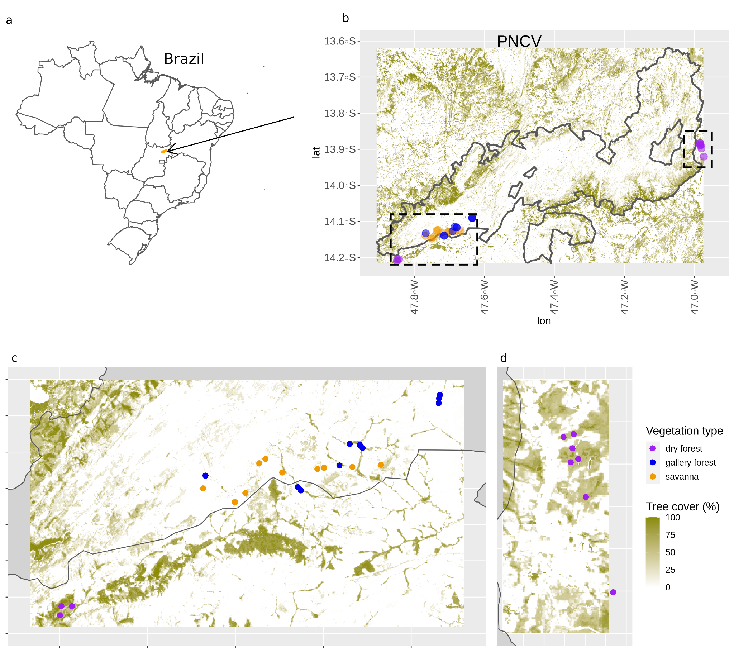

Figure 1: In (a), Brazilian map with the arrow pointing to the Chapada dos Veadeiros National Park (PNCV) highlighted in orange. In (b), the PNCV is limited by a gray line and shows tree cover according to the legend. Dotted squares are zoomed in (c) and (d). Our sample plots are shown in circles with each color representing different vegetation types as described by the legend. (c) and (d): zooming in our sample plots showing the position of each plot in relation to the PNCV borders. Note that dry forests (purple dots) are outside the PNCV.

#### *2.1.2.2 Environmental conditions*

##### 2.1.2.2.1 Precipitation and fire frequency data

We use monthly precipitation time series from the Climate Hazards Group InfraRed Precipitation with Station data (CHIRPS) dataset, with 0.05° spatial resolution (Funk et al., 2015) for the period between January 1981 and June 2018. We extract time series from the 30 pairs of coordinates of our sample plots and calculate the mean annual precipitation (MAP), and rainfall seasonality using the Markham Seasonality Index (MSI) (Markham, 1970) to characterize the large-scale rainfall regimes for the study area (Fig. S2). We also characterize rainfall regimes for neotropical biomes (i.e., Amazon, Cerrado, and Caatinga) to situate our sample plots along the range of values for these Biomes.

To compare precipitation regimes among the sampled vegetation types and among neotropical Biomes, we perform pairwise comparisons between factors to compute marginal means and confidence intervals for each combination of factors. Subsequently, we conduct multiple comparison tests to identify significant differences between groups (or not) by comparing all factor levels, such as biomes and vegetation types. Analysis was performed with the R package *emmeans* (Lenth, 2022).

In addition, we use MapBiomas Fire Collection 1 (Alencar et al., 2022) to obtain fire frequency data from 1985 to 2018 with 30 m resolution extracted from the plot coordinates to characterize fire regimes for the different vegetation types (Projeto Mapbiomas; Souza et al., 2020).

##### 2.1.2.2.2 Soil samples

We collect three superficial soil samples (0 - 20 cm) well spaced in each plot to represent local soil characteristics. Samples were analyzed at the Soil Department Laboratory of the Universidade Federal de Viçosa, Brazil, for the following: effective cation exchange capacity (t), sum of bases (SB), soil pH, aluminum (Al3+), iron (Fe), potential acidity, base saturation index (V), aluminum saturation index (m), soil texture and available nutrients [i.e., total phosphorus (P), calcium (Ca2+), nitrogen (N), potassium (K), copper (Cu), zinc (Zn), magnesium (Mg2+) and manganese (Mn)]. pH was extracted with H2O; remaining phosphorus (P-Rem), potassium (K), iron (Fe), zinc (Zn), manganese (Mn) and copper (Cu) with Mehlich-1; calcium (Ca2+), magnesium (Mg2+) and aluminum (Al3+) with KCl 1 mol/L. The colorimetric method (ascorbic acid) was used to determine P; flame emission spectrometer for K, Na, Fe, Mn, Zn and Cu; atomic absorption spectrometer for Ca2+ and Mg2+; titration with bromothymol blue and NaOH for Al3+.

Using all soil variables, we perform a Principal Component Analysis (PCA) based on Euclidean distances of the standardized variables to simplify part of the variance of several soil attributes, using the ‘decostand’ and ‘rda’ functions from the ‘vegan’ package (Oksanen et al., 2020) and the ‘prcomp’ function from the ‘stats’ package in the R Software for Statistical Computing (R Core Team, 2021). To understand how samples are grouped by similarity regarding soil attributes, we used the Ward's minimum variance method (Murtagh & Legendre, 2014) to clusterize sample plots by Euclidean distances of their soil characteristics using both ‘dist’ and ‘hclust’ functions from the ‘stats’ package.

##### 2.1.2.2.3 Topographic Wetness Index (TWI): water in the soil

To characterize plant water access conditions, we use the Topographic Wetness Index (TWI) as a proxy for water availability from each plot coordinate. The TWI (Beven & Kirkby, 1979) has long been used on hydrological studies (e.g., Western et al., 1999) as a proxy for soil moisture, and more recently has been applied to ecological studies to explain the distribution of vegetation along topographic gradients (Alexander et al., 2016; Moeslund et al., 2013). The TWI is defined as ln(A/tan β), where A is the specific catchment area above a certain point in the terrain and β is the terrain slope. Larger TWI values are associated with lower convergent areas where water tends to accumulate and soil moisture availability is high. We calculate the TWI using the GRASS package on the open-source QGIS software, using the MERIT-Hydro Digital Elevation Model (90 m resolution) as the basis for our calculations (Yamazaki et al., 2019). We note that this is a first-order estimate of soil water conditions, based only on topography, and does not account for factors such as difference in soil properties and local geology. Despite these limitations, the TWI has been shown to be useful in differentiating hydrologic environments (e.g., drier uplands vs wetter lowlands) and their effect on vegetation distribution and structure (Metzen et al., 2019; El-Hoyakem et al., 2023; Alexander et al., 2016).

#### *2.1.2.3 Ecosystem state variables*

##### 2.1.2.3.1 Tree community structure and functional traits

We chose 4 structural and functional traits to serve as ecosystem state variables (i.e. variables characterizing the ecosystem) and to test their performance in relation to the coupling: tree height, bark thickness, tree basal area and deciduousness. Trees were selected depending on the vegetation type: for forests, we selected individuals with diameter at breast height greater or equal than 10 cm (DBH 10 cm); while for savannas, we sampled trees when the DBH was greater or equal than 3 cm, i.e., with lower DBH than forest individuals (Maracahipes et al., 2018). We defined such sampling design to ensure the effective representation of the total basal area of woody vegetation in both forest and savanna ecosystems.

We sample tree height because it has already been used to characterize distinct vegetation types (Xu et al., 2016) and because it is an indicator of several ecosystem functions. For example, tree height is related to resource availability, respiration, hydraulic traits and also to aboveground biomass (Liu et al., 2019; McDowell et al., 2002; Ryan & Yoder, 1997). We also measure bark thickness given its role in determining vegetation structure and function related to fire regimes (Bernardino et al., 2021; Dantas et al., 2013; Lawes et al., 2011; Pausas, 2015). Moreover, bark thickness has been reported to have multiple additional functions, such as protection against herbivores, storage of water and other compounds, photosynthetic activity and mechanical support (Rosell, 2019). This trait was measured using the bark gauge MAC-100 by Haglöf Sweden and relativized using tree basal area (Lawes et al., 2013). Although relative bark thickness has not been used in the literature as a state variable so far, it can clearly separate forest and savanna states (Bernardino et al., 2021; Dantas et al., 2013). To characterize tree communities of each plot, we calculate the community mean for tree height and relative bark thickness.

Another ecosystem state variable selected was the tree basal area (TBA). TBA is an indicator of aboveground biomass, nutrient availability and soil physical characteristics (Emilio et al., 2013; Rozendaal et al., 2020; Slik et al., 2009) and has been used as a state variable describing vegetation structure (Dantas et al., 2016). It is calculated as the sum of areas of tree trunks and scaled to one hectare. We computed the trunk areas based on DBH.

We calculate community-level deciduousness as the difference between wet and dry season tree cover measured in the field, as an indicator of changes in green leaf area. Wet and dry season measures were taken in April and September respectively. We were unable to measure deciduousness for 5 dry forest plots, for 2 gallery forest plots and for 2 savanna plots due to vegetation burning and cutting between the measurements. Deciduousness can be used as an integrative indicator of vegetation functioning, depending on water and nutrient availability (Oliveira et al., 2021).

In addition to plot sampling (see above in section 2.1), we use satellite-derived tree cover measurements (Hansen et al., 2013) to compare with our tree cover percentage measured in the field. We estimate tree cover for our plots (i.e., at the community scale) as the mean of 16 measurements for each plot, with four measurements at each corner (facing North, South, East and West), using a convex densiometer. For our 30 sample plots, the *in situ* densiometer-derived tree cover and the remotely-sensed estimated tree cover are strongly correlated (*ρ* = 0.84, t = 7.57, p < 0.05), but satellite data tend to overestimate savanna coverage, while underestimating forest tree cover (Fig. S1). Although such mismatches might not make a substantial difference in large-scale analyses (e.g., Hirota et al., 2011; Staver et al., 2011), here, 12 out of our 20 forest plots would not be classified as forests using satellite data. The densiometer-derived tree cover represents vegetation type structure with more precision by capturing the fine scale structure (Fig. S1b). Hence, we choose to use field densiometer-derived tree cover as our metrics for tree cover at the community level. The relationship between structural/functional state variables (e.g., tree height, basal area, bark thickness) and tree cover has been used to test if functional alternative states correspond to structural ones (e.g., Bernardino et al., 2021; Dantas et al., 2016; Xu et al., 2016).

##### 2.1.2.3.2 Satellite EVI2 data for vegetation greenness

As a proxy for vegetation greenness (Biudes et al., 2021), we use the 2-band Enhanced Vegetation Index (EVI2) from Landsat 8 (OLI), at 30m spatial resolution, available for the period between April 2013 to June 2018. EVI2 is calculated based on both red (Band 4) and near infrared (Band 5) bands. These bands represent fractions of the electromagnetic spectrum (640-1400 nm) that correspond to photosynthetic radiation reflected and absorbed by plant leaves, respectively, thus indicating vegetation greenness; in particular with new green leaves exposed to sunlight. We computed the EVI2 using the formula:

EVI2 = 2.5 \* (band 5 – band 4) / (band 5 + 2.4 \* (band 4) + 1).

EVI2 was developed to have the efficiency of Enhanced Vegetation Index (EVI) and to avoid saturation at high vegetation biomass, while minimizing soil and atmosphere influences without the blue band (Jiang et al., 2008), i.e., to improve the representation of greenness heterogeneity in forest ecosystems. We extract the 16-day values for each sample plot and calculate the mean EVI2 for each month, as well as standard deviation, maximum values and amplitude. We excluded time series values that have a quality flag indicating cloud cover. Given the temporal resolution of 16 days in which Landsat 8 acquires the images used, all time series have between 1% and 4% of their values contaminated by clouds. Such contamination was not a major concern because we were able to ensure at least one cloud-free value per month. This suggests that despite cloud cover, there was sufficient data available for analysis in each month.

We calculate mean, maximum and standard deviation in EVI2 for each plot to additionally serve as functional state variables.

##### 2.1.2.3.3 Coupling between precipitation and greenness

We propose to use the coupling between EVI2 and rainfall as a state variable that comprises the temporal dynamics of vegetation response to rainfall fluctuations. The coupling between the monthly time series of precipitation and EVI2 for each plot is computed using the Kendall cross-correlation coefficient (*tau*). Positive *tau* values indicate that vegetation is in phase with precipitation (EVI2 changes together with precipitation), whereas negative values indicate the opposite (EVI2 follows an opposite direction of precipitation changes). Additionally to the calculation of the coupling, we also perform a cross-correlation analysis that results in values of maximum coupling and associated lag (moving precipitation from 0 to 6 months backward to be correlated with the current EVI2). Finally, we also considered the maximum coupling as a functional state variable to differentiate vegetation types. A flowchart illustrating the step-by-step process for deriving the biotic and abiotic variables is provided in Figure S13.

We utilized statistical tests to differentiate between vegetation types based on the EVI2 signal, which indicates vegetation greenness behavior, as well as state variables that describe vegetation functioning, structure, and environmental conditions. We use the Mann-Kendall trend test from the Kendall package (McLeod, 2011) to assess trends in monthly median EVI2 values during the dry season months. This analysis aids in highlighting differences in vegetation behavior during the drier months and may also reveal the impact of rainfall-water stress on greenness direction. Furthermore, we conducted a Mann-Whitney U test (Sijtsma & Emons, 2010) to compare pairs of different vegetation types across various attributes, including maximum coupling, lag, tree height, total basal area, relative bark thickness, deciduousness (changes in tree cover), TWI, fire frequency, soil variables and PCA derived axis between pairs of different vegetation types, using the R package ‘stats’ (R Core Team, 2021). We also set the *alternative* argument in the *wilcox.test* function to either *less* or *greater* to test the hypothesis that values of one vegetation type are lower or greater, respectively, than values of the other vegetation type. Analyses and data manipulation were performed in R version 4.1 (R Core Team, 2021).

### **2.1.3 Results**

#### *2.1.3.1 Heterogeneity in environmental conditions*

Gallery forests and savannas are embedded within the same rainfall regime (both mean annual precipitation, MAP, and seasonality), whereas dry forests are set under a statistically different mean annual precipitation (Fig. S2). Despite differences shown in the analysis of MAP for dry forests, the values are very close compared with the range of values for the Cerrado biome (Fig. S2a). Furthermore, all vegetation types are inside the bistability zone for MAP defined by Staver et al. (2011), i.e. they exist within a rainfall envelope that supports both forests and savannas. At finer scales, however, savannas, gallery forests and dry forests occur in distinct environmental conditions regarding water access, soil characteristics and fire frequency (Fig. 2, Figs. S3-6; Fig. S7; Table S1). First, soil moisture availability is higher in gallery forests followed by savannas and dry forests (Fig. 2; Tables S1 and S2; Figs. S6-d).

Secondly, regarding soil characteristics, gallery forests have higher amounts of Ca, Mg, N, total P, K, Zn, Mn, sum of bases, and cation exchange capacity than savannas (Table S3). Nevertheless, they are more similar to savannas than to dry forests (Fig. S4b; Table S1), as shown by their overlap in the PC1 (Fig. 2-a, Fig. S4 a; Table S1). PC1 explains more than 63.85% of soil variance and is positively correlated with base saturation index, Mg2, sum of bases, Ca2, t, Mn, pH and K; PC1 is also negatively correlated with Aluminum saturation index, exchangeable Aluminum and potential acidity (Fig. S4; Table S3). PC2 explains 19.13% of soil variance and is more related to total N, effective cation exchange capacity, potential acidity, Fe, and P; it also separates all vegetation types (Tables S1 and S3; Figs. S4 and S7b). Except for N, Fe and total P, overall concentrations of soil nutrients in the dry forests are higher than in gallery forests and savannas (Figs. S3-4 and S6a-b; Table S4). Despite the similarities in PC1, gallery forests and savannas have well pronounced differences (Fig. S7a) such as higher amounts of N and P and lower sand content in gallery forests (Table S4; Figs. S3-5). Gallery forests and savannas are present within more acidic soils if compared to dry forests (Table S4), while dry forests are related to more fertile soils with higher cation exchange capacity (positive values in the PC1; Table S4) without exchangeable aluminum (Figs. S3-4).

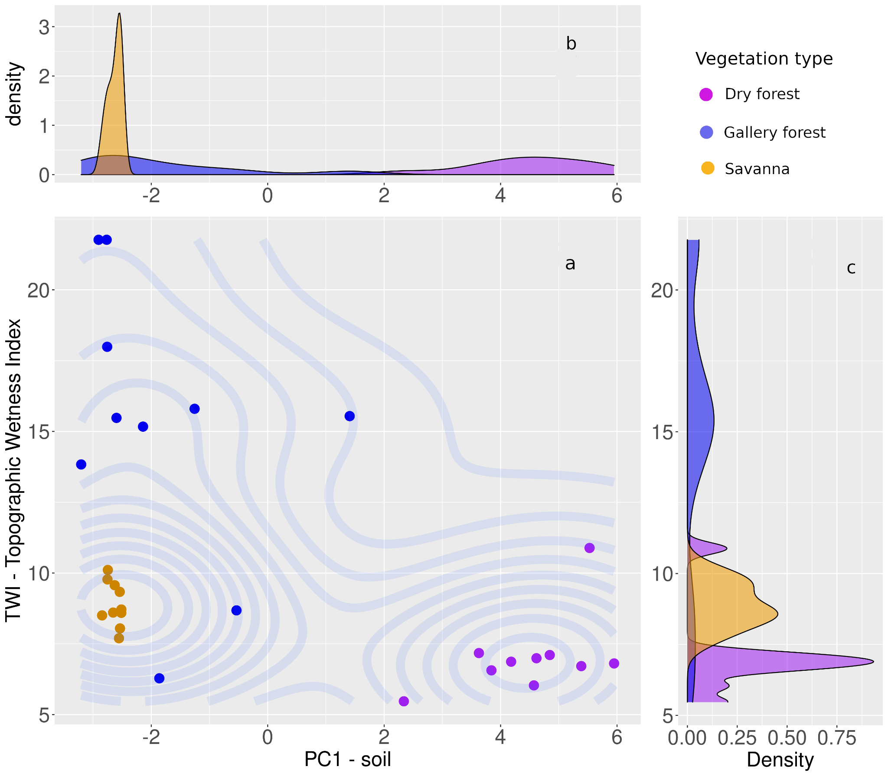

Figure 2: Three coexisting vegetation types within a two-dimensional space of environmental conditions. a) The main panel shows the density distribution of environmental conditions (vertical axis: TWI; horizontal axis: soil first principal component) represented in a plane for the different vegetation types at the Chapada dos Veadeiros National Park. b) Density distribution of the PC1 of soil variables shows overlap of soil conditions for gallery forests and savannas, while dry forests are distinct from the rest. c) TWI separates gallery forests from savannas, but overlaps occur for savannas and dry forests in one case, as well as for gallery and dry forests.

Fire frequency differs between vegetation types (Fig. S6; Fig. S7b; Table S1), with savannas more frequently affected by fire than both forest types for the study period (Table S2). Forest types also differ in fire frequency: while only one dry forest plot burned (twice) in the 33 years, gallery forests burned on average 2.9 times (Table S2). Thus, our results show that fire events occur in gallery forests (less frequent) and savannas (more frequent) (Table S2), but rarely in dry forests.

#### *2.1.3.2 Ecosystem state variables*

The maximum coupling reveals substantial differences among vegetation types (Fig. 3a, Figs. S8-10; Table S3; Fig. S7c). Dry forests present the largest positive maximum coupling (Table S6; median *tau* = 0.4), indicating that greening follows the increase in rainfall amounts during the wet season (Figs. S11b,e and S12c). On the other hand, gallery forests have the largest negative maximum coupling, indicating that greening occurs before the start of the wet season (median *tau* = -0.27), more specifically, with a peak at the end of the dry season (Figs. S11c,f and S12b). Savannas have a small maximum coupling (median *tau* = 0.18, Fig. S12a), with the least variation (Table S6) in EVI2 (mean standard deviation = 0.16; Figs. 3a,b and S11d,g). All vegetation types have significant differences among their distributions of coupling (Table S5; Fig. S7c), with little overlap (Fig. 3a). Moreover, different vegetation types respond to precipitation with different lags for the strongest response: gallery forests are the fastest (lag in response of 0 to 1 month), while dry forests respond within 1-2 months and savannas have a mean lag of 2.8 months (Fig. S7c; Tables S5,S6).

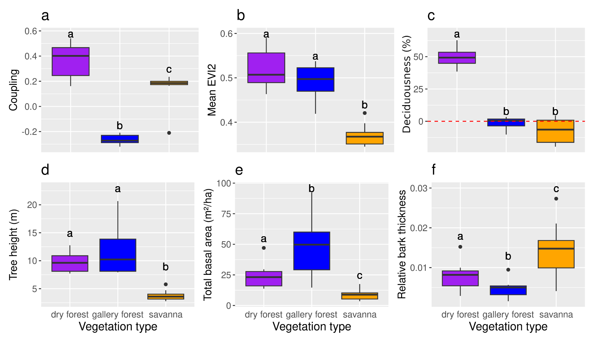

Figure 3: Functional state variables used in this study to highlight differences and similarities among vegetation types in the Chapada dos Veadeiros National Park (PNCV), Brazil. (a) Coupling between 2-band Enhanced vegetation Index (EVI2) and precipitation. Note that the magnitude of the coupling is indicated by the absolute value of the maximum coupling with lag between monthly EVI2 and precipitation; (b) Mean values of EVI2; (c) Deciduousness: green leaf area changes (positive values, loss or gain, negative values) from the wet to the dry season as evidence of growth for savanna and gallery forest during the dry season. Negative values mean increase in tree cover while positive values mean decrease in tree cover.; (d) Tree height; (e) Total basal area per hectare; and (f) Bark thickness relative to tree basal area for dry forests, gallery forests and savannas. Letters above each box indicate the differences and similarities between vegetation types based on Mann-Whitney U tests, with p-value < 0.05.

Savannas are the most stable in terms of greenness fluctuations (EVI2 standard deviation = 0.02), and present the lowest mean values (mean = 0.37) (Fig. 3b, Fig. S11e-g; Table S5). EVI2 means and variations in dry and gallery forests are similar (Figure 3b; Fig. S7c; Table S4), but the annual cycle is different in terms of the time greening occurs (Figs. S11-S12). During the dry season, gallery forests have a positive trend (*tau* = 0.867, p < 0.05), i.e., an increase in greenness before rainfall starts (Figs. S11c,f and S12b), dry forests have a negative trend (*tau* = -1, p < 0.05), indicating a decline in canopy greenness (Figs. S11b,e and S12b,c). Savannas are fairly insensitive to rainfall variation (*tau* = -0.6, p > 0.05) and maintain a stable EVI2 throughout the dry season (Figs. S11d,g and S12a).

In terms of deciduousness, gallery forests and savannas are similar (Fig. S7c; Table S5), characterized by relatively small increases in the percentage of green leaf area (gallery forest: mean = -1.43, sd = 4.94; savanna: mean = -7.3, sd = 10.02) during the dry season, while dry forests present a pronounced decrease (mean = 49.67, sd = 8.43) (Fig. 3c).

Gallery and dry forests are clearly differentiated from savannas, with higher values in tree height and TBA for both forest types (Fig. 3d-e; Table S5; Table S6; Fig. S7b). Gallery forests have the highest TBA followed by dry forests and savannas (Fig. 3e; Table S6). Furthermore, savannas have a higher relative bark thickness in comparison with both types of forests (Table S6), and dry forests have a higher relative bark thickness than gallery forests (Table S6; Fig. 3f).

The three vegetation types can be clearly distinguished when viewed in the tree cover-coupling and tree cover-deciduousness two-dimensional spaces (Figs. 4a, c). However, only coupling is able to separate all three vegetation types when considered as a single state variable (Fig. 4; Fig. S7; Table S5), whereas deciduousness alone cannot separate between gallery forests and savannas (Fig. S7; Table S5). Moreover, only forests (both types) and savannas appear as separate states when tree cover is combined with mean EVI2, tree height, TBA and relative bark thickness, missing the distinction between dry and gallery forests (Fig. 4b, d-f).

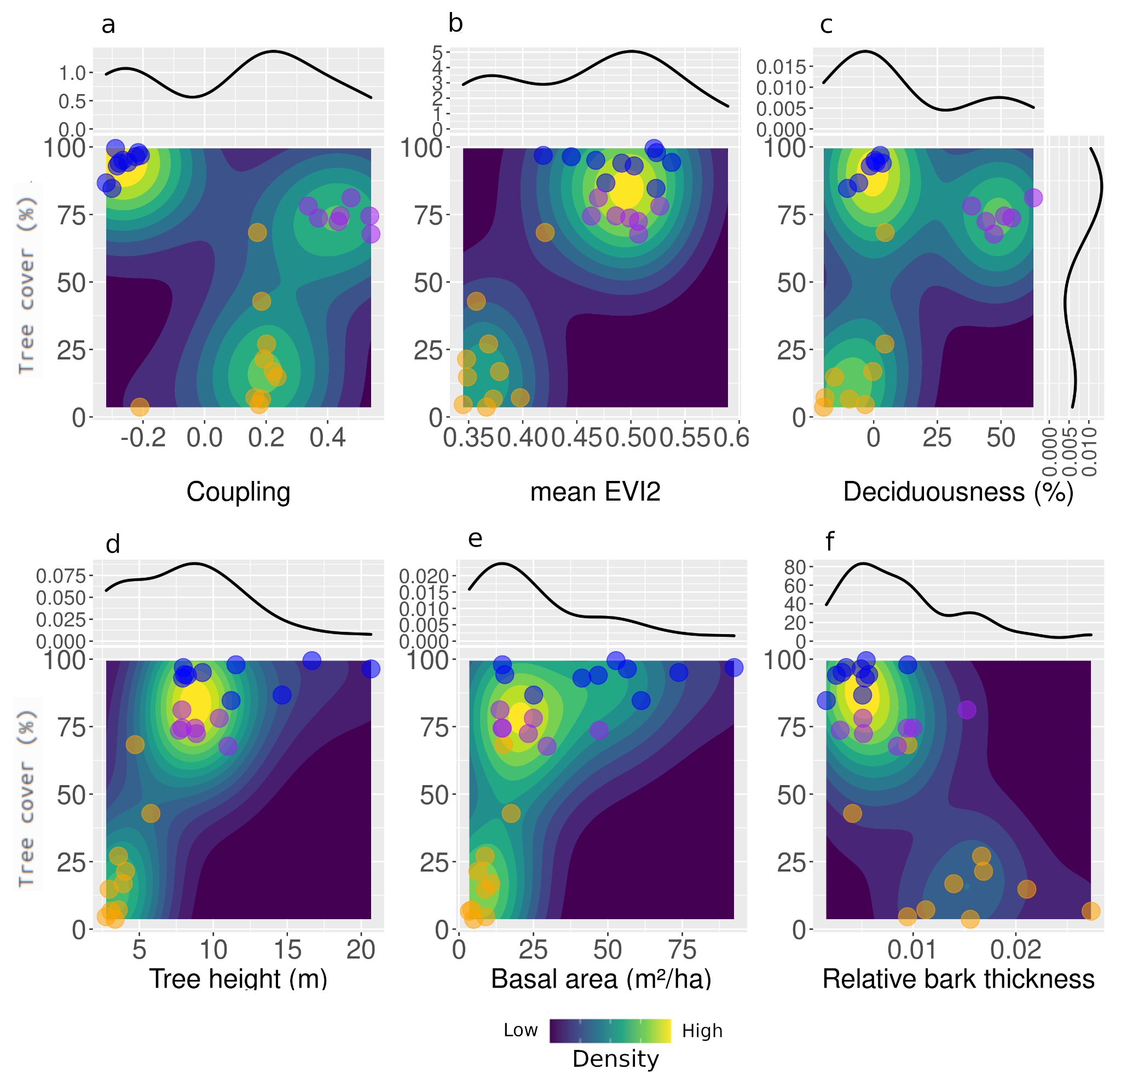

Figure 4: Relations between state variables with tree cover to test for correspondence between functioning and structure. The color gradient in panels represent density distribution of plots (low density – marine blue; high density - yellow). Orange dots are savannas, purple dots are dry forests, and blue dots are gallery forests. (a) Maximum coupling; (b) mean EVI2; (c) deciduousness derived from the difference between percentages of tree covers in the end of the wet season and in the end of the dry season; (d) tree height (m); (e) total basal area per hectare (m²/ha); and (f) Relative bark thickness (bark thickness divided by tree basal area).

### 

### 

### **2.1.4 Discussion**

Our findings suggest that the greenness-rainfall coupling can be a novel and mechanistic way of differentiating between coexisting vegetation types in the same rainfall envelope (Fig. 4). This ecosystem-level functional variable shines new light on tropical landscape heterogeneity (Turner & Chapin, 2005), separating dry and gallery forests that were previously indistinguishable using the satellite-derived tree cover data (e.g. Hirota et al. 2011). Other structural/functional variables previously used to characterize alternative stable states (Xu et al., 2016; Dantas et al., 2016; Bernardino et al., 2021), such as tree height, TBA, and relative bark thickness also failed in differentiating between forest types. Even with distinct TBA and relative bark thickness, gallery and dry forests are still in the same attractor of forests (see Table 1 from Dantas et al., 2016; and Figure 2 from Bernardino et al., 2021). Although deciduousness has been proposed by an integrative variable to define strategies to deal with droughts (Oliveira et al., 2021), it did not differentiate gallery forests and savannas (Figs. 3 and 4; Table S5). Our results thus indicate that the temporal dynamics of vegetation responses to rainfall provides a more meaningful indicator (i.e. a functional one) for characterizing distinct ecosystems in the landscape than simple structural variables (Dronova & Taddeo, 2022).

Our results show that gallery forests, dry forests and savannas coexist in the same landscape under different conditions of soil nutrients and water accessibility (Ratter & Dargie, 1992; Oliveira & Marquis, 2002; Ribeiro & Walter, 2008; Cowling & Potts, 2015; Lira-Martins et al., 2022) (Fig. 2; Fig. S3; Fig. S5; Fig. S6 a-c; Fig. S7a-b), suggesting they may not be alternative stable states after all (Veenendaal et al., 2015). Fire regimes could be another explanation for the distribution of forests and savannas in this landscape (Hoffmann et al. 2012; van Nes et al. 2018), but our analyses also suggest that they might play a smaller role, compared to soil conditions (Veneendaal et al. 2015). Soil conditions shape the variety of strategies to cope with the strong water deficit experienced by all vegetation types during the dry season and the consequent response each vegetation type presents to rainfall seasonal variation (Oliveira et al. 2021). For instance, savannas invest primarily on deep roots to access water and build a drought resistant xylem (Oliveira et al., 2005; Scholz et al., 2008; Loram-Lourenço et al., 2022, Jancoski et al., 2022). As a result, we observe a high stability in greenness and consequent weak coupling, particularly because all plots have significant woody tree strata (mean = 62%, sd = 35). Annual C4 herbaceous species tend to be highly coupled with rainfall and thus more variable (Ma et al., 2020; Whitecross et al., 2017), whereas savanna trees with deep roots may contribute to a lower variability in water availability, and consequently in ecosystem greenness (Lee et al., 2021; Oliveira et al., 2005; Priyadarshini et al., 2016).

Biogeographical and evolutionary processes may have contributed to make savannas in the Cerrado (a tropical savanna biome) more diverse in strategies to deal with their environment (Simon et al., 2009), compared to evergreen and deciduous forests that occupy smaller areas within the savanna landscape (Projeto Mapbiomas, 2022). One hypothesis is that higher diversity of plant strategies may have contributed to increasing savanna greenness stability to rainfall fluctuations (Liang et al., 2016; Oheri et al., 2017). A similar pattern was observed in the dry forests of the Caatinga biome, where areas with higher phylogenetic diversity had higher greenness stability than areas with lower diversity (Mazzochini et al., 2019).

The dominant ecological strategy in dry forests for dealing with seasonal drought relies on deciduousness to avoid water losses and possible hydraulic system collapse (Castro et al., 2018; Cuba et al., 2018; Oliveira et al., 2021). With high nutrient availability, trees lose their leaves because they can easily grow new leaves before the next rainy season (Sobrado, 1991; Kikuzawa, 1995). Indeed, dry forest soils in our study landscape had a higher cation exchange capacity and low exchangeable aluminum content than gallery forests and savannas and this is likely determined by geomorphic processes not by feedback with vegetation (Dexter et al., 2018; Lira-Martins et al. 2022; Paula et al., 2023). The new leaves produced by the tree community every year may thus contribute to boost greening during the rainy season (Mazzochini et al., 2019). This way, dry forests exhibit greenness closely following rainfall seasonal variations, with a significant decrease during the dry season (Fig. S11), reflected in their EVI2 signal (Goldstein et al., 1989; Eamus, 1999; Ishida et al., 2006; de Souza et al., 2020).

Gallery forests were the only vegetation type showing increased greenness during the dry season and thus a negative coupling with rainfall (Fig. 3a, Figs. S11-12). One possible explanation is that gallery forests have perennial access to groundwater (Veneklaas et al., 2005; Bueno et al. 2018), i.e., they are not water-limited (Green et al., 2020; Smith et al., 2020). Increased greening is likely a result of dry-season leaf flushing, which allows trees to attain higher photosynthetic activity in a period of lower cloud cover and increased radiation (Saleska et al., 2007). Similar to our sampled gallery forests, Amazonian forests reach peak greenness during the dry season, when cloud cover is low and incoming radiation is high (Guan et al., 2015).

Contrary to the well reported fire-vegetation feedback maintaining savannas and forests as alternative stable states (Bernardino et al., 2021; Bond et al., 2005; Dantas et al., 2013; Hoffmann et al., 2012; Murphy & Bowman, 2012; Pausas & Bond, 2021; Staver et al., 2011), we found that gallery forests have higher fire frequency than previously reported (Ribeiro & Walter, 2008). Even with the highest tree cover and moisture availability, all gallery forests experienced at least one fire event between 1985 and 2018 (mean = 2.9 fires), while only one dry forest plot burned in this period (Fig. S6c). Dry forests likely burnt from fires ignited to expand the surrounding pastures for cattle. Gallery forests are narrow and surrounded by flammable savannas, from where such fires may spread into the forest (Ribeiro & Walter, 2008; Kellman & Maeve 1997). Nonetheless, gallery forests may suffer mild burns and still keep high tree cover under a long fire return interval, likely because fire events may not be strong enough to open the forest canopy (Veenendaal et al., 2018). Strong widespread fires, however, may severely impact the ecosystem, killing most trees and destroying the organic soil layer (Flores et al., 2021).

### **2.1.5 Conclusion**

We have shown how the temporal coupling between greenness and precipitation inferred from satellite can be an integrative state variable and a promising ecological indicator for broad-scale analyses differentiating between coexisting vegetation types. Our coupling measure reveals that savannas, gallery forests and dry forests at the same landscape have distinct responses in terms of greenness to rainfall seasonality partially determined by nutrient and water availability at the local scale. Our results have also shown that vegetation with similar structure (i.e. gallery and dry forests) may have contrasting functioning and responses to rainfall variability. Combined, these results suggest that presuming the absence of feedback mechanisms (Staal and Flores, 2015), coexisting vegetation types may not necessarily be alternative stable states (Hirota et al. 2011; Staver et al. 2011), since their distribution is strongly determined by fine scale heterogeneity in environmental conditions.

**REFERENCES**

Abdi, A. M., Brandt, M., Abel, C., & Fensholt, R. (2022). Satellite Remote Sensing of Savannas: Current Status and Emerging Opportunities. *Journal of Remote Sensing*, *2022*.<https://doi.org/10.34133/2022/9835284>Alberton, B.; da Silva Torres, R.; Sanna Freire Silva, T.; Rocha, H.R.d.; S. B. Moura, M.; Morellato, L.P.C. (2019). Leafing Patterns and Drivers across Seasonally Dry Tropical Communities. *Remote Sensing*. 11, 2267.<https://doi.org/10.3390/rs11192267>

Alencar, A.A.C.; Arruda, V.L.S.; Silva, W.V.d.; Conciani, D.E.; Costa, D.P.; Crusco, N.; Duverger, S.G.; Ferreira, N.C.; Franca-Rocha, W.; Hasenack, H.; et al. (2022). Long-Term Landsat-Based Monthly Burned Area Dataset for the Brazilian Biomes Using Deep Learning. *Remote Sensing.* 14(11):2510.<https://doi.org/10.3390/rs14112510>

Alessandri, A., and Navarra, A. (2008), On the coupling between vegetation and rainfall inter-annual anomalies: Possible contributions to seasonal rainfall predictability over land areas, *Geophysical Research Letters*, 35, L02718. [https://doi.org/](https://doi.org/10.3390/rs14112510)[10.1029/2007GL032415](https://doi.org/10.1029/2007GL032415)

Alexander, C., Deák, B., & Heilmeier, H. (2016). Micro-topography driven vegetation patterns in open mosaic landscapes. *Ecological Indicators*, *60*, 906–920.<https://doi.org/10.1016/j.ecolind.2015.08.030>

Ayanlade, A., Jeje, O. D., Nwaezeigwe, J. O., Orimoogunje, O.O.I., Olokeogun, O.S. (2021). Rainfall seasonality effects on vegetation greenness in different ecological zones. *Environmental Challenges*, 4, 100144.<https://doi.org/10.1016/j.envc.2021.100144>

Barbosa, H.A., Lakshmi Kumar, T.V. & Silva, L.R.M. (2015). Recent trends in vegetation dynamics in the South America and their relationship to rainfall. *Natural Hazards,* 77, 883–899.<https://doi.org/10.1007/s11069-015-1635-8>

Berdugo, M., Maestre, F. T., Kéfi, S., Gross, N., Le Bagousse-Pinguet, Y., & Soliveres, S. (2019). Aridity preferences alter the relative importance of abiotic and biotic drivers on plant species abundance in global drylands. *Journal of Ecology*, *107*(1), 190–202.<https://doi.org/10.1111/1365-2745.13006>

Berdugo, M., Vidiella, B., Solé, R. V., & Maestre, F. T. (2022). Ecological mechanisms underlying aridity thresholds in global drylands. *Functional Ecology*, *36*(1), 4–23.<https://doi.org/10.1111/1365-2435.13962>

Bernardino, P. N., Dantas, V. L., Hirota, M., Pausas, J. G., & Oliveira, R. S. (2021). Savanna–Forest Coexistence Across a Fire Gradient. *Ecosystems*, 1–12.<https://doi.org/10.1007/s10021-021-00654-4>

Beven, K. J., & Kirkby, M. J. (1979). A physically based, variable contributing area model of basin hydrology / Un modèle à base physique de zone d’appel variable de l’hydrologie du bassin versant. *Hydrological Sciences Bulletin*, *24*(1), 43–69.<https://doi.org/10.1080/02626667909491834>

Biudes, M. S., Vourlitis, G. L., Velasque, M. C. S., Machado, N. G., de Morais Danelichen, V. H., Pavão, V. M., Arruda, P. H. Z., & de Souza Nogueira, J. (2021). Gross primary productivity of Brazilian Savanna (Cerrado) estimated by different remote sensing-based models. *Agricultural and Forest Meteorology*, *307*, 108456. [https://doi.org/10.1016/j.agrformet.2021.108456](https://doi.org/https://doi.org/10.1016/j.agrformet.2021.108456)

Bond, W. J., Woodward, F. I., & Midgley, G. F. (2005). The global distribution of ecosystems in a world without fire. *New Phytologist*, *165*(2), 525–538. https://doi.org/10.1111/j.1469-8137.2004.01252.x

Bueno, M. L., Dexter, K. G., Pennington, R. T., Pontara, V., Neves, D. M., Ratter, J. A., & de Oliveira-Filho, A. T. (2018). The environmental triangle of the Cerrado Domain: Ecological factors driving shifts in tree species composition between forests and savannas. *Journal of Ecology*, *106*(5), 2109–2120.<https://doi.org/10.1111/1365-2745.12969>

Caparros-Santiago, J.A., Rodriguez-Galiano, V., Dash, J. (2021). Land surface phenology as indicator of global terrestrial ecosystem dynamics: a systematic review. *ISPRS Journal of Photogrammetry and Remote Sensing,* 171, 330–347.<https://doi.org/10.1016/j.isprsjprs.2020.11.019>

Castro, S. M., Sanchez-Azofeifa, G. A., & Sato, H. (2018). Effect of drought on productivity in a Costa Rican tropical dry forest. *Environmental Research Letters*, *13*(4), 045001.<https://doi.org/10.1088/1748-9326/AAACBC>

Chen, Z., Wang, W., & Fu, J. (2020). Vegetation response to precipitation anomalies under different climatic and biogeographical conditions in China. *Scientific Reports*, *10*(1), 1–16.<https://doi.org/10.1038/s41598-020-57910-1>

Cowling, R. M., & Potts, A. J. (2015). Climatic, edaphic and fire regime determinants of biome boundaries in the eastern Cape Floristic Region. *South African Journal of Botany*, *101*, 73–81.<https://doi.org/10.1016/J.SAJB.2015.03.182>

Cuba, N., Lawrence, D., Rogan, J., & Williams, C. A. (2018). Local variability in the timing and intensity of tropical dry forest deciduousness is explained by differences in forest stand age. *GIScience and Remote Sensing*, *55*(3), 437–456.<https://doi.org/10.1080/15481603.2017.1403136>

Dantas, V. de L., Batalha, M. A., & Pausas, J. G. (2013). Fire drives functional thresholds on the savanna–forest transition. *Ecology*, *94*(11), 2454–2463.<https://doi.org/10.1890/12-1629.1>

Dantas, V. de L., Hirota, M., Oliveira, R. S., & Pausas, J. G. (2016). Disturbance maintains alternative biome states. *Ecology Letters*, *19*(1), 12–19. [https://doi.org/10.1111/ele.12537](https://doi.org/https://doi.org/10.1111/ele.12537)

Davenport, M.L. & Nicholson, S.E. (1993) On the relation between rainfall and the Normalized Difference Vegetation Index for diverse vegetation types in East Africa. *International Journal of Remote Sensing*. 14:12, 2369-2389.<https://doi.org/10.1080/01431169308954042>

De Keersmaecker, W.; Lhermitte, S.; Hill, M.J.; Tits, L.; Coppin, P.; Somers, B. (2017). Assessment of Regional Vegetation Response to Climate Anomalies: A Case Study for Australia Using GIMMS NDVI Time Series between 1982 and 2006. *Remote Sensing*. *9*, 34.<https://doi.org/10.3390/rs9010034>

Dexter, K. G., Pennington, R. T., Oliveira-Filho, A. T., Bueno, M. L., Silva de Miranda, P. L., & Neves, D. M. (2018). Inserting Tropical Dry Forests Into the Discussion on Biome Transitions in the Tropics. *Frontiers in Ecology and Evolution*, *6*(July), 1–7.<https://doi.org/10.3389/fevo.2018.00104>

Dronova, I., & Taddeo, S. (2022). Remote sensing of phenology: Towards the comprehensive indicators of plant community dynamics from species to regional scales. *Journal of Ecology*.<https://doi.org/10.1111/1365-2745.13897>

Eamus, D. (1999). Ecophysiological traits of deciduous and evergreen woody species in the seasonally dry tropics, *Trends in Ecology & Evolution*, Volume 14, Issue 1, p.11-16, ISSN 0169-5347.<https://doi.org/10.1016/S0169-5347(98)01532-8>

El-Hokayem, L., De Vita, P., Conrad, C. (2023). Local identification of groundwater dependent vegetation using high-resolution Sentinel-2 data – A Mediterranean case study. Ecological Indicators, 146, 109784.<https://doi.org/10.1016/j.ecolind.2022.109784>

Elias, F., Marimon Junior, B. H., de Oliveira, F. J. M., de Oliveira, J. C. A., & Marimon, B. S. (2019). Soil and topographic variation as a key factor driving the distribution of tree flora in the Amazonia/Cerrado transition. *Acta Oecologica*, *100*, 103467. [https://doi.org/10.1016/j.actao.2019.103467](https://doi.org/https://doi.org/10.1016/j.actao.2019.103467)

Emilio, T., Quesada, C. A., Costa, F. R. C., Magnusson, W. E., Schietti, J., Feldpausch, T. R., Brienen, R. J. W., Baker, T. R., Chave, J., Álvarez, E., Araújo, A., Bánki, O., Castilho, C. v., Honorio C, E. N., Killeen, T. J., Malhi, Y., Oblitas Mendoza, E. M., Monteagudo, A., Neill, D., … Phillips, O. L. (2013). Soil physical conditions limit palm and tree basal area in Amazonian forests. *Plant Ecology & Diversity*, *7*(1–2), 215–229.<https://doi.org/10.1080/17550874.2013.772257>

Flores, B. M., de Sá Dechoum, M., Schmidt, I. B., Hirota, M., Abrahão, A., Verona, L., Pecoral, L. L. F., Cure, M. B., Giles, A. L., de Britto Costa, P., Pamplona, M. B., Mazzochini, G. G., Groenendijk, P., Minski, G. L., Wolfsdorf, G., Sampaio, A. B., Piccolo, F., Melo, L., de Lima, R., & Oliveira, R. S. (2021). Tropical riparian forests in danger from large savanna wildfires. *Journal of Applied Ecology*, *58*(2), 419–430. [https://doi.org/10.1111/1365-2664.13794](https://doi.org/https://doi.org/10.1111/1365-2664.13794)

Flores, B. M., Staal, A., Jakovac, C. C., Hirota, M., Holmgren, M., & Oliveira, R. S. (2020). Soil erosion as a resilience drain in disturbed tropical forests. *Plant and Soil*.<https://doi.org/10.1007/s11104-019-04097-8>

Funk, C., Peterson, P., Landsfeld, M., Pedreros, D., Verdin, J., Shukla, S., Husak, G., Rowland, J., Harrison, L., Hoell, A., & Michaelsen, J. (2015). The climate hazards infrared precipitation with stations - a new environmental record for monitoring extremes. *Scientific Data*, *2*(150066). [https://doi.org/10.1038/sdata.2015.66](https://doi.org/https://doi.org/10.1038/sdata.2015.66)

Gao, X., McGregor, I. R., Gray, J. M., Friedl, M. A., & Moon, M. (2023). Observations of satellite land surface phenology indicate that maximum leaf greenness is more associated with global vegetation productivity than growing season length. *Global Biogeochemical Cycles*, 37.<https://doi.org/10.1029/2022GB007462>

Goldstein, G., Rada, F., Rundel, P., Azocar, A., & Orozco, A. (1989). Gas exchange and water relations of evergreen and deciduous tropical savanna trees. In Annales des sciences forestières. 46, 448s-453s. EDP Sciences.

Green, J. K., Berry, J., Ciais, P., Zhang, Y., & Gentine, P. (2020). Amazon rainforest photosynthesis increases in response to atmospheric dryness. *Science Advances*, *6*(47), eabb7232.<https://doi.org/10.1126/sciadv.abb7232>

Guan, K., Pan, M., Li, H., Wolf, A., Wu, J., Medvigy, D., Caylor, K. K., Sheffield, J., Wood, E. F., Malhi, Y., Liang, M., Kimball, J. S., Saleska, S. R., Berry, J., Joiner, J., & Lyapustin, A. I. (2015). Photosynthetic seasonality of global tropical forests constrained by hydroclimate. *Nature Geoscience 2014 8:4*, *8*(4), 284–289.<https://doi.org/10.1038/ngeo2382>

Hansen, M. C., Potapov, P. v., Moore, R., Hancher, M., Turubanova, S. A., Tyukavina, A., Thau, D., Stehman, S. v., Goetz, S. J., Loveland, T. R., Kommareddy, A., Egorov, A., Chini, L., Justice, C. O., & Townshend, J. R. G. (2013). High-resolution global maps of 21st-century forest cover change. *Science*, *342*(6160), 850–853.<https://doi.org/10.1126/SCIENCE.1244693>

Hély, C., Bremond, L., Alleaume, S., Smith, B., Sykes, M. T., & Guiot, J. (2006). Sensitivity of African biomes to changes in the precipitation regime. *Global Ecology and Biogeography*, *15*(3), 258–270.<https://doi.org/10.1111/J.1466-8238.2006.00235.X>

Hirota, M., Holmgren, M., van Nes, E. H., & Scheffer, M. (2011). Global resilience of tropical forest and savanna to critical transitions. *Science*, *334*(6053), 232–235.<https://doi.org/10.1126/science.1210657>

Hoffmann, W. A., Geiger, E. L., Gotsch, S. G., Rossatto, D. R., Silva, L. C. R., Lau, O. L., Haridasan, M., & Franco, A. C. (2012). Ecological thresholds at the savanna-forest boundary: how plant traits, resources and fire govern the distribution of tropical biomes. *Ecology Letters*, *15*(7), 759–768.<https://doi.org/10.1111/j.1461-0248.2012.01789.x>

Ichii, K., Kawabata, A., & Yamaguchi, Y. (2002). Global correlation analysis for NDVI and climatic variables and NDVI trends: 1982-1990. *International journal of remote sensing*, *23*(18), 3873-3878.<https://doi.org/10.1080/01431160110119416>

Ishida, A., Diloksumpun, S., Ladpala, P., Staporn,D., Panuthai, S., Gamo, M., Yazaki, K., Ishizuka, M., Puangchit, L. (2006). Contrasting seasonal leaf habits of canopy trees between tropical dry-deciduous and evergreen forests in Thailand. Tree Physiology. 26, 5, 643–656.<https://doi.org/10.1093/treephys/26.5.643>

Jiang, Z., Huete, A. R., Didan, K., & Miura, T. (2008). Development of a two-band enhanced vegetation index without a blue band. *Remote Sensing of Environment*, *112*(10), 3833–3845.<https://doi.org/10.1016/j.rse.2008.06.006>

Kellman, M., & Meave, J. (1997). Fire in the tropical gallery forests of Belize. *Journal of Biogeography*, *24*(1), 23–34.<https://doi.org/10.1111/j.1365-2699.1997.tb00047.x>

Kikuzawa, K. (1995). The basis for variation in leaf longevity of plants. *Vegetatio 1995 121:1*, *121*(1), 89–100.<https://doi.org/10.1007/BF00044675>

Lawes, M. J., Richards, A., Dathe, J., & Midgley, J. J. (2011). Bark thickness determines fire resistance of selected tree species from fire-prone tropical savanna in north Australia. *Plant Ecology 2011 212:12*, *212*(12), 2057–2069.<https://doi.org/10.1007/S11258-011-9954-7>

Lawes, M. J., Midgley, J. J., & Clarke, P. J. (2013). Costs and benefits of relative bark thickness in relation to fire damage: A savanna/forest contrast. *Journal of Ecology*, *101*(2), 517–524.<https://doi.org/10.1111/1365-2745.12035>

Lee, E., Kumar, P., Knowles, J. F., Minor, R. L., Tran, N., Barron-Gafford, G. A., & Scott, R. L. (2021). Convergent Hydraulic Redistribution and Groundwater Access Supported Facilitative Dependency Between Trees and Grasses in a Semi-Arid Environment. *Water Resources Research*, *57*(6).<https://doi.org/10.1029/2020WR028103>

Lehmann, C. E. R., Anderson, T. M., Sankaran, M., Higgins, S. I., Archibald, S., Hoffmann, W. A., Hanan, N. P., Williams, R. J., Fensham, R. J., Felfili, J., Hutley, L. B., Ratnam, J., San Jose, J., Montes, R., Franklin, D., Russell-Smith, J., Ryan, C. M., Durigan, G., Hiernaux, P., … Bond, W. J. (2014). Savanna vegetation-fire-climate relationships differ among continents. *Science*, *343*(6170), 548–552.<https://doi.org/10.1126/SCIENCE.1247355>

Lenth, R.V. (2022). emmeans: Estimated Marginal Means, aka Least-Squares Means. R package version 1.7.4-1. [https://CRAN.R-project.org/package=emmeans](https://cran.r-project.org/package=emmeans)

Liang, J., Crowther, T. W., Picard, N., Wiser, S., Zhou, M., Alberti, G., Schulze, E. D., McGuire, A. D., Bozzato, F., Pretzsch, H., De-Miguel, S., Paquette, A., Hérault, B., Scherer-Lorenzen, M., Barrett, C. B., Glick, H. B., Hengeveld, G. M., Nabuurs, G. J., Pfautsch, S., … Reich, P. B. (2016). Positive biodiversity-productivity relationship predominant in global forests. *Science*, *354*(6309).<https://www.science.org/doi/10.1126/science.aaf8957>

Lira-Martins, D., Luciano Nascimento, D., Abrahão, A., de Britto Costa, P., D, A. M., Valézio, E., Rowland, L., Oliveira, R. S., Lira-Martins, D., de Britto Costa, P., Oliveira, R. S., Nascimento, D. L., Abrahão, A., Valézio, E., & Rowland, L. (2022). Soil properties and geomorphic processes influence vegetation composition, structure, and function in the Cerrado Domain. *Plant and Soil 2022*, 1–40.<https://doi.org/10.1007/S11104-022-05517-Y>

Liu, H., Gleason, S. M., Hao, G., Hua, L., He, P., Goldstein, G., & Ye, Q. (2019). Hydraulic traits are coordinated with maximum plant height at the global scale. *Science Advances*, *5*(2). [https://doi.org/10.1126/SCIADV.AAV1332/](https://doi.org/10.1126/SCIADV.AAV1332/SUPPL_FILE/AAV1332_TABLE_S1.XLSX)

Lohbeck, M., Poorter, L., Lebrija-Trejos, E., Martínez-Ramos, M., Meave, J.A., Paz, H., Pérez-García, E.A., Romero-Pérez, I.E., Tauro, A. and Bongers, F. (2013), Successional changes in functional composition contrast for dry and wet tropical forest. *Ecology*, 94: 1211-1216.<https://doi.org/10.1890/12-1850.1>

Lopes, A.S. & Cox, F.R. (1977), Cerrado Vegetation in Brazil: An Edaphic Gradient. *Agronomy Journal*, 69: 828-831.<https://doi.org/10.2134/agronj1977.00021962006900050025x>

Loram-Lourenço, L., Farnese, F. S., Alves, R. D. F. B., Dario, B. M. M., Martins, A. C., Aun, M. A., Batista, P. F., Silva, F. G., Cochard, H., Franco, A. C., & Menezes-Silva, P. E. (2022). Variations in bark structural properties affect both water loss and carbon economics in neotropical savanna trees in the Cerrado region of Brazil. *Journal of Ecology*.<https://doi.org/10.1111/1365-2745.13908>

Lotsch, A., Friedl, M. A., Anderson, B. T., and Tucker, C. J. (2003), Coupled vegetation-precipitation variability observed from satellite and climate records, *Geophysical Research Letters*, 30, 1774.<https://doi.org/10.1029/2003GL017506>

Ma, X., Huete, A., Moore, C. E., Cleverly, J., Hutley, L. B., Beringer, J., Leng, S., Xie, Z., Yu, Q., & Eamus, D. (2020). Spatiotemporal partitioning of savanna plant functional type productivity along NATT. *Remote Sensing of Environment*, *246*, 111855. [https://doi.org/10.1016/j.rse.2020.111855](https://doi.org/https://doi.org/10.1016/j.rse.2020.111855)

Maestre, F. T., Eldridge, D. J., Soliveres, S., Kéfi, S., Delgado-Baquerizo, M., Bowker, M. A., García-Palacios, P., Gaitán, J., Gallardo, A., Lázaro, R., & Berdugo, M. (2016). Structure and functioning of dryland ecosystems in a changing world. *Annual Review of Ecology, Evolution, and Systematics*, *47*, 215–237.<https://doi.org/10.1146/ANNUREV-ECOLSYS-121415-032311>

Maksic, J., Venancio, I. M., Shimizu, M. H., Chiessi, C. M., Piacsek, P., Sampaio, G., Cruz, F. W., & Alexandre, F. F. (2022). Brazilian biomes distribution: Past and future. *Palaeogeography, Palaeoclimatology, Palaeoecology*, *585*, 110717.<https://doi.org/10.1016/J.PALAEO.2021.110717>

Maracahipes, L., Carlucci, M. B., Lenza, E., Marimon, B. S., Marimon, B. H., Guimarães, F. A. G., & Cianciaruso, M. v. (2018). How to live in contrasting habitats? Acquisitive and conservative strategies emerge at inter- and intraspecific levels in savanna and forest woody plants. *Perspectives in Plant Ecology, Evolution and Systematics*, *34*, 17–25.<https://doi.org/10.1016/j.ppees.2018.07.006>

Markham, C. G. (1970). Seasonality of precipitation in the United States. *Annals of the Association of American Geographers*, *60*(3), 593–597.<https://doi.org/10.1111/J.1467-8306.1970.TB00743.X>

Mattos, C. R., Hirota, M., Oliveira, R. S., Flores, B. M., Miguez-Macho, G., Pokhrel, Y., & Fan, Y. (2023). Double stress of waterlogging and drought drives forest–savanna coexistence. *Proceedings of the National Academy of Sciences*, *120*(33), e2301255120.<https://doi.org/10.1073/pnas.2301255120>

Mazzochini, G. G., Fonseca, C. R., Costa, G. C., Santos, R. M., Oliveira-Filho, A. T., & Ganade, G. (2019). Plant phylogenetic diversity stabilizes large-scale ecosystem productivity. *Global Ecology and Biogeography*, *28*(10), 1430–1439.<https://doi.org/10.1111/geb.12963>

McDowell, N., Barnard, H., Bond, B. J., Hinckley, T., Hubbard, R. M., Ishii, H., Köstner, B., Magnani, F., Marshall, J. D., Meinzer, F. C., Phillips, N., Ryan, M. G., & Whitehead, D. (2002). The relationship between tree height and leaf area: Sapwood area ratio. *Oecologia*, *132*, 12–20.<https://doi.org/10.1007/S00442-002-0904-X>

McLeod, A. I. (2011). *Kendall rank correlation and Mann-Kendall trend test* (2.2).<https://cran.r-project.org/web/packages/Kendall/Kendall.pdf>

[McNaughton](https://www.nature.com/articles/341142a0" \l "auth-S__J_-McNaughton), [S. J.](https://www.nature.com/articles/341142a0" \l "auth-S__J_-McNaughton), [Oesterheld](https://www.nature.com/articles/341142a0" \l "auth-M_-Oesterheld), [M.](https://www.nature.com/articles/341142a0" \l "auth-M_-Oesterheld) , [Frank](https://www.nature.com/articles/341142a0" \l "auth-D__A_-Frank), [D. A.](https://www.nature.com/articles/341142a0" \l "auth-D__A_-Frank) & [Williams](https://www.nature.com/articles/341142a0" \l "auth-K__J_-Williams), [K. J.](https://www.nature.com/articles/341142a0" \l "auth-K__J_-Williams) (1989). Ecosystem-level patterns of primary productivity and herbivory in terrestrial habitats. *Nature* 341, 142–144.<https://doi.org/10.1038/341142a0>

Metzen, D., Sheridan, G., Benyon, R., Bolstad, P.V., Griebel, A., Lane, P.N.J. (2019). Spatio-temporal transpiration patterns reflect vegetation structure in complex upland terrain Science of the Total Environment, 694, 133551.<https://doi.org/10.1016/j.scitotenv.2019.07.357>

Michaletz, S., Cheng, D., Kerkhoff, A. et al. (2014). Convergence of terrestrial plant production across global climate gradients. *Nature*, 512, 39–43.<https://doi.org/10.1038/nature13470>

Migliavacca, M., Musavi, T., Mahecha, M.D. et al. The three major axes of terrestrial ecosystem function. *Nature*, 598, 468–472 (2021).<https://doi.org/10.1038/s41586-021-03939-9>

Moeslund, J. E., Arge, L., Bøcher, P. K., Dalgaard, T., Odgaard, M. V., Nygaard, B., & Svenning, J.-C. (2013). Topographically controlled soil moisture is the primary driver of local vegetation patterns across a lowland region. *Ecosphere*, *4*(7), art91.<https://doi.org/10.1890/ES13-00134.1>

Monteith, J. L. (1972). Solar Radiation and Productivity in Tropical Ecosystems. *Journal of Applied Ecology*, *9*(3), 747–766.<https://doi.org/10.2307/2401901>

Murphy, B. P., & Bowman, D. M. J. S. (2012). What controls the distribution of tropical forest and savanna? *Ecology Letters*, *15*(7), 748–758. [https://doi.org/10.1111/j.1461-0248.2012.01771.x](https://doi.org/https://doi.org/10.1111/j.1461-0248.2012.01771.x)

Murtagh, F., Legendre, P. (2014). Ward’s Hierarchical Agglomerative Clustering Method: Which Algorithms Implement Ward’s Criterion?. *Journal of Classification.* 31, 274–295.<https://doi.org/10.1007/s00357-014-9161-z>

Oehri, J., Schmid, B., Schaepman-Strub, G., & Niklaus, P. A. (2017). Biodiversity promotes primary productivity and growing season lengthening at the landscape scale. *Proceedings of the National Academy of Sciences*, *114*(38), 10160–10165.<https://doi.org/10.1073/pnas.1703928114>

Oksanen, J., Blanchet, F. G., Friendly, M., Kindt, R., Legendre, P., McGlinn, D., Minchin, P., O’Hara, R., Simpson, G., Solymos, P., Stevens, M., Szöcs, E., & Wagner, H. (2020). *Vegan community ecology package version 2.5-7 november 2020*.

Oliveira, P. S. , & Marquis, R. J. (2002). *The Cerrados of Brazil: Ecology and Natural History of a Neotropical Savanna*. Columbia University Press. 398 p

Oliveira, R. S., Bezerra, L., Davidson, E. A., Pinto, F., Klink, C. A., Nepstad, D. C., & Moreira, A. (2005). Deep root function in soil water dynamics in cerrado savannas of central brazil. *Functional Ecology*, *19*(4), 574–581.<https://doi.org/10.1111/j.1365-2435.2005.01003.x>

Oliveira, R. S., Eller, C. B., Barros, F. de v., Hirota, M., Brum, M., & Bittencourt, P. (2021). Linking plant hydraulics and the fast‐slow continuum to understand resilience to drought in tropical ecosystems. *New Phytologist*.<https://doi.org/10.1111/nph.17266>

Paula, G. A., Fischer, E., Silveira, M., Almeida, H., & van den Berg, E. (2023). Woody species distribution across a savanna-dry forest soil gradient in the Brazilian Cerrado/Distribuição de espécies arbóreas em gradiente de solo savana-floresta seca no Cerrado brasileiro. *Brazilian Journal of Biology*, *83*.<https://doi.org/10.1590/1519-6984.243245>

Pausas, J. G. (2015). Bark thickness and fire regime. *Functional Ecology*, *29*(3), 315–327.<https://doi.org/10.1111/1365-2435.12372>

Pausas, J. G., & Bond, W. J. (2021). Alternative biome states challenge the modelling of species’ niche shifts under climate change. *Journal of Ecology*, *109*(12), 3962–3971.<https://doi.org/10.1111/1365-2745.13781>

Pennington, R. T., Lehmann, C. E. R., & Rowland, L. M. (2018). Tropical savannas and dry forests. *Current Biology*, *28*(9), R541–R545.<https://doi.org/10.1016/j.cub.2018.03.014>

Pinheiro J, Bates D, DebRoy S, Sarkar D, R Core Team (2019). nlme: Linear and Nonlinear Mixed Effects Models\_. R package version 3.1-140. [https://CRAN.R-project.org/package=nlme](https://cran.r-project.org/package=nlme)

Priyadarshini, K. V. R., Prins, H. H. T., Bie, S. de, Heitkönig, I. M. A., Woodborne, S., Gort, G., Kirkman, K., Ludwig, F., Dawson, T. E., & Kroon, H. de. (2016). Seasonality of hydraulic redistribution by trees to grasses and changes in their water-source use that change tree – grass interactions. *Ecohydrology*, *9*, 218–228.<https://doi.org/10.1002/eco.1624>

Projeto MapBiomas – Fire Scars Mapping in Brazil Collection 1, accessed on October 08, 2021, through the link:<https://code.earthengine.google.com/?scriptPath=users%2Fmapbiomas%2Fuser-toolkit%3Amapbiomas-user-toolkit-fire.js>

Projeto MapBiomas - Collection 7 of the Annual Series of Land Use and Land Cover Maps of Brazil, accessed on April 08, 2022, via the link: [https://mapbiomas.org](https://mapbiomas.org/)

R Core Team. (2021). *R: A language and environment for statistical computing*. R Foundation for Statistical Computing. [https://www.R-project.org/](https://www.r-project.org/)

Ratter, J. A.; Dargie, T. C. D. (1992). An analysis of the floristic composition of 26 Cerrado areas in Brazil. *Edinburgh Journal of Botany*, Edinburgh, v. 49, n. 2, p. 235-250.

Ribeiro, J. F., & Walter, B. M. T. (2008). As principais fitofisionomias do bioma Cerrado. In *Cerrado: Ecologia e Flora* (1st ed., Vol. 1, pp. 151–212).

Ribeiro, J. F., Sano, S. M., Macedo, J., & Silva, J. A. da. (1983). *Os principais tipos fitofisionomicos da regiao dos cerrados*. EMBRAPA - CPAC.<https://www.embrapa.br/busca-de-publicacoes/-/publicacao/548930/os-principais-tipos-fitofisionomicos-da-regiao-dos-cerrados>

Rosell, J. A. (2019). Bark in Woody Plants: Understanding the Diversity of a Multifunctional Structure. *Integrative and Comparative Biology*, *59*(3), 535–547.<https://doi.org/10.1093/ICB/ICZ057>

Rozendaal, D. M. A., Phillips, O. L., Lewis, S. L., Affum-Baffoe, K., Alvarez-Davila, E., Andrade, A., Aragão, L. E. O. C., Araujo-Murakami, A., Baker, T. R., Bánki, O., Brienen, R. J. W., Camargo, J. L. C., Comiskey, J. A., Djuikouo Kamdem, M. N., Fauset, S., Feldpausch, T. R., Killeen, T. J., Laurance, W. F., Laurance, S. G. W., … Vanderwel, M. C. (2020). Competition influences tree growth, but not mortality, across environmental gradients in Amazonia and tropical Africa. *Ecology*, *101*(7).<https://doi.org/10.1002/ECY.3052>

Ryan, M. G., & Yoder, B. J. (1997). Hydraulic limits to tree height and tree growth: What keeps trees from growing beyond a certain height? *BioScience*, *47*(4), 235–242.<https://doi.org/10.2307/1313077>

Saleska, S. R., Didan, K., Huete, A. R., & Rocha, H. R. (2007). Amazon Forests Green-Up During 2005 Drought. *Science*, *318*, 612.<https://doi.org/10.1126/science.1146663>

Santos, P., & Negri, A.J. (1997). A Comparison of the Normalized Difference Vegetation Index and Rainfall for the Amazon and Northeastern Brazil. *Journal of Applied Meteorology Climatology*, 36, 958–965.<https://doi.org/10.1175/1520-0450(1997)036%3C0958:ACOTND%3E2.0.CO;2>

Scheffer, M., Carpenter, S., Foley, J. A., Folke, C., & Walker, B. (2001). Catastrophic shifts in ecosystems. *Nature 2001 413:6856*, *413*(6856), 591–596.<https://doi.org/10.1038/35098000>

Schmidt, H., & Karnieli, A. (2000). Remote sensing of the seasonal variability of vegetation in a semi-arid environment. *Journal of arid environments*. 45(1), 43-59.<https://doi.org/10.1006/jare.1999.0607>

Scholz, F. G., Bucci, S. J., Goldstein, G., Moreira, M. Z., Meinzer, F. C., Domec, J. C., Villalobos-Vega, R., Franco, A. C., & Miralles-Wilhelm, F. (2008). Biophysical and life-history determinants of hydraulic lift in Neotropical savanna trees. *Functional Ecology*, *22*(5), 773–786.<https://doi.org/10.1111/J.1365-2435.2008.01452.X>

Silva, J. F., Farinas, M. R., Felfili, J. M., & Klink, C. A. (2006). Spatial heterogeneity, land use and conservation in the cerrado region of Brazil. *Journal of Biogeography*, *33*(3), 536–548.<https://doi.org/10.1111/j.1365-2699.2005.01422.x>

Simon, M. F., Grether, R., Queiroz, L. P. de, Skema, C., Pennington, R. T., & Hughes, C. E. (2009). Recent assembly of the Cerrado, a neotropical plant diversity hotspot, by in situ evolution of adaptations to fire. *Proceedings of the National Academy of Sciences*, *106*(48), 20359–20364.<https://doi.org/10.1073/PNAS.0903410106>

Simon, M. F., & Pennington, T. (2012). Evidence for Adaptation to Fire Regimes in the Tropical Savannas of the Brazilian Cerrado. *International Journal of Plant Sciences*, *173*(6), 711–723.<https://doi.org/10.1086/665973>

Sijtsma, K., Emons, W.H.M. (2010). Nonparametric Statistical Methods. in: Peterson, P., Baker, E., McGaw, B. (Eds). International Encyclopedia of Education (Third Edition), Elsevier, pp. 347-353, ISBN 9780080448947.<https://doi.org/10.1016/B978-0-08-044894-7.01353-1>

Slik, J. W. F., Aiba, S.-I., Brearley, F. Q., Cannon, C. H., Forshed, O., Kitayama, K., Nagamasu, H., Nilus, R., Payne, J., Paoli, G., Poulsen, A. D., Raes, N., Sheil, D., Sidiyasa, K., Suzuki, E., & van Valkenburg, J. L. C. H. (2009). *Environmental correlates of tree biomass, basal area, wood specific gravity and stem density gradients in Borneo’s tropical forests*.<https://doi.org/10.1111/j.1466-8238.2009.00489.x>

Smith, M. N., Taylor, T. C., van Haren, J., Rosolem, R., Restrepo-Coupe, N., Adams, J., Wu, J., de Oliveira, R. C., da Silva, R., de Araujo, A. C., de Camargo, P. B., Huxman, T. E., & Saleska, S. R. (2020). Empirical evidence for resilience of tropical forest photosynthesis in a warmer world. *Nature Plants*, *6*(10), 1225–1230.<https://doi.org/10.1038/s41477-020-00780-2>

Sobrado, M. A. (1991). Cost-benefit relationships in deciduous and evergreen leaves of tropical dry forest species. *Functional Ecology*, *5*(5), 616.<https://doi.org/10.2307/2389479>

de Souza, B.C., Carvalho, E.C.D., Oliveira, R.S., de Araújo, F.S., de Lima, A.L.A., Rodal, M.J.N. (2020). Drought response strategies of deciduous and evergreen woody species in a seasonally dry neotropical forest. *Oecologia* 194, 221–236.<https://doi.org/10.1007/s00442-020-04760-3>

Souza, C. M., Jr., Shimbo, J.Z., Rosa, M.R., Parente, L.L., Alencar, A.A., Rudorff, B.F.T., Hasenack, H., Matsumoto, M., Ferreira, L.G., Souza-Filho, P.W.M., and et al. (2020). Reconstructing Three Decades of Land Use and Land Cover Changes in Brazilian Biomes with Landsat Archive and Earth Engine. Remote Sensing. 12, 17: 2735.<https://doi.org/10.3390/rs12172735>

Staal, A., & Flores, B. M. (2015). Sharp ecotones spark sharp ideas: comment on “Structural, physiognomic and above-ground biomass variation in savanna-forest transition zones on three continents-how different are co-occurring savanna and forest formations?” by Veenendaal et al. (2015). *Biogeosciences*, *12*, 5563–5566.<https://doi.org/10.5194/bg-12-5563-2015>

Staver, A. C., Archibald, S., & Levin, S. A. (2011). The global extent and determinants of savanna and forest as alternative biome states. *Science*, *230–232*(334).<https://doi.org/10.1126/science.1210465>

Turner, M.G., Chapin, F.S. (2005). Causes and Consequences of Spatial Heterogeneity in Ecosystem Function. In: Lovett, G.M., Turner, M.G., Jones, C.G., Weathers, K.C. (eds) Ecosystem Function in Heterogeneous Landscapes. Springer, New York, NY.<https://doi.org/10.1007/0-387-24091-8_2>

Ustin, S.L. and Gamon, J.A. (2010), Remote sensing of plant functional types. *New Phytologist*, 186: 795-816.<https://doi.org/10.1111/j.1469-8137.2010.03284.x>

Veenendaal, E. M., Torello-Raventos, M., Feldpausch, T. R., Domingues, T. F., Gerard, F., Schrodt, F., Saiz, G., Quesada, C. A., Djagbletey, G., Ford, A., Kemp, J., Marimon, B. S., Marimon-Junior, B. H., Lenza, E., Ratter, J. A., Maracahipes, L., Sasaki, D., Sonké, B., Zapfack, L., … Lloyd, J. (2015). Structural, physiognomic and above-ground biomass variation in savanna-forest transition zones on three continents-how different are co-occurring savanna and forest formations? *Biogeosciences*, *12*, 2927–2951.<https://doi.org/10.5194/bg-12-2927-2015>

Veenendaal, E. M., Torello-Raventos, M., Miranda, H. S., Sato, N. M., Oliveras, I., van Langevelde, F., Asner, G. P., & Lloyd, J. (2018). On the relationship between fire regime and vegetation structure in the tropics. *New Phytologist*, *218*(1), 153–166. [https://doi.org/10.1111/nph.14940](https://doi.org/https://doi.org/10.1111/nph.14940)

Veneklaas, E. J., Fajardo, A., Obregon, S., Lozano, J. (2005). Gallery forest types and their environmental correlates in a Colombian savanna landscape. *Ecography*, *28*(2), 236–252.<https://doi.org/10.1111/J.0906-7590.2005.03934.X>

Wang, J., Rich, P.M. & Price, K.P. (2003). Temporal responses of NDVI to precipitation and temperature in the central Great Plains, USA. *International Journal of Remote Sensing*. 24:11, 2345-2364.<https://doi.org/10.1080/01431160210154812>

Western, A. W., Grayson, R. B., Blöschl, G., Willgoose, G. R., & McMahon, T. A. (1999). Observed spatial organization of soil moisture and its relation to terrain indices. *Water Resources Research*, *35*(3), 797–810.<https://doi.org/10.1029/1998WR900065>

Whitecross, M. A., Witkowski, E. T. F., & Archibald, S. (2017). Savanna tree-grass interactions: A phenological investigation of green-up in relation to water availability over three seasons. *South African Journal of Botany*, *108*, 29–40.<https://doi.org/https://doi.org/10.1016/j.sajb.2016.09.003>

Xu, C., Hantson, S., Holmgren, M., Staal, A., & Scheffer, M. (2016). *Remotely sensed canopy height reveals three pantropical ecosystem states*.<https://doi.org/10.1002/ecy.1470>

Yamazaki, D., Ikeshima, D., Sosa, J., Bates, P. D., Allen, G. H., & Pavelsky, T. M. (2019). MERIT hydro: A high-resolution global hydrography map based on latest topography dataset. *Water Resources Research*, *55*(6), 5053–5073.<https://doi.org/10.1029/2019WR024873>

Zhang, X., Friedl, M. A., Schaaf, C. B., Strahler, A. H., and Liu, Z. (2005), Monitoring the response of vegetation phenology to precipitation in Africa by coupling MODIS and TRMM instruments, *Journal of Geophysical Research*, 110, D12103.<https://doi.org/10.1029/2004JD005263>

**SUPPORTING INFORMATION**

The following Supporting Information is available for this article:

Fig. S1 Tree cover distribution at the PNCV and in our sample plots..

Fig. S2 Large-scale rainfall regimes for the study area.

Fig. S3 Differences in soil compounds for savannas, gallery forests and dry forests at the Chapada dos Veadeiros National Park.

Fig. S4 Principal component analysis of soil characteristics.

Fig. S5 Soil granulometry for the studied vegetation types in the PNCV.

Fig. S6 Environmental conditions to characterize vegetation types.

Fig. S7 P-values of Mann-Whitney U-test used for comparison between pairs of vegetation types for soil variables, structural and functional state variables.

Fig. S8 Cross-correlation between 2-band Enhanced Vegetation Index (EVI2) and precipitation with different lags for savannas.

Fig. S9 Cross-correlation between 2-band Enhanced Vegetation Index (EVI2) and precipitation with different lags for gallery forests.

Fig. S10 Cross-correlation between 2-band Enhanced Vegetation Index (EVI2) and precipitation with different lags for dry forests.

Fig. S11 Greenness behavior in relation to precipitation for the sampled plots in each vegetation type.

Fig. S12 Greenness behavior in the dry season for each vegetation type and field evidence of leaf growth and deciduousness.

Fig. S13 Flowchart illustrating the step-by-step process for deriving the biotic and abiotic variables.

Table S1 Comparison of ranked distributions of the environmental conditions variables (soil PC1 and PC2, TWI and fire frequency) between pairs of vegetation types.

Table S2 Testing which vegetation type has higher values than the others in relation to environmental conditions variables.

Table S3 Eigenvalues of soil Principal Component Analysis.

Table S4 Testing which vegetation type has higher values than the others in relation to soil variables.

Table S5 Comparison of ranked distributions of the functional and structural state variables between pairs of vegetation types.

Table S6 Testing which vegetation type has higher values than the others in relation to functional and structural state variables.

Fig. S1 (a) Tree cover distribution from the Hansen et al (2013) dataset at the Chapada dos Veadeiros National Park, at the central Brazilian Cerrado. Coloured dots represent tree cover of the sample plots distributed along savannas (orange), gallery forests (blue), and dry forests (purple). In (b), the distribution of tree cover of our sample plots measured in the field with a concave densiometer correctly classified overall plots as forests or savannas. (c) For our sample plots, the *in situ* measured tree cover and the remotely-sensed tree cover are strongly correlated, but satellite data tend to overestimate savanna coverage, while underestimating forest tree cover (the dashed black line depicts 1:1 values).

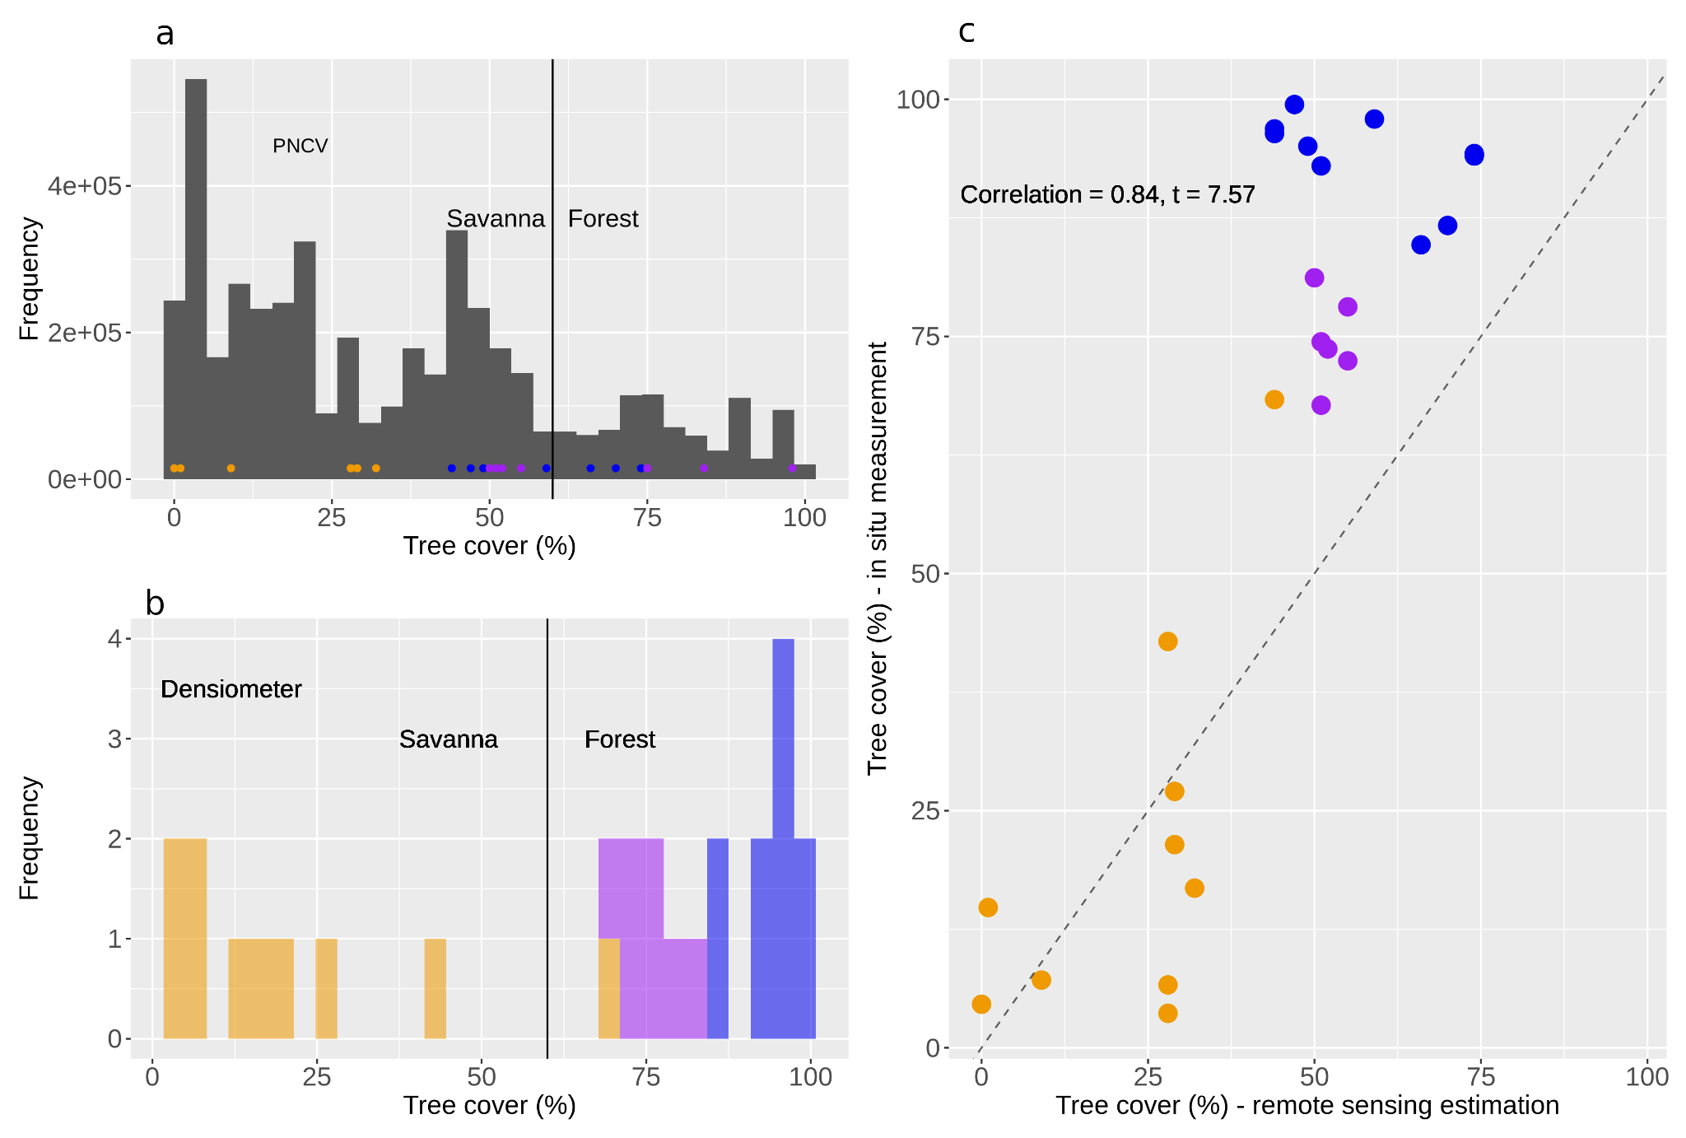

Fig. S2 Precipitation distribution for Amazon, Caatinga and Cerrado Biomes (left hand boxplots) and for our sample plots (right hand boxplots) shows that the precipitation values at dry forests, gallery forests and savannas are in the range where both forests and savannas can occur (red dashed line; Staver et al., 2011). (a) Mean annual precipitation (MAP) and (b) Markham Seasonality Index. Precipitation data from CHIRPS dataset. Letters above each box indicate the differences and similarities between vegetation types based on the pairwise post-hoc test using generalized least-square model parameter, with p-value < 0.05.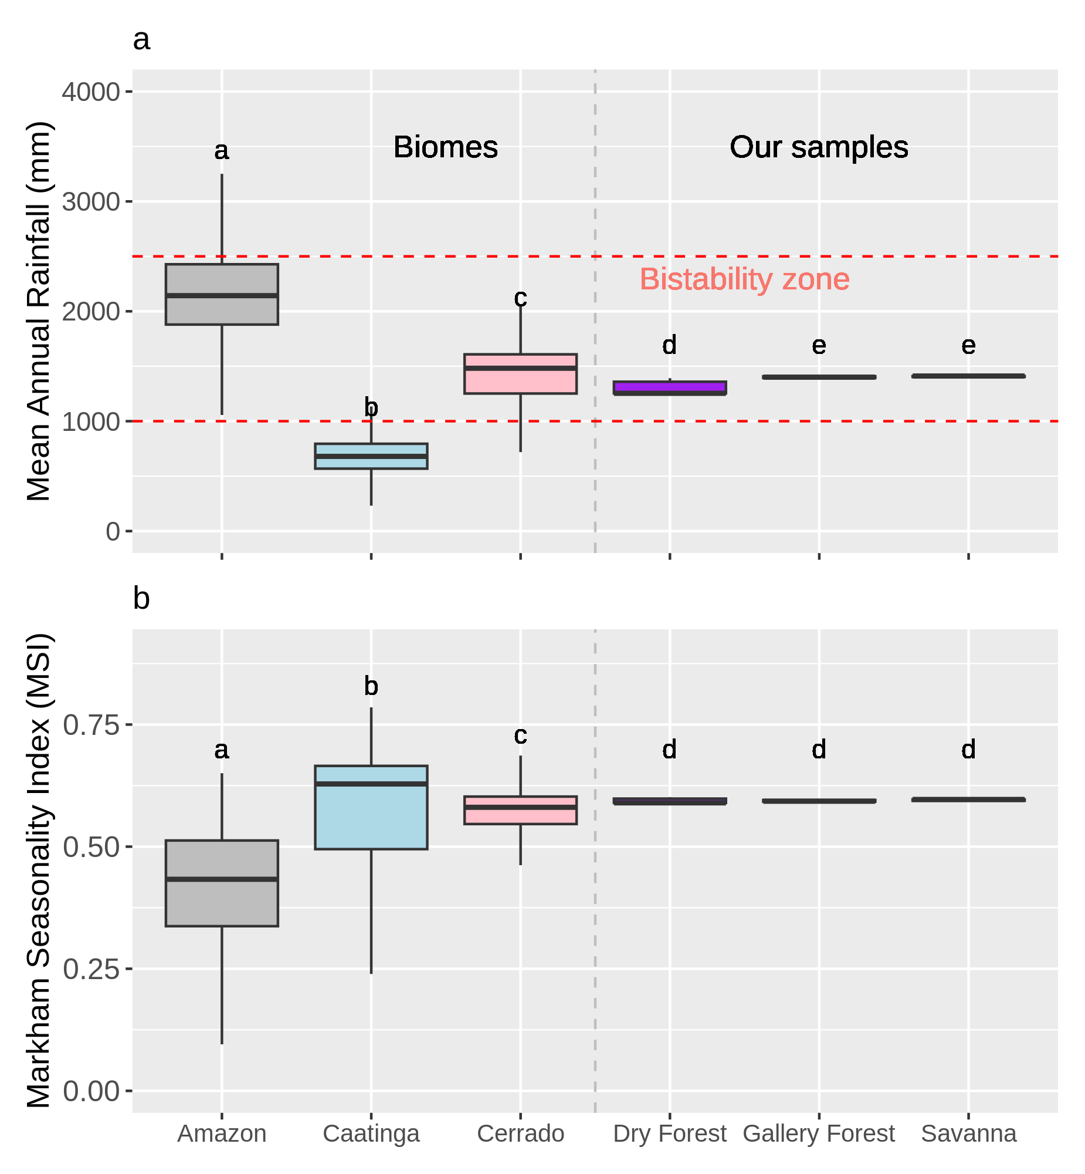

Fig. S3 Differences in soil compounds for savannas, gallery forests and dry forests at the Chapada dos Veadeiros National Park. In (a) pH; (b) total phosphorus; (c) Potassium ; (d) Calcium; (e) Magnesium; (f) Exchangeable Aluminum; (g) Potential acidity; (h) Sum of bases; (i) Cation exchange capacity; (j) Effective cation exchange capacity; (k) Base saturation index; and (l) Aluminum saturation index; (m) Remaining phosphorus; (n) Cupper; (o) Manganese; (p) Iron, (q) Zinc; and (r) Nitrogen from all soil traits standardized that explained 63.85% of the variance in the data. Letters above each box indicate the differences and similarities between vegetation types based on t-tests, with p-value < 0.05.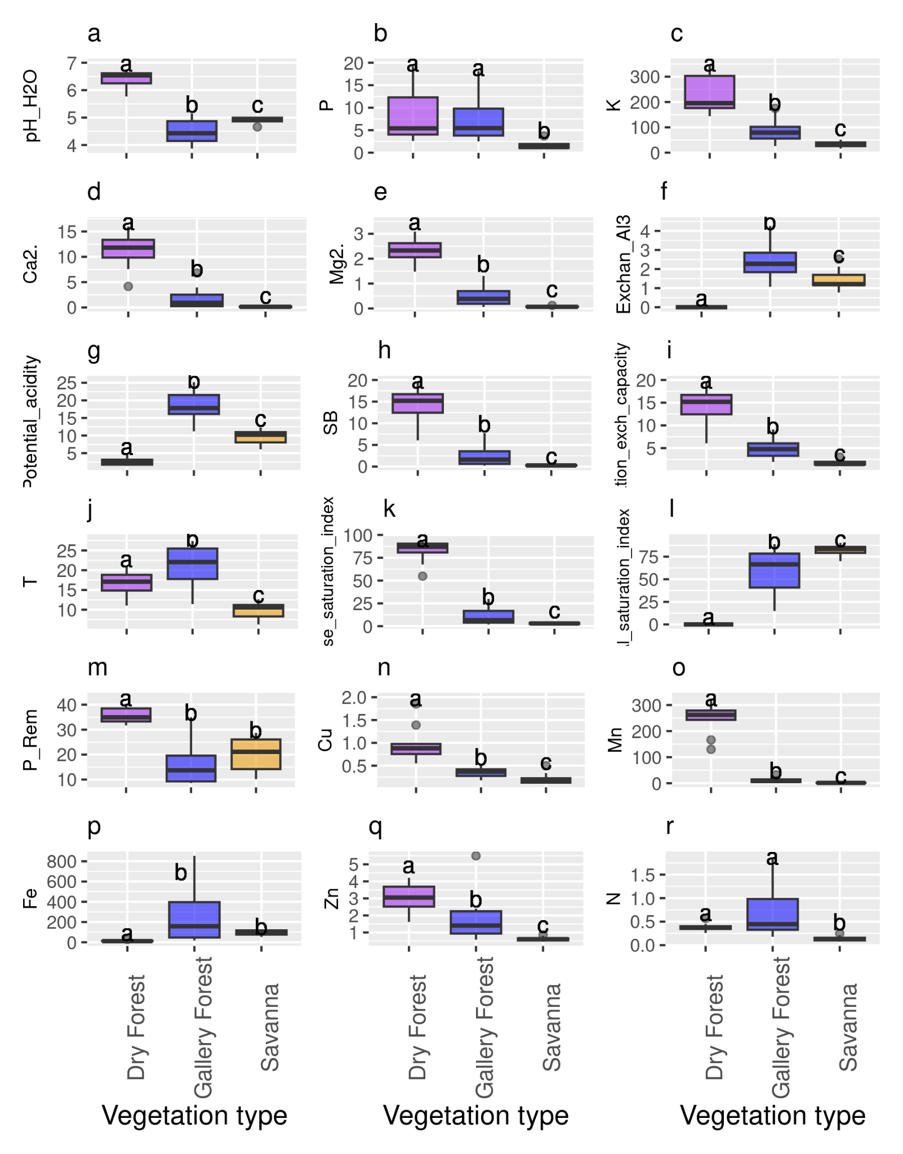

Fig. S4 (a) Principal component analysis of soil characteristics (i.e. listed above) for distinct vegetation types (purple: dry forests; blue: gallery forests; orange: savannas) at the Chapada dos Veadeiros National Park. (b) Cluster dendrogram of soil characteristics based on Ward’s minimum variance method (Murtagh & Legendre, 2014). Dissimilarity was squared before clustering.

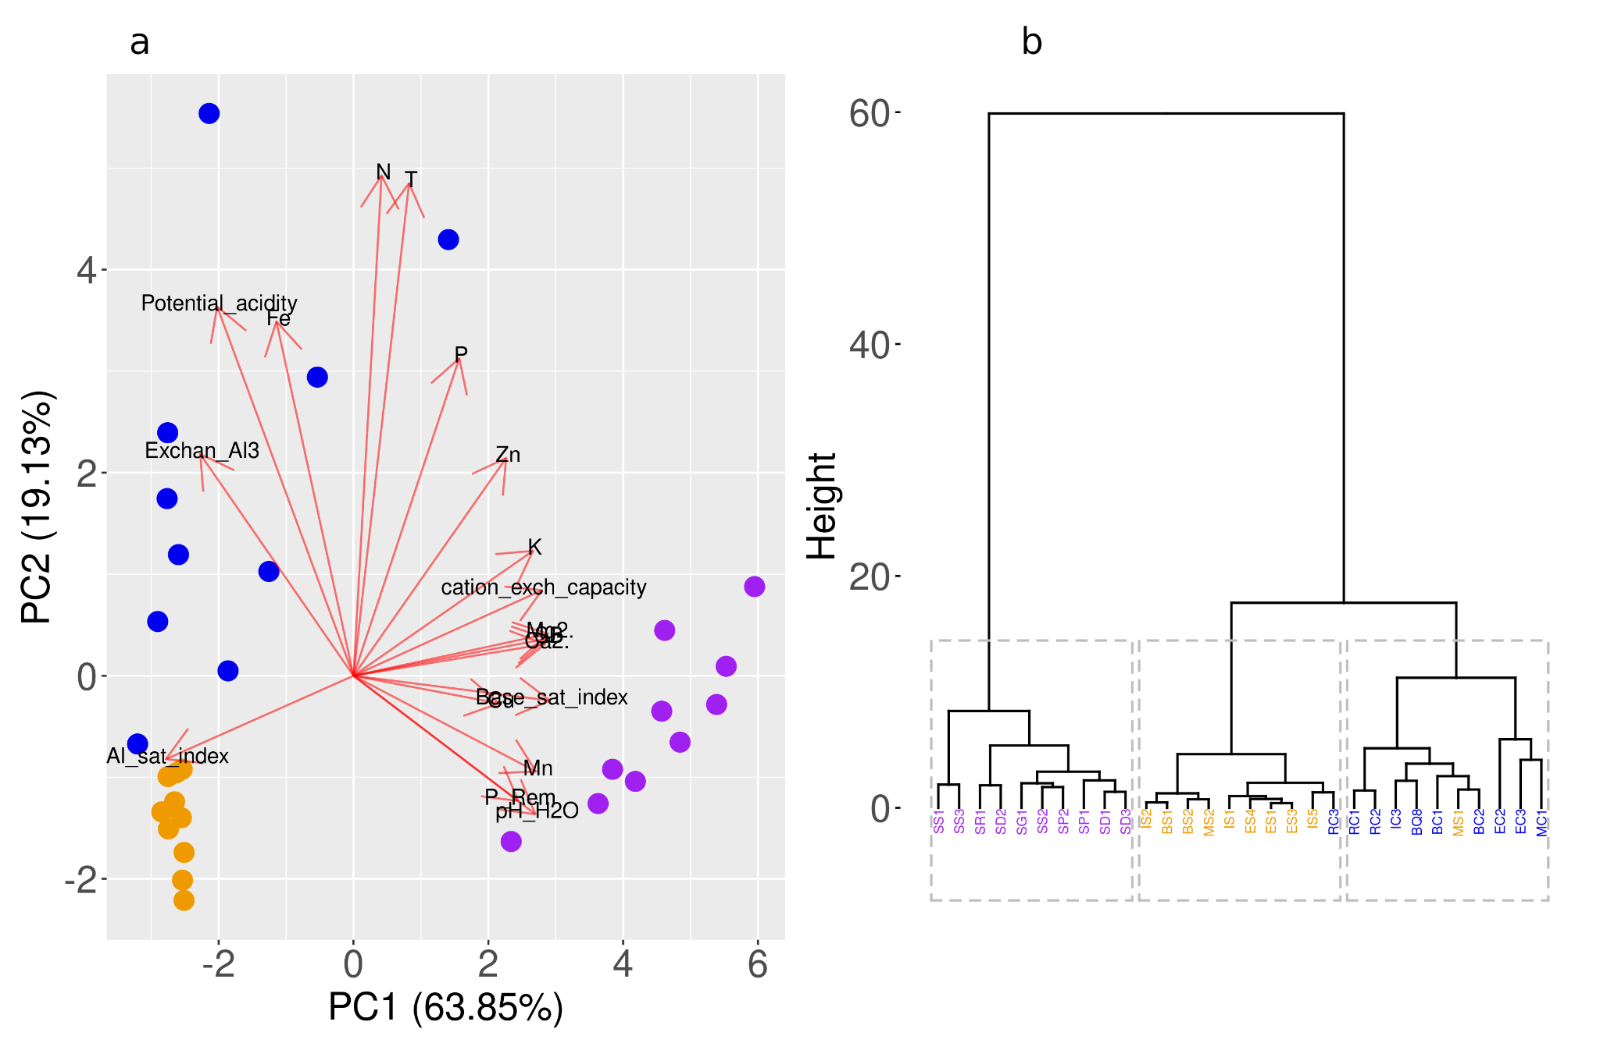

Fig. S5 Differences in soil granulometry for savannas, gallery forests and dry forests at the Chapada dos Veadeiros National Park. Proportions of (a) sand; (b) silt; and (c) clay. Letters above each box indicate the differences and similarities between vegetation types based on Mann-Whitney U tests, with p-value < 0.05.

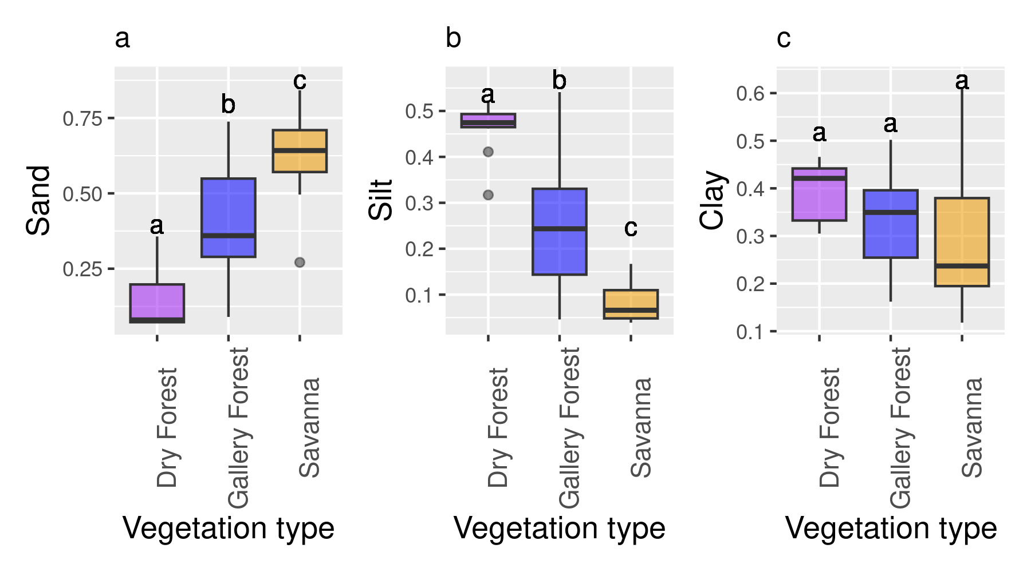

Fig. S6 Environmental conditions to test for differences in vegetation states at the Chapada dos Veadeiros National Park. (a) The first principal component (PC1 - soil) representing 63.85% of the variance in soil nutrients; (b) the second principal component (PC2 - soil) representing 19.13% of the variance in soil nutrients.; (c) Topographic Wetness Index (TWI) as a proxy for water availability in the soil; (d) Fire frequency from the Mapbiomas dataset from 1985 to 2018 as an indicator of vegetation structure affecting feedbacks. See Supplementary Material 7 for principal component analysis details. Letters above each box indicate the differences and similarities between vegetation types based on Mann-Whitney U tests, with p-value < 0.05.

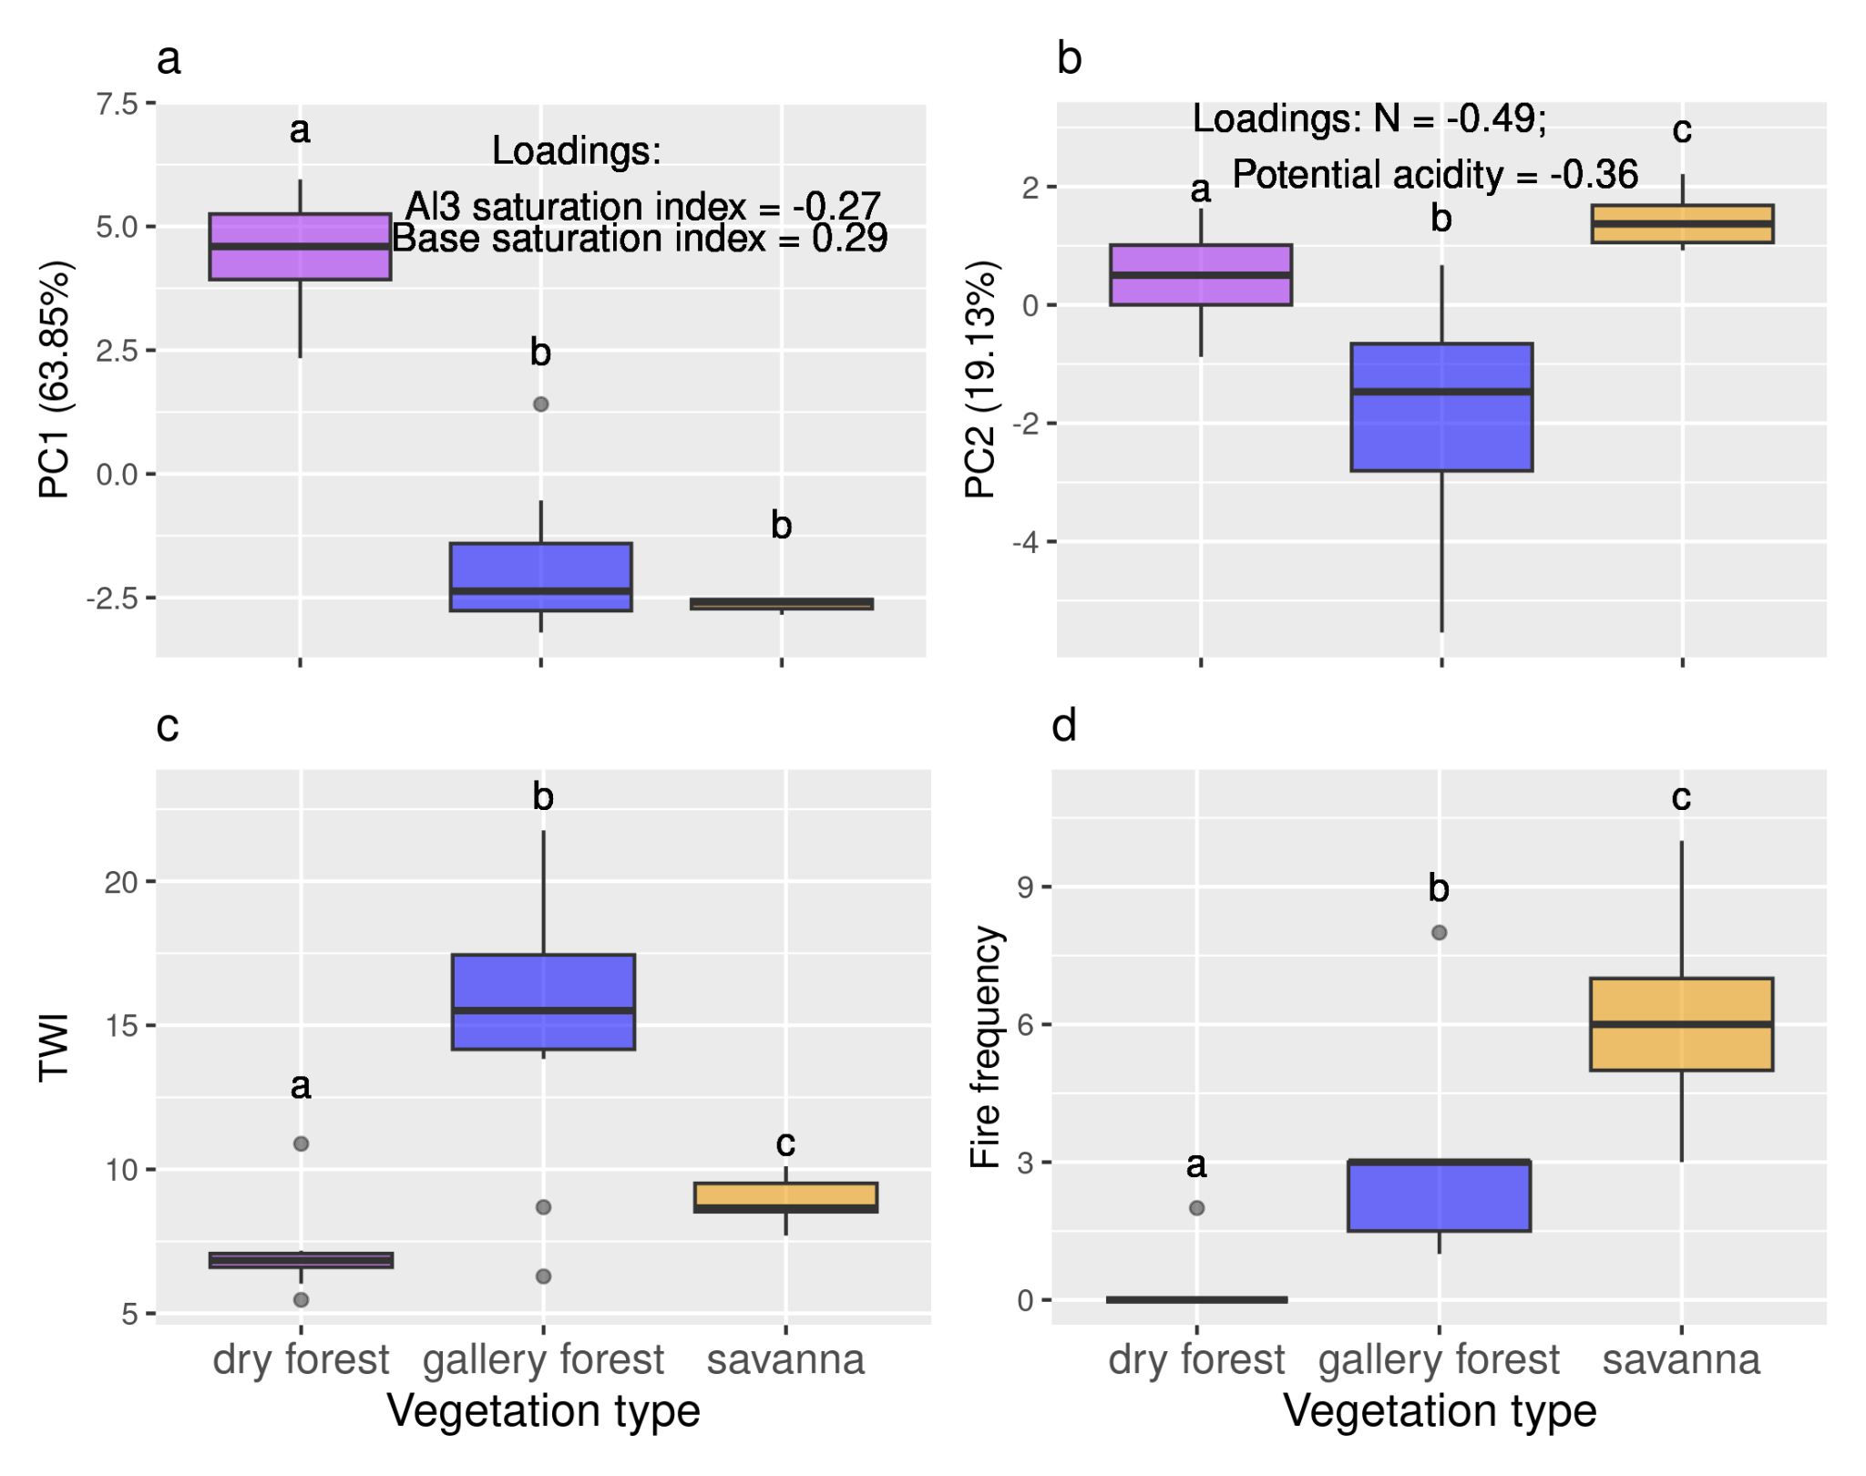

Fig. S7 P-values of Mann-Whitney U tests used for comparison between pairs of vegetation types for soil variables (a), environmental conditions (b) and structural and functional (c) state variables. P-values lower than 0.05 (red line) indicate significant differences in variables between pairs of vegetation types.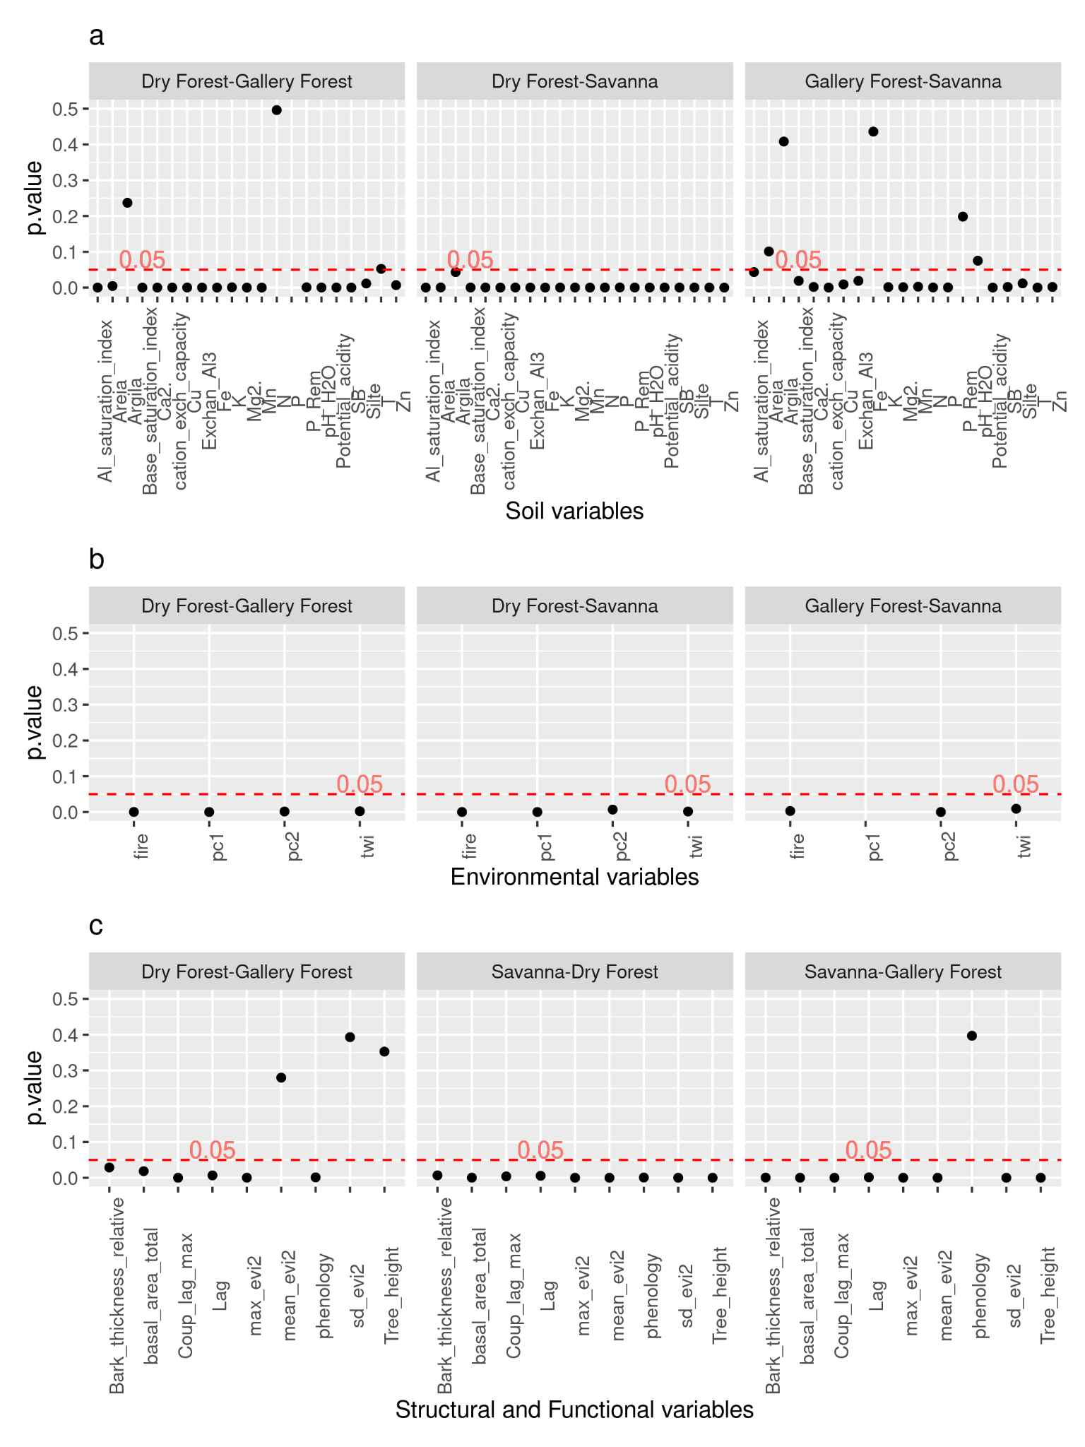

Fig. S8 Cross-correlation between 2-band Enhanced Vegetation Index (EVI2) and precipitation with different lags for savannas at the Chapada dos Veadeiros National Park, located in Brazil. The coupling in the y (vertical) axis is defined as the Kendall correlation between monthly EVI2 and precipitation. Data from Landsat 8 and CHIRPS.

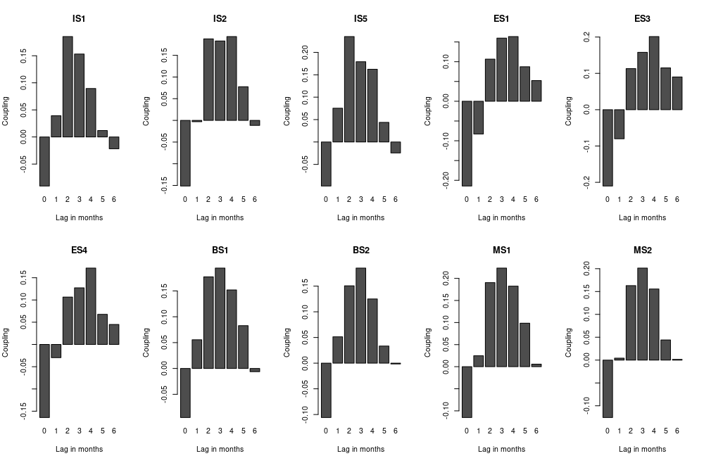

Fig. S9 Cross-correlation between 2-band Enhanced Vegetation Index (EVI2) and precipitation with different lags for gallery forests at the Chapada dos Veadeiros National Park, located in Brazil. The coupling in the y (vertical) axis is defined as the Kendall correlation between monthly EVI2 and precipitation. Data from Landsat 8 and CHIRPS.

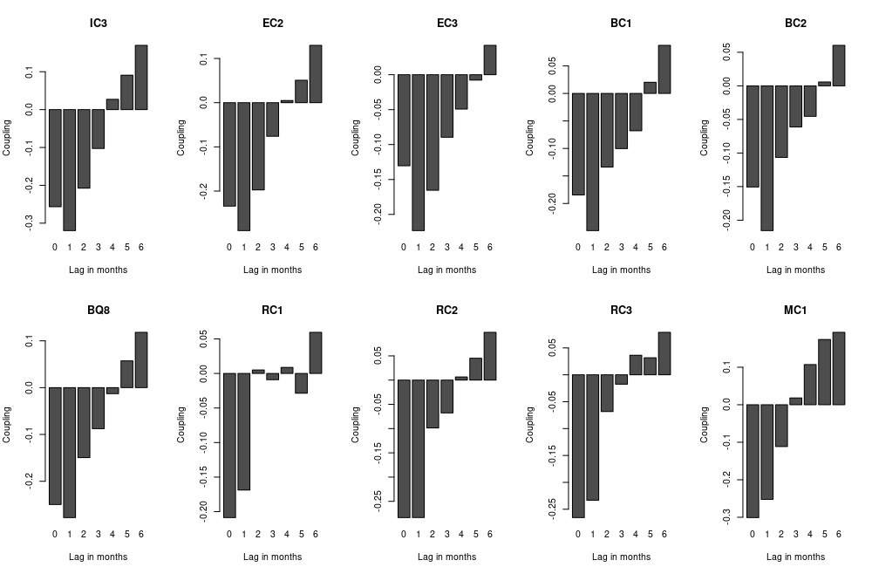

Fig. S10 Cross-correlation between 2-band Enhanced Vegetation Index (EVI2) and precipitation with different lags for dry forests at the Chapada dos Veadeiros National Park, located in Brazil. The coupling in the y (vertical) axis is defined as the Kendall correlation between monthly EVI2 and precipitation. Data from Landsat 8 and CHIRPS.

# 

Fig. S11 (a) Mean monthly precipitation in the Chapada dos Veadeiros National Park, Brazil (from 1981, January to 2018, June) for distinct vegetation types (dry forests: purple; gallery forests: blue; savannas: orange); The monthly 2-band Enhanced Vegetation Index (EVI2), for savannas (b), gallery forests (c), and dry forests (d) from 2013, April to 2018, June. Smoothed EVI2 with monthly precipitation in millimeters (black dashed line; right axis) is shown for the same period for dry forests (e), for gallery forests (f) and for savannas (g). EVI2 is derived from Landsat 8 (OLI) and precipitation data from CHIRPS dataset.

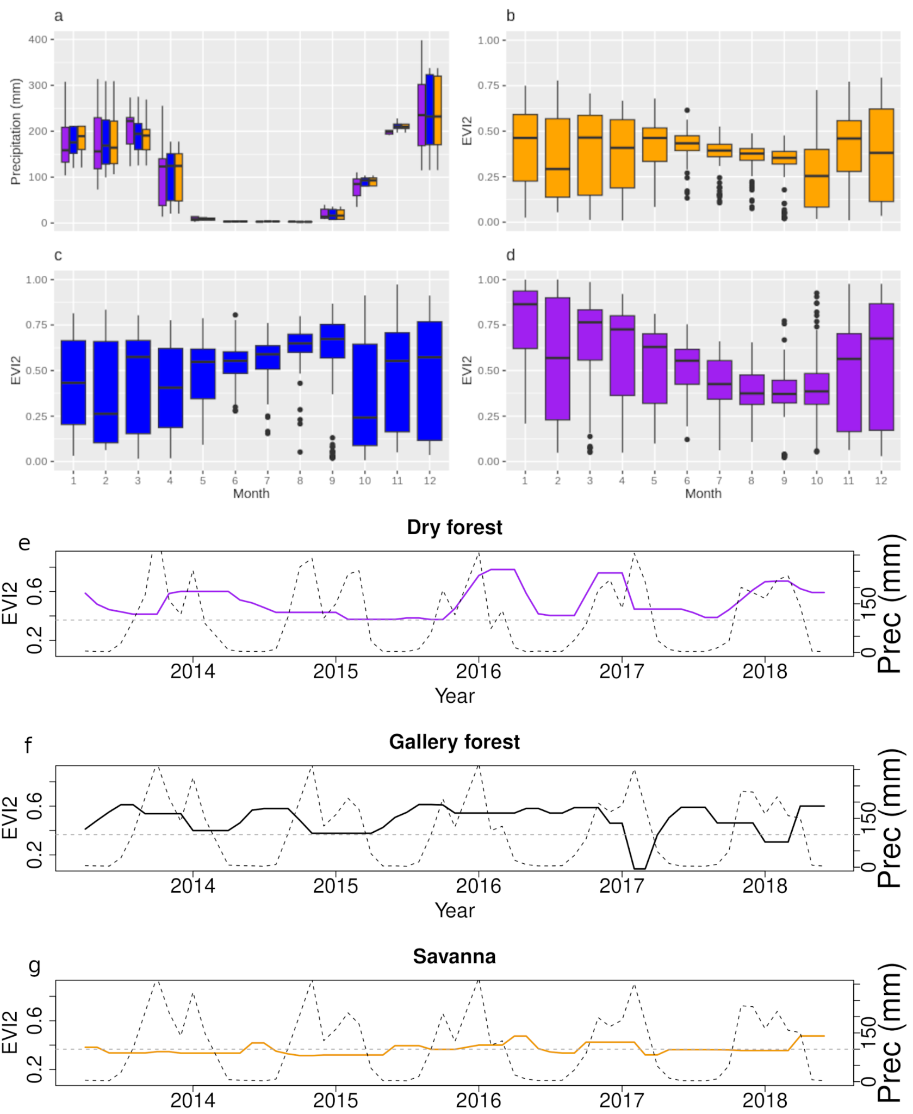

Fig. S12 Dry season growth: Median EVI2 by month in the dry season for savannas (A), gallery forests (B) and dry forests (C). Tau and p values for the Mann-Kendall trend test performed for each season are shown; Brand new leaves as evidence of tree growth during the dry season at the Chapada dos Veadeiros National Park for gallery forests (D - *Ficus sp*, E - *Protium heptaphyllum*, F - *Myrcia magnoliifolia*, G - *Clusia gardnerii*) and savannas (H - *Chamaecrista orbiculata*, I - *Neea theifera*, J - *Miconia sp*, K - *Miconia ferruginata*). (L) Dry forest with almost all canopy opened.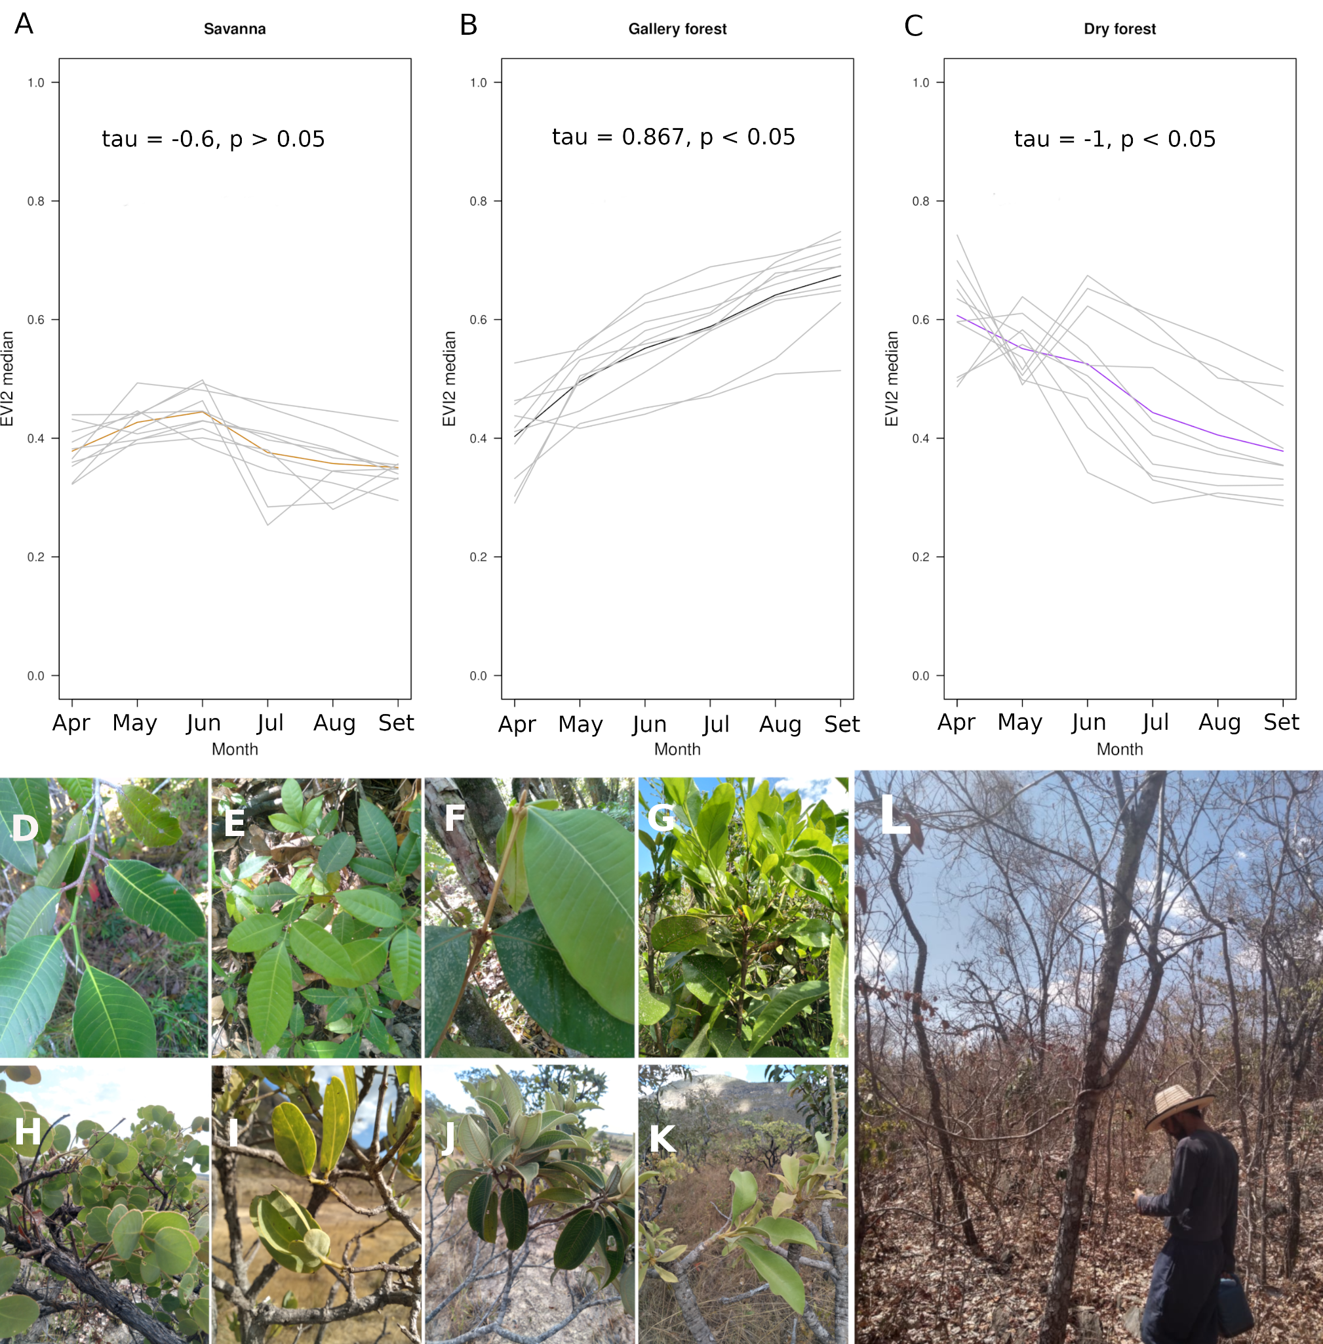

# 

Fig. S13 Flowchart illustrating the step-by-step process for deriving the biotic (green boxes) and abiotic (orange boxes) variables.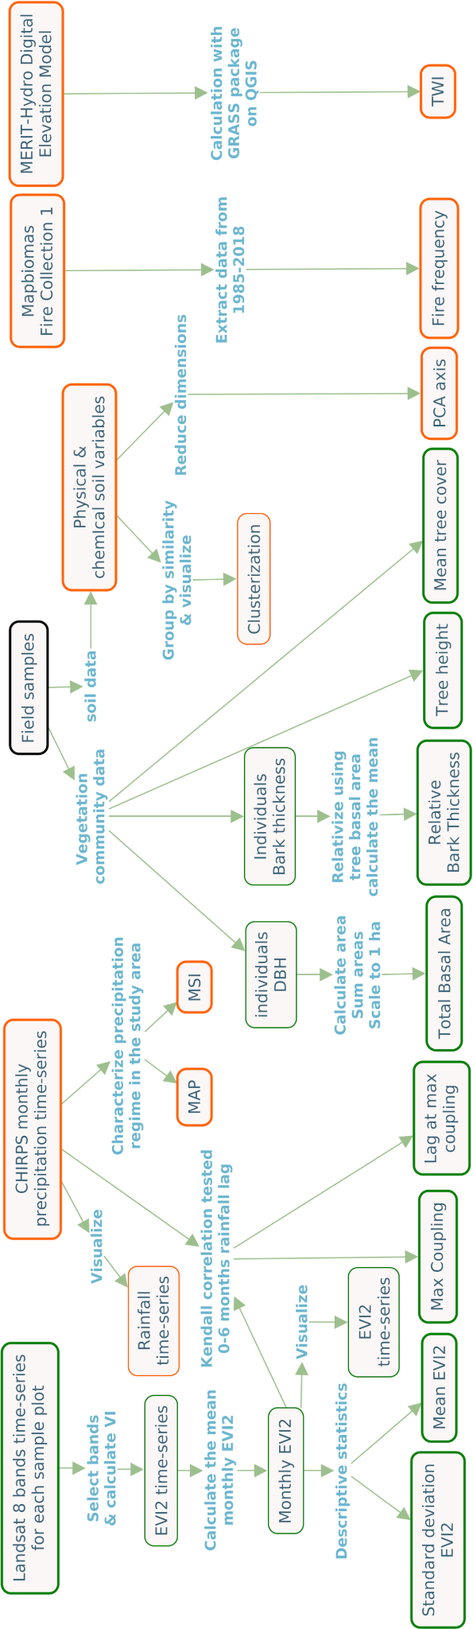

Table S1 Comparison of ranked distributions of the environmental conditions variables (soil PC1 and PC2, TWI and fire frequency) between pairs of vegetation types through Mann-Whitney U tests performed in R. The table shows the output of the Mann-Whitney test with the statistics of the test (U-statistic), and the p-value.

|  |  |  |  |
| --- | --- | --- | --- |
| Variable | Pair | U-statistic | p-value |
| PC1 | Savanna-Gallery Forest | 57 | >0.05 |
| PC1 | Savanna-Dry Forest | 100 | <0.001 |
| PC1 | Dry Forest-Gallery Forest | 100 | <0.001 |
| PC2 | Savanna-Gallery Forest | 0 | <0.001 |
| PC2 | Savanna-Dry Forest | 15 | <0.01 |
| PC2 | Dry Forest-Gallery Forest | 90 | <0.01 |
| TWI | Savanna-Gallery Forest | 85 | <0.01 |
| TWI | Savanna-Dry Forest | 10 | <0.01 |
| TWI | Dry Forest-Gallery Forest | 9 | <0.01 |
| Fire frequency | Savanna-Gallery Forest | 11 | <0.01 |
| Fire frequency | Savanna-Dry Forest | 0 | <0.001 |
| Fire frequency | Dry Forest-Gallery Forest | 3 | <0.001 |

Table S2 Testing which vegetation type has higher values than the others in relation to environmental conditions variables (soil PC1 and PC2, TWI and fire frequency) through Mann-Whitney U tests performed in R with the *alternative* argument set to *greater*. The table shows the output of the Mann-Whitney U test with the statistics of the test (U-statistic), and the p-value.

|  |  |  |  |  |
| --- | --- | --- | --- | --- |
| Variable | pair | alternative | U-statistic | p.value |
| PC1 | Gal for - Sav | greater | 57 | > 0.05 |
| PC2 | Gal for - Sav | greater | 0 | > 0.05 |
| TWI | Gal for - Sav | greater | 85 | < 0.05 |
| Fire Frequency | Gal for - Sav | greater | 11 | > 0.05 |
| PC1 | Dry for - Gal for | greater | 100 | < 0.001 |
| PC2 | Dry for - Gal for | greater | 90 | < 0.01 |
| TWI | Dry for - Gal for | greater | 9 | > 0.05 |
| Fire Frequency | Dry for - Gal for | greater | 3 | > 0.05 |
| PC1 | Dry for - Sav | greater | 100 | < 0.001 |
| PC2 | Dry for - Sav | greater | 15 | > 0.05 |
| TWI | Dry for - Sav | greater | 10 | > 0.05 |
| Fire Frequency | Dry for - Sav | greater | 0 | > 0.05 |

Table S3Principal Component Analysis of soil characteristics. PC1 and PC2 loadings for each soil variable.

|  |  |  |
| --- | --- | --- |
| **Variable** | **PC1** | **PC2** |
| pH (H2O) | 0.27 | 0.14 |
| P | 0.16 | -0.31 |
| K | 0.27 | -0.12 |
| Ca2 | 0.28 | -0.03 |
| Mg2 | 0.29 | -0.04 |
| Exchan Al3 | -0.23 | -0.22 |
| Potential acidity | -0.2 | -0.36 |
| SB | 0.29 | -0.04 |
| cation exchange capacity | 0.28 | -0.08 |
| T | 0.08 | -0.48 |
| Base saturation index | 0.29 | 0.02 |
| Al saturation index | -0.28 | 0.08 |
| Remaining P | 0.24 | 0.12 |
| Cu | 0.22 | 0.03 |
| Mn | 0.27 | 0.09 |
| Fe | -0.11 | -0.35 |
| Zn | 0.23 | -0.21 |
| N | 0.04 | -0.49 |

Table S4 Testing which vegetation type has higher values than the others in relation to soil variables through Mann-Whitney U tests performed in R with the *alternative* argument set to *greater*. The table shows the output of the Mann-Whitney U test with the statistics of the test (U-statistic), and the p-value.

|  |  |  |  |  |
| --- | --- | --- | --- | --- |
| **Variable** | **Pair** | **alternative** | **U-statistic** | **p.value** |
| Sand | Gallery Forest-Savanna | greater | 23.5 | >0.05 |
| Sand | Dry Forest-Savanna | greater | 6 | >0.05 |
| Sand | Dry Forest-Gallery Forest | greater | 11 | >0.05 |
| **Silt** | **Gallery Forest-Savanna** | **greater** | **68** | **<0.05** |
| **Silt** | **Dry Forest-Savanna** | **greater** | **100** | **<0.001** |
| **Silt** | **Dry Forest-Gallery Forest** | **greater** | **69** | **<0.01** |
| Clay | Gallery Forest-Savanna | greater | 50 | >0.05 |
| **Clay** | **Dry Forest-Savanna** | **greater** | **77** | **<0.05** |
| Clay | Dry Forest-Gallery Forest | greater | 54 | >0.05 |
| pH\_H2O | Gallery Forest-Savanna | greater | 26 | >0.05 |
| **pH\_H2O** | **Dry Forest-Savanna** | **greater** | **100** | **<0.001** |
| **pH\_H2O** | **Dry Forest-Gallery Forest** | **greater** | **100** | **<0.001** |
| **Total P** | **Gallery Forest-Savanna** | **greater** | **97** | **<0.001** |
| **Total P** | **Dry Forest-Savanna** | **greater** | **98** | **<0.001** |
| Total P | Dry Forest-Gallery Forest | greater | 55 | >0.05 |
| **Ca2.** | **Gallery Forest-Savanna** | **greater** | **92** | **<0.001** |
| **Ca2.** | **Dry Forest-Savanna** | **greater** | **100** | **<0.001** |
| **Ca2.** | **Dry Forest-Gallery Forest** | **greater** | **99** | **<0.001** |
| **Mg2.** | **Gallery Forest-Savanna** | **greater** | **93.5** | **<0.001** |
| **Mg2.** | **Dry Forest-Savanna** | **greater** | **100** | **<0.001** |
| **Mg2.** | **Dry Forest-Gallery Forest** | **greater** | **100** | **<0.001** |
| **Exchan\_Al3** | **Gallery Forest-Savanna** | **greater** | **81.5** | **<0.01** |
| Exchan\_Al3 | Dry Forest-Savanna | greater | 0 | >0.05 |
| Exchan\_Al3 | Dry Forest-Gallery Forest | greater | 0 | >0.05 |
| **Potential\_acidity** | **Gallery Forest-Savanna** | **greater** | **98** | **<0.001** |
| Potential\_acidity | Dry Forest-Savanna | greater | 0 | >0.05 |
| Potential\_acidity | Dry Forest-Gallery Forest | greater | 0 | >0.05 |
| **Sum of Bases** | **Gallery Forest-Savanna** | **greater** | **92** | **<0.001** |
| **Sum of Bases** | **Dry Forest-Savanna** | **greater** | **100** | **<0.001** |
| **Sum of Bases** | **Dry Forest-Gallery Forest** | **greater** | **99** | **<0.001** |
| **cation exchange capacity** | **Gallery Forest-Savanna** | **greater** | **96** | **<0.001** |
| **cation exchange capacity** | **Dry Forest-Savanna** | **greater** | **100** | **<0.001** |
| **cation exchange capacity** | **Dry Forest-Gallery Forest** | **greater** | **97** | **<0.001** |
| **T** | **Gallery Forest-Savanna** | **greater** | **98** | **<0.001** |
| **T** | **Dry Forest-Savanna** | **greater** | **96** | **<0.001** |
| T | Dry Forest-Gallery Forest | greater | 24 | >0.05 |
| **Base\_saturation\_index** | **Gallery Forest-Savanna** | **greater** | **81.5** | **<0.01** |
| **Base\_saturation\_index** | **Dry Forest-Savanna** | **greater** | **100** | **<0.001** |
| **Base\_saturation\_index** | **Dry Forest-Gallery Forest** | **greater** | **100** | **<0.001** |
| Al\_saturation\_index | Gallery Forest-Savanna | greater | 23 | >0.05 |
| Al\_saturation\_index | Dry Forest-Savanna | greater | 0 | >0.05 |
| Al\_saturation\_index | Dry Forest-Gallery Forest | greater | 0 | >0.05 |
| P\_Rem | Gallery Forest-Savanna | greater | 32.5 | >0.05 |
| **P\_Rem** | **Dry Forest-Savanna** | **greater** | **100** | **<0.001** |
| **P\_Rem** | **Dry Forest-Gallery Forest** | **greater** | **95** | **<0.001** |
| **Cu** | **Gallery Forest-Savanna** | **greater** | **85** | **<0.01** |
| **Cu** | **Dry Forest-Savanna** | **greater** | **100** | **<0.001** |
| **Cu** | **Dry Forest-Gallery Forest** | **greater** | **100** | **<0.001** |
| **Mn** | **Gallery Forest-Savanna** | **greater** | **90.5** | **<0.01** |
| **Mn** | **Dry Forest-Savanna** | **greater** | **100** | **<0.001** |
| **Mn** | **Dry Forest-Gallery Forest** | **greater** | **100** | **<0.001** |
| Fe | Gallery Forest-Savanna | greater | 61 | >0.05 |
| Fe | Dry Forest-Savanna | greater | 0 | >0.05 |
| Fe | Dry Forest-Gallery Forest | greater | 1 | >0.05 |
| **Zn** | **Gallery Forest-Savanna** | **greater** | **92** | **<0.001** |
| **Zn** | **Dry Forest-Savanna** | **greater** | **100** | **<0.001** |
| **Zn** | **Dry Forest-Gallery Forest** | **greater** | **85** | **<0.01** |
| **N** | **Gallery Forest-Savanna** | **greater** | **98** | **<0.001** |
| **N** | **Dry Forest-Savanna** | **greater** | **100** | **<0.001** |
| N | Dry Forest-Gallery Forest | greater | 40.5 | >0.05 |

Table S5 Comparison of ranked distributions of the functional and structural state variables between pairs of vegetation types through Mann-Whitney U test performed in R. The table shows the output of the Mann-Whitney test with the statistics of the test (U-statistic), and the p-value.

|  |  |  |  |
| --- | --- | --- | --- |
| Variable | Pair | U-statistic | p.value |
| Maximum coupling | Savanna-Gallery Forest | 1 | <0.001 |
| Maximum coupling | Savanna-Dry Forest | 87 | <0.01 |
| Maximum coupling | Dry Forest-Gallery Forest | 100 | <0.001 |
| Lag | Savanna-Gallery Forest | 8 | 0.001 |
| Lag | Savanna-Dry Forest | 14 | <0.01 |
| Lag | Dry Forest-Gallery Forest | 82 | <0.01 |
| Maximum evi2 | Savanna-Gallery Forest | 99 | <0.001 |
| Maximum evi2 | Savanna-Dry Forest | 100 | <0.001 |
| Maximum evi2 | Dry Forest-Gallery Forest | 95 | <0.001 |
| Mean evi2 | Savanna-Gallery Forest | 99 | <0.001 |
| Mean evi2 | Savanna-Dry Forest | 100 | <0.001 |
| Mean evi2 | Dry Forest-Gallery Forest | 65 | 0.279 |
| Sd evi2 | Savanna-Gallery Forest | 100 | <0.001 |
| Sd evi2 | Savanna-Dry Forest | 100 | <0.001 |
| Sd evi2 | Dry Forest-Gallery Forest | 62 | 0.393 |
| Deciduousness | Savanna-Gallery Forest | 36 | 0.396 |
| Deciduousness | Savanna-Dry Forest | 48 | <0.001 |
| Deciduousness | Dry Forest-Gallery Forest | 42 | 0.001 |
| Tree height | Savanna-Gallery Forest | 100 | <0.001 |
| Tree height | Savanna-Dry Forest | 100 | <0.001 |
| Tree height | Dry Forest-Gallery Forest | 37 | 0.352 |
| Total basal area | Savanna-Gallery Forest | 97 | <0.001 |
| Total basal area | Savanna-Dry Forest | 94 | <0.001 |
| Total basal area | Dry Forest-Gallery Forest | 19 | <0.05 |
| Relative bark thickness | Savanna-Gallery Forest | 7 | <0.001 |
| Relative bark thickness | Savanna-Dry Forest | 15 | <0.01 |
| Relative bark thickness | Dry Forest-Gallery Forest | 79 | <0.05 |

# 

Table S6 Testing which vegetation type has higher values than the others in relation to functional and structural state variables through Mann-Whitney U tests performed in R with the *alternative* argument set to *greater*. The table shows the output of the Mann-Whitney U test with the statistics of the test (U-statistic), and the p-value.

|  |  |  |  |  |
| --- | --- | --- | --- | --- |
| **Variable** | **Pair** | **alternative** | **U-statistic** | **p.value** |
| Coupling | Gallery Forest-Savanna | greater | 1 | >0.05 |
| **Coupling** | **Dry Forest-Savanna** | **greater** | **87** | **<0.01** |
| **Coupling** | **Dry Forest-Gallery Forest** | **greater** | **100** | **<0.001** |
| Lag | Gallery Forest-Savanna | greater | 8 | >0.05 |
| Lag | Dry Forest-Savanna | greater | 14 | >0.05 |
| **Lag** | **Dry Forest-Gallery Forest** | **greater** | **82** | **<0.01** |
| **Maximum EVI2** | **Gallery Forest-Savanna** | **greater** | **99** | **<0.001** |
| **Maximum EVI2** | **Dry Forest-Savanna** | **greater** | **100** | **<0.001** |
| **Maximum EVI2** | **Dry Forest-Gallery Forest** | **greater** | **95** | **<0.001** |
| **Mean EVI2** | **Gallery Forest-Savanna** | **greater** | **99** | **<0.001** |
| **Mean EVI2** | **Dry Forest-Savanna** | **greater** | **100** | **<0.001** |
| Mean EVI2 | Dry Forest-Gallery Forest | greater | 65 | >0.05 |
| **Standard deviation in EVI2** | **Gallery Forest-Savanna** | **greater** | **100** | **<0.001** |
| **Standard deviation in EVI2** | **Dry Forest-Savanna** | **greater** | **100** | **<0.001** |
| Standard deviation in EVI2 | Dry Forest-Gallery Forest | greater | 62 | >0.05 |
| Deciduousness | Gallery Forest-Savanna | greater | 36 | >0.05 |
| **Deciduousness** | **Dry Forest-Savanna** | **greater** | **48** | **<0.001** |
| **Deciduousness** | **Dry Forest-Gallery Forest** | **greater** | **42** | **<0.001** |
| **Tree height** | **Gallery Forest-Savanna** | **greater** | **100** | **<0.001** |
| **Tree height** | **Dry Forest-Savanna** | **greater** | **100** | **<0.001** |
| Tree height | Dry Forest-Gallery Forest | greater | 37 | >0.05 |
| **Total basal area** | **Gallery Forest-Savanna** | **greater** | **97** | **<0.001** |
| **Total basal area** | **Dry Forest-Savanna** | **greater** | **94** | **<0.001** |
| Total basal area | Dry Forest-Gallery Forest | greater | 19 | >0.05 |
| Relative bark thickness | Gallery Forest-Savanna | greater | 7 | >0.05 |
| Relative bark thickness | Dry Forest-Savanna | greater | 15 | >0.05 |
| **Relative bark thickness** | **Dry Forest-Gallery Forest** | **greater** | **79** | **<0.05** |

# **3. CAPÍTULO II**

## 3.2 UNRAVELING DISTINCT LEAF PHENOLOGIES IN TROPICAL VEGETATION TYPES

Marcio Baldissera Cure; Bernardo Monteiro Flores, Marina Hirota

Submetido para [STOTEN](https://www.sciencedirect.com/journal/science-of-the-total-environment).

**Highlights**

* Leaf phenology indicates vegetation strategies to cope with seasonal water stress.
* Floristic-based leaf flush classes barely represent remote-sensed greenness dynamics.
* The greenness-rainfall coupling indicates vegetation responses to seasonal rainfall.
* Deciduous and evergreens differ in responses, and semideciduous shows both behaviors.
* The coupling depends on the climatic regimes where the community is embedded.

# 

**Graphical Abstract**

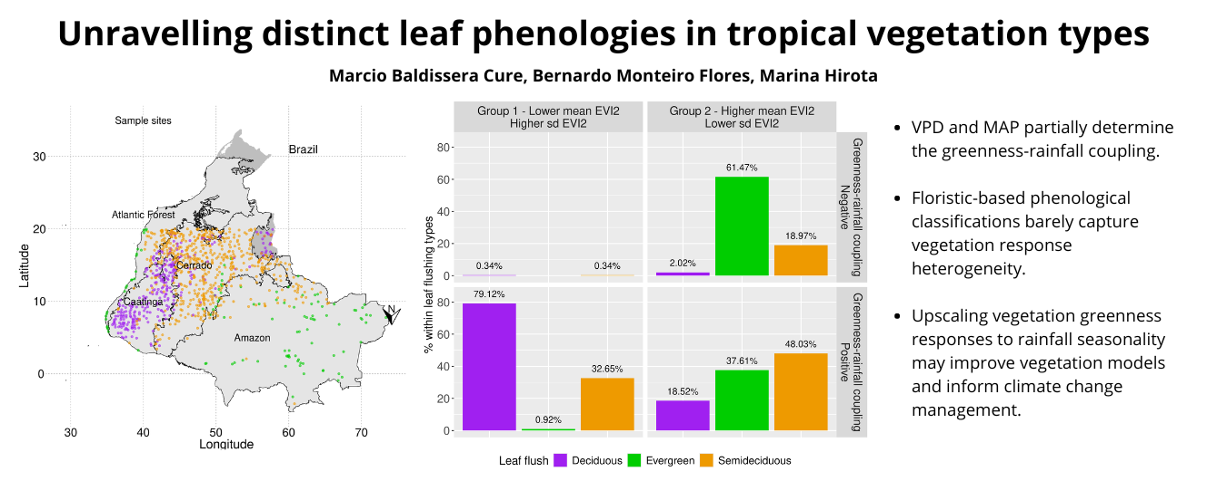

**ABSTRACT**

Biomes are mosaics of vegetation types distributed according to their ability to overcome environmental filters. The response of vegetation types to seasonal variations in water availability reveals distinct strategies for dealing with these fluctuations. Deciduous communities dominate in the driest regions of tropical Brazil, while evergreen vegetation is more common in the wettest areas. However, the heterogeneity in responses within biomes is still barely understood. We aim to understand how distinct vegetation and floristic-based phenological types respond to seasonal fluctuations in rainfall across the Brazilian tropical biomes. We hypothesize that across biomes, vegetation response to rainfall seasonality differs and depends on the climate regime. We correlated remote sensing time series of EVI2, a proxy for greenness, and precipitation to investigate vegetation types' responses to rainfall seasonality across 991 sites distributed through tropical Brazilian biomes. We grouped floristic-based phenological types according to metrics of the greenness annual cycle. Finally, we tested the relationship between communities' responses in terms of greenness to seasonal rainfall and large-scale climatic variables.The response of deciduous, evergreen, and semideciduous communities to rainfall fluctuations depends on the large-scale climatic regime and varies among vegetation types and biomes. Overall evergreens present a negative coupling with rainfall, indicating increasing greenness during the dry season, deciduous communities present a positive coupling, reflecting the leaf fall during the dry season, and semideciduous communities are divided into the two types of responses. Our results unravel that the response of distinct vegetation types to rainfall fluctuations may differ in a gradient of vapor pressure deficit regimes, indicating distinct strategies to deal with rainfall seasonality within phenological groups.Understanding vegetation types' responses in terms of greenness to rainfall seasonality is key to improving vegetation models' performance and thus advancing the discussion on vegetation distribution and management in the face of climatic change.

Keywords: phenology; tropical biomes; vegetation response; seasonality; remote sensing; ecosystem function

### **3.2.1 Introduction**

The variety of leaf phenologies in tropical vegetation reflects distinct strategies to deal with seasonal variations in water availability, while affecting ecosystem processes such as tree growth and water recycling (Oliveira et al., 2021). Such cascading effects on ecosystem function depend on how coupled to rainfall different vegetation types are (Cure et al., 2023; Mazzochini et al., 2024, GCB). As a result, an immense vegetation heterogeneity takes place in tropical environments, forming mosaics of distinct tree-dominated vegetation types such as evergreen, deciduous, and semi-deciduous communities (Dexter et al., 2018), which are floristic distinct (Silva de Miranda et al., 2018). For instance, moist communities exist under abundant rainfall and are mostly composed of evergreen trees that close stomata earlier under water stress avoiding embolism that may cause loss of stems or even death (Skelton et al., 2015). At the driest end of the rainfall gradient, on the other hand, deciduous communities exhibit more deciduous trees used to release their leaves to avoid loss of water and embolism, as the leaf cost is low in more fertile soils where they usually exist (e.g., Sobrado, 1991). Together with this rainfall-driven large-scale distribution, tree strategies to cope with water shortages are also driven by local-scale environmental factors such soil nutrients and water access from the groundwater (Cure et al., 2023; Mattos et al., 2023a; Mattos et al., 2023b; Oliveira et al., 2021, Veenendaal et al., 2015). Thus, tree strategies to cope with water shortages and their responses vary not only between these large-scale vegetation patterns but also within them (Souza et al., 2020; Wu et al., 2015).

These landscape heterogeneity and complexity challenge the understanding of how tropical ecosystems will respond to global changes, particularly when associated with water availability. Such responses depict leaf phenology, reflecting seasonal leaf flushing and senescence. Consequently, different types of forests may exhibit distinct phenological responses since vegetation functioning at finer scales is heterogeneous (Cure et al., 2023). The leaf phenology, or the life cycle of a plant’s leaf, directly influences the greenness and productivity of the ecosystem (Biudes et al., 2021; Alberton et al., 2023). For example, during the peak foliage period, when trees are fully covered by leaves, the canopy greenness is more intense, and ecosystem productivity is generally higher due to increased photosynthetic capacity (Gao et al., 2023). Similarly, changes in leaf phenology, such as the onset or end of the growing season, can affect greenness and productivity (Fang et al., 2023). Therefore, it is very challenging to predict ecosystem responses based solely on species composition or satellite data, and also to upscale ground-based data to satellite products (Tang et al., 2016), requiring the integration of the environmental variations to which each community is subjected. It is essential to emphasize individual- to ecosystem-level responses in greenness and productivity to comprehensively capture the dynamic interplay among vegetation and environmental factors. Thus, understanding whether and how vegetation responses to rainfall seasonality changes at the biome-level is key to advancing the representation of ecosystem-level functioning and its impacts in the face of climate changes.

The uncertainty in phenological responses to rainfall annual cycle can lead to variations in the annual estimate of carbon stock, gross primary productivity (GPP) and evapotranspiration (ET), affecting the estimation and overall quantification of the carbon and water cycles (Magliavacca et al., 2012). For instance, dynamic vegetation models have faced challenges in accurately representing the seasonal variations of carbon flux in tropical ecosystems (Restrepo‐Coupe et al., 2019). Several studies and models rely on the information of plant characteristics concerning vegetation phenology (e.g., Dexter et al., 2018) and/or standardized values of functional and structural traits (e.g. PFT) to represent an individual average type. Nevertheless, there is considerable uncertainty regarding the ability of PFTs to accurately characterize plant strategies given that some species may exhibit traits and functional variability in response to environmental conditions, expanding the realized niche that accommodates such populations (Violle & Jiang, 2009). As a consequence, ecosystem properties, processes (Schimel et al., 2014; Caldararu, Purves & Smith, 2016), and functions (Bolnick et al., 2011) may change depending on intraspecific trait variation altering biotic interactions (Albert et al., 2010). Thus, considering fixed parameters to species and communities may shadow relevant heterogeneities in vegetation functions existing in complex environments (Albert et al., 2010).

In this context, upscaling local vegetation responses to environmental oscillations is key when providing meaningful information to feed models that properly represent tropical vegetation function. Satellite-based products hold significant potential and are widely utilized for understanding vegetation phenology spanning broader landscapes (Li & Qu, 2013; Dronova and Taddeo, 2022; Abdi et al., 2022). For example, a previous study employing monthly median NDVI to classify vegetation types into phenological functional types (PhFT) found distinct classes of phenological groups showing phenological heterogeneities (Kumar et al., 2022). In this study, we combined the floristic classification of the leaf flush regime used by Dexter et al (2018), a proxy for the PhFT, with remote sensing-based data to (1) test whether the classification of floristic-based leaf flush vegetation types relates to the satellite-based classification of greenness leaf flush regimes; and (2) test whether responses of vegetation types to rainfall seasonality change along climatic gradients. We hypothesize that (1) floristic-based communities classified within the same leaf flush regime present a distinct greenness annual cycle depending on the biomes they are embedded in, and (2) the response of vegetation types to rainfall seasonality is dependent on the rainfall regime.

### 3.2.2 Methods

To test the hypothesis that communities classified within the same leaf flush regime present contrasting responses across biomes, we performed the following analyses: 1) characterize sampled vegetation communities based on several EVI2-derived metrics; 2) select the best metrics that represent each floristic-based leaf flush class using a random forest classification approach; 3) use the best satellite-based metrics to clusterize the sampled vegetation communities; 4) check if the greenness-based leaf flush clusters agree with the leaf flush classification based on species composition from Dexter et al (2018); 5) analyze how the greenness-based leaf flush metrics within each cluster vary according to the biomes and vegetation types.

To test the second hypothesis that the response of vegetation types to rainfall seasonality is dependent on the climatic regime, we calculate how coupled the response of greenness from the sampled vegetation communities is to monthly rainfall and then analyze how such coupling varies along a climatic gradient.

Below, we describe the detailed methods to test both hypotheses.

#### 3.2.2.1 Sampled vegetation communities and greenness

We selected plots located within tropical Brazil (north of latitude 20º S, Figure 1) from the study of Dexter et al. (2018) based on the NeoTropTree database (Oliveira-Filho, 2017). Dexter et al. (2018) employed a prior classification of leaf flush regimes in South American tropical vegetation based on floristic inventories (Silva de Miranda et al., 2018) to understand biome transition. They categorized communities as deciduous, semideciduous, or evergreen based on the leaf flush regimes of the existing tree species, indicating distinct strategies influenced by the environment (Oliveira et al., 2021). We filtered out unchanged vegetation cover from 2000 to 2021 using Mapbiomas collection 7 ([https://mapbiomas.org](https://mapbiomas.org/)), and kept only forests and savannas (excluding few samples of grasslands and wetlands). We used the 2-band Enhanced Vegetation Index (EVI2; Jiang et al., 2008) to characterize vegetation greenness, a proxy of ecosystem-level productivity (Biudes et al., 2021). EVI2 maintains accuracy even in regions with dense vegetation by decreasing the saturation effects of other satellite-based vegetation indices (Huete et al., 2002). It also mitigates the effects of soil and atmosphere interference in comparison with other vegetation indices (Jiang et al., 2008). Time series of the Harmonized Sentinel-2 MultiSpectral Instrument Level-2A (id collection 'COPERNICUS/S2\_SR\_HARMONIZED') were downloaded using the Google Earth Engine platform. We calculated the EVI2 using the red and NIR (near infra-red) bands using the equation:

2.5\*(NIR-RED)/(NIR+(2.4\*RED)+1).

We used Sentinel-2 due to its fine temporal scale resolution that allows us to deal with the interference of cloud cover during long periods in our sampled communities. Sentinel-2 spatial resolution is 10 m with a time-frequency of 5 days between images. It provides consistency with ground-based measurements and is able to capture vegetation seasonality (Song et al., 2024). We selected images with cloud cover lower than 30% from the first available image (it varies among plots from December, 2018 to April, 2019) to January, 2022.

Some sampled communities are located in regions covered by clouds most of the year (e.g., as in the Amazon basin), and these data gaps could affect our analysis. Thus, we excluded sampled points with less than 35% of data (Feng et al., 2021), and, when the point was included, the NA values were replaced by linear interpolation using the *na.approx* function from the R package *zoo* (Zeileis and Grothendieck, 2005). Then, we calculated the mean monthly EVI2 to use only one value per month. As a result, we initially based our analysis on 1,037 out of 3,990 plots from Dexter et al. (2018) dataset.

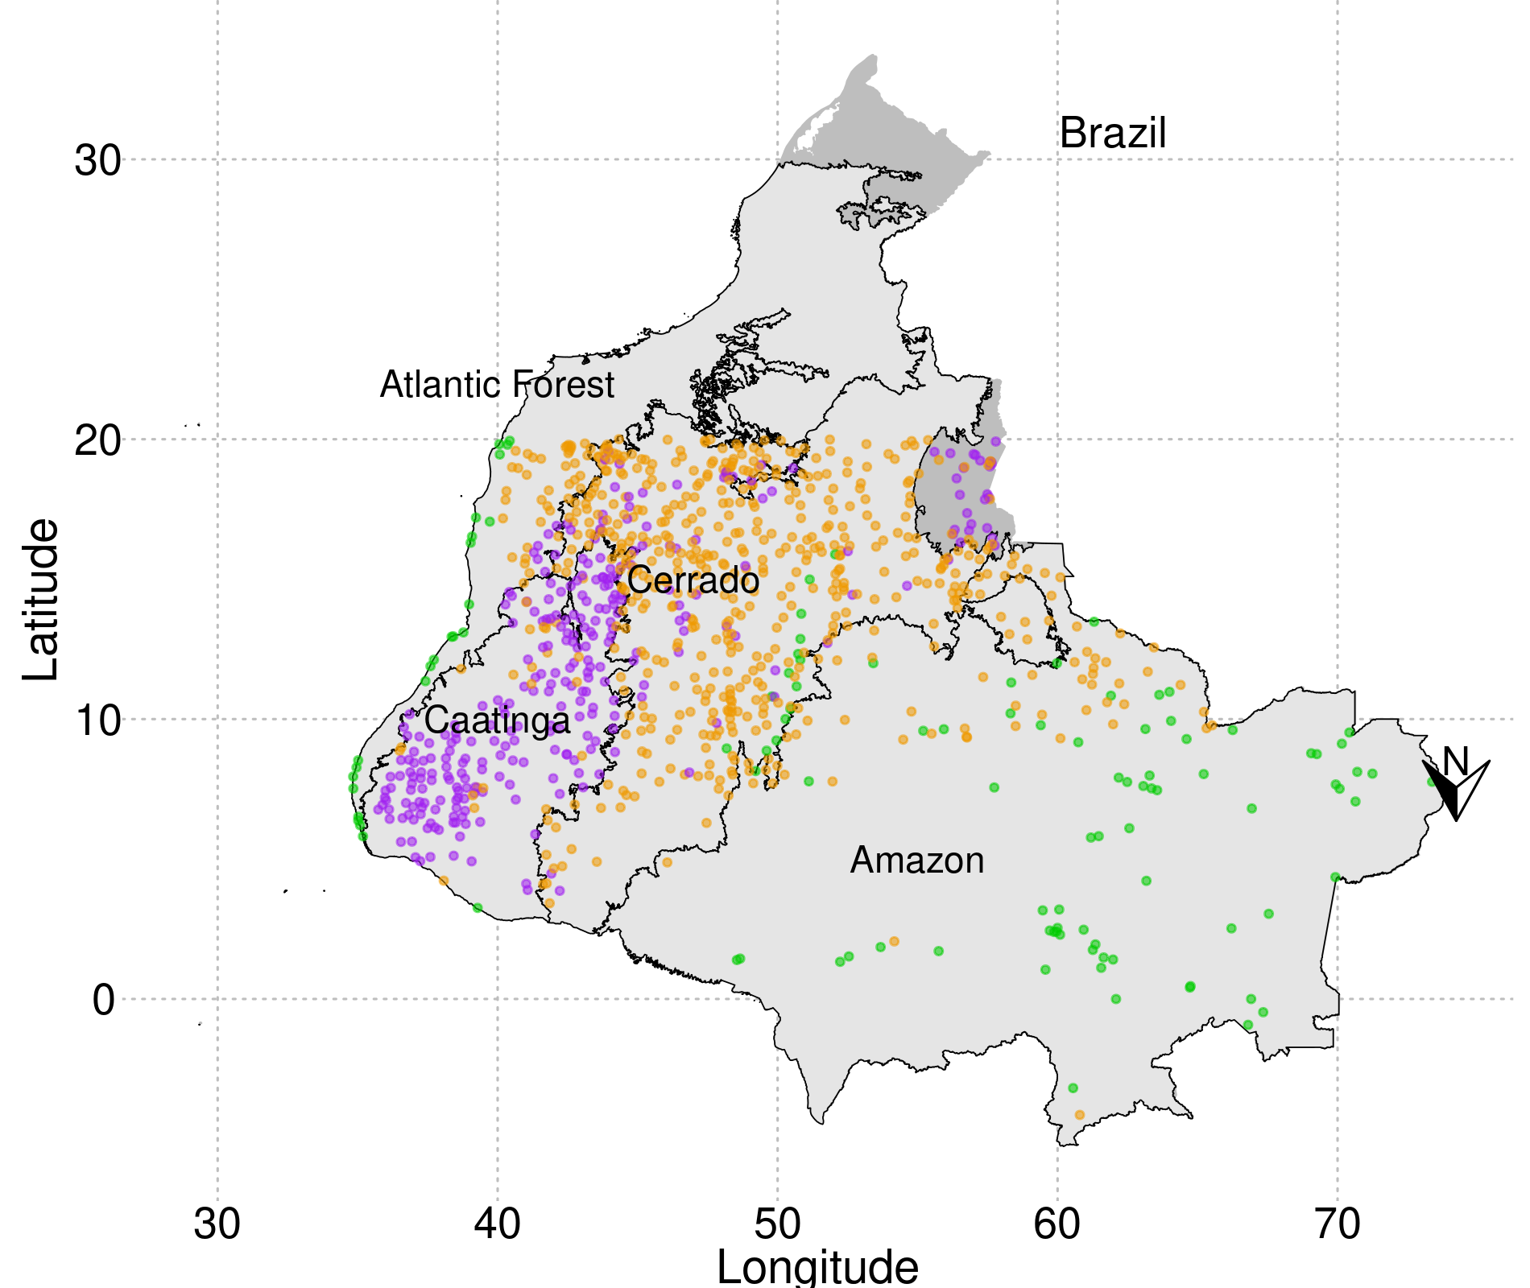

Figure 1: Brazilian map showing the distribution of sampled communities coloured by the floristic-based leaf flush classes. Shape files for biomes were downloaded from TerraBrasilis platform (Assis et al., 2019). North is at the bottom.

#### 3.2.2.2 Is the floristic-based classification of the phenological types related with the greenness annual cycle?

##### 3.2.2.2.1 Metrics for characterizing the annual cycle of vegetation greenness

To characterize our sampled points regarding the annual cycle of the vegetation greenness (EVI2), we calculated the mean annual EVI2 (mean\_evi), maximum and minimum values, the range of EVI2 values (i.e. maximum minus minimum values, range\_evi), the standard deviation of EVI2, the interquartile range and the respective anomaly of the interquartile range, and the entropy of the time series for each sampled point.

Entropy, a measure of uncertainty and disorder of the time series, was estimated by taking the spectral density of the EVI2 time-series for all points with the R function *spec.pgram*. This was then normalized by dividing by its sum, and the resulting values were applied to the function *entropy* from the package *entropy* (Hausser & Strimmer, 2021).

To aggregate the metrics of annual cycle greenness and have a general view of the sampled points along the axes of a bidimensional-space, we performed a principal component analysis (PCA) using the function *prcomp* with all those metrics standardized with the function *decostand* from the package *vegan* (Oksanen et al., 2022).

##### 3.2.2.2.2 Clusterization of the EVI2-based leaf flush regime

We employed the random forest classification algorithm (Breiman, 2001) to identify the most significant variables for (fuzzy) clustering communities according to their leaf flush regimes. To improve the separation of leaf flush regimes based on the greenness behavior, we used all the metrics (see section "Metrics for characterizing the annual cycle of vegetation greenness" above) related to the annual cycle of greenness, and added the mean EVI2 values for each month as explanatory variables to capture differences among leaf flushing regime types.

The random forest model was employed, particularly, to determine which metrics for characterizing the annual cycle of vegetation greenness are good predictors of the leaf flush regime classification based on species composition (i.e., evergreen, deciduous, and semideciduous). The random forest model is built based on a subset of variables selected to grow a decision tree, thus performing an automatic variable selection. First, due to the unbalanced samples regarding the number of communities in each leaf flush regime classification, we used the *downSample* function from the *caret* (Kuhn, 2021) package to ensure an equal number of communities for each leaf flush classification. This resulted in a total of 115 sampled points for each type of community, using as basis the evergreen communities, the least represented. We used 70% of the sample points (243) to train the model and the remaining 30% (102) to test the model performance. We used the 'randomForest' function from the R package *randomForest* (Liaw & Wiener, 2002). For the function parameter *ntree*, we chose 5,000 trees to ensure robust predictions for each input row. Additionally, we selected 3 variables randomly as candidates for each split, setting the parameter *mtry* to 3. We then calculate the importance of variables that show the total reduction in node impurities achieved by splitting the variable across all trees. In classification tasks, the impurity of a node is measured using the Gini index. The higher the Gini Index, the more important the variable is for the random forest model.

We performed a fuzzy clustering using the most important variables from the random forest classification. To determine the optimal number of clusters using those variables, we used the average silhouette width method with the function *fviz\_nbclust* from the package *factoextra* (Kassambara & Mundt, 2020). We used the R function *cmeans* from the package *e1071* (Meyer et al., 2023), which performs a fuzzy version of k-means in which each sampled point (n = 1,037) is attributed to different groups with a distinct degree of membership called pertinence. Pertinence is determined by the similarity between the data point and the cluster centroid. We filtered only sampled plots with pertinence higher than 70% (991 plots) to guarantee communities were classified with lower uncertainty.

##### 3.2.2.2.3 Statistical analyses of the greenness metrics

We used the *gls* function from the package *nlme* (Pinheiro et al., 2019) to fit a linear mixed-effects model to compare greenness metrics condensed in the first principal component among biomes and leaf flush regimes, both provided by the Dexter et al (2018) dataset. This model considered separate leaf flush regimes (with three categories: deciduous, evergreen, and semideciduous) and biomes (with four categories: Amazon, Caatinga, Atlantic Forest, and Cerrado) as response variables. We, then, performed an analysis of variance (ANOVA) using the *anova* function to assess the statistical significance of the main effects of factors. Subsequently, we conducted multiple comparison tests using the *contrast* function, also from *emmeans* package (Lenth, 2023), with the argument *method = "pairwise"*. This test allowed us to identify significant differences between groups (or not) by comparing all factor levels, such as biomes and leaf flush regimes. Adjusted p-values were considered to control the family-wise error rate by the Tukey method. To compare the PC1 between vegetation types (forests and savannas), we used a pairwise t-test. Additionally, we tested for greater values between groups regarding mean EVI2 and standard deviation in EVI2, using the *t.test* function with the argument *alternative* set to *greater*.

All analyses were performed using the R software, version 4.3.2 (R core team, 2023).

#### 3.2.2.3 Is the response of vegetation types to rainfall seasonality dependent on the climatic regimes?

##### 3.2.2.3.1 Data on climatic variables

We used monthly rainfall extracted from the CHIRPS dataset at 0.05º spatial resolution (Funk et al., 2015) to calculate the EVI2-rainfall coupling (see the next section, “Coupling between greenness and rainfall as a measure of vegetation response to precipitation”). CHIRPS data was sampled based on the centroid coordinates of the 1,037 points described above. Additionally, we calculated mean annual precipitation (MAP) and Markham Seasonality Index (MSI; Markham, 1970) to characterize the rainfall regimes.

We also obtained 2-meter air temperature ([](https://www.codecogs.com/eqnedit.php?latex=T_A" \l "0)) and 2-meter dew point temperature ([](https://www.codecogs.com/eqnedit.php?latex=T_D" \l "0)) from ERA5-Land with a spatial resolution of 0.1° (Muñoz-Sabater et al., 2021) to derive 2 climatic variables. First, we derived the mean annual temperature (MAT) for each sampled point (McFadden et al., 2019), by extracting ERA5-Land data using the centroid coordinates of the 1,037 points described above. Then, we computed VPD using the dew point temperature ([](https://www.codecogs.com/eqnedit.php?latex=T_D" \l "0)), which indicates the temperature at which air becomes saturated with water vapor, and [ (](https://www.codecogs.com/eqnedit.php?latex=T_A" \l "0)Allen et al., 1998) using the following equation:

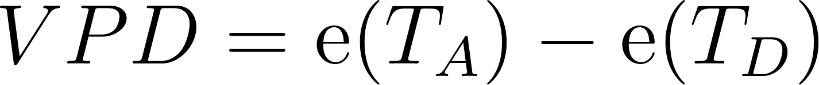

where vapor pressure (kPa) is calculated by

[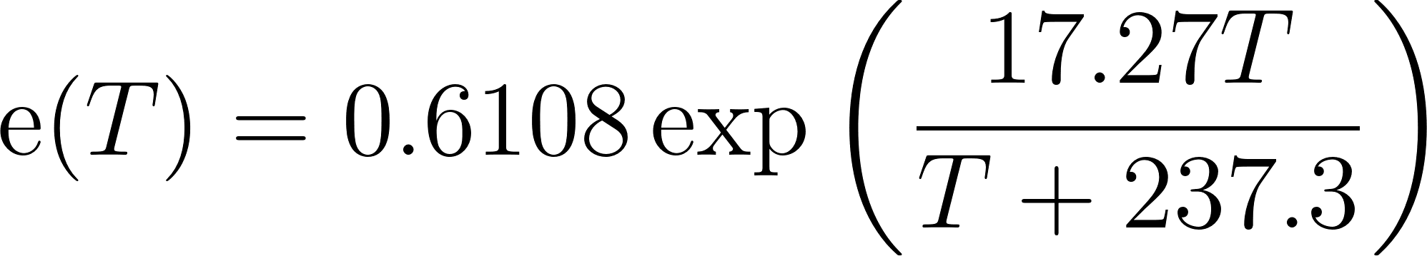](https://www.codecogs.com/eqnedit.php?latex=%5Cmathrm%7Be%7D(T)%20%3D%200.6108%20%5Cexp%20%5Cleft(%5Cfrac%7B17.27%20T%7D%7BT%2B237.3%7D%5Cright)" \l "0)

The VPD is widely used to assess atmospheric moisture conditions and their impact on various physiological processes in plants (Grossiord et al., 2020). Higher VPD values typically means drier atmospheric conditions and potentially higher water stress for vegetation.

The 4 climatic variables are used across tropical biomes to characterize the large-scale climatic conditions that have been proven to affect the distribution and function of vegetation cover in tropical zones (Hirota et al., 2011; Staver et al., 2011; Corlett, 2011; Middleby, Chessman and Cernusak, 2024).

##### 3.2.2.3.2 Coupling between greenness and rainfall as a measure of vegetation response to rainfall

To quantify the response of vegetation greenness to rainfall variation, i.e. greenness-rainfall coupling, we used the *cor.test* function to calculate the Kendall correlation between monthly EVI2, a proxy of greenness, and monthly rainfall for the selected 1,037 plots. The coupling reflects functional differences among vegetation types more directly and serves as a state variable to differentiate them (Cure et al., 2023). Moreover, the coupling signal, whether positive or negative, not only distinguishes the EVI2 signal but also reveals the direction of greenness responses to rainfall, providing valuable insights. Positive values indicate vegetation greenness increases with increasing rainfall, whereas negative values reveal decreases in greenness while responding to rainfall variation.

We calculated vegetation-rainfall coupling with lags from 0 to 4 months in the response to rainfall. For this, we used the function *Lag* from the package *quantmod* (Ryan and Ulrich, 2020). We adopted the maximum coupling value as the lagged-response with the highest coupling value. We also used those metrics (i.e., lag and coupling) to compare among vegetation types (i.e. forest and savanna), floristic-based leaf flush classes, and biomes.

##### 3.2.2.3.3 Statistical analysis of the vegetation communities responses

To test the second hypothesis, i.e. for the effect of MAP (logarithmized), MAT, MSI and VPD on the coupling, we used the *gls* function from the R package *nlme* (Pinheiro et al., 2019) to fit two linear least square models for each large-scale environmental variable: one for points with negative coupling (NEG), and the other for points with positive coupling (POS). We used the estimated slopes as proxies for the relationship between the responses of vegetation and the independent large-scale environmental variables. We elected the best model using the AIC computed with the function *glance* from the package *broom.mixed* (Bolker and Robinson, 2022). Finally, to understand the variance of the coupling along a gradient in MAP, we separated the gradient of rainfall into 5 intervals using the *cut\_interval* function from the package *ggplot2* (Wikham, 2016) and computed the variance of the coupling and the mean MAP for each rainfall interval. All analyses were performed using the R software, version 4.3.2 (R core team, 2023).

Additionally, we performed secondary statistical tests to understand differences in the greenness-rainfall coupling and in the lag to the maximum coupling among floristic-based leaf flush classes and biomes. To differentiate the maximum coupling among distinct floristic-based leaf flush classes and biomes we used the Kruskal-Wallis rank sum test and also calculated the descriptive statistics. We also tested for greater (lower) absolute values (i.e. the intensity of the response) of the maximum coupling between pairs of leaf flush regime classes and pairs of biomes, using the Mann-Whitney rank sum test with the argument *alternative* set to greater (lower). To test for differences in the lag in months to the maximum coupling among leaf flush regimes (3 levels) and Biomes (4 levels), we performed the Welch's ANOVA using the package *rstatix* (Kassambara, 2023)followed by a Games-Howell test (ANOVA post-hoc) using the package *biostat* (Gegzna, 2020). We differentiate the lag in the maximum response among pairs of biomes using the Kruskal-Wallis test followed by the post hoc Dunn test with the package *FSA* (Ogle et al., 2023). Finally, we tested for differences in the lag for communities from distinct groups formed by the c-means clusterization (2 levels), using the Mann-Whitney’s test with the function *wilcoxon.test*.

### 3.2.3 Results

Our results show that floristic-based classification is partially related to the greenness-based classes, with evergreen and deciduous dynamics mostly separated in two distinct greenness-clusters, while semideciduous communities present more variable dynamic patterns, consistent with the biomes or structural vegetation types (forests x savannas) they are embedded in (Table 1; Figures 2-4). Furthermore, the coupling between greenness and rainfall increases with drier conditions (decreasing MAP and increasing VPD and MSI) (Figure 7; SM 4; Table 3) supporting our second hypothesis that the climatic regime determines vegetation responses to rainfall.

#### 3.2.3.1 Annual cycle of vegetation greenness: semideciduous communities have more diverse dynamics

The PCA analysis of vegetation greenness metrics reveals that the distinct floristic-based phenological communities differ in terms of the annual cycle of EVI2 (Figure 2; Table 1). The first axis explains 49.58% of data distribution and is negatively correlated with the standard deviation, range, and third quartile of EVI2 values (Figure 2b). The second axis shows a negative correlation with the mean, maximum, and minimum EVI2 (Figure 2c) explaining 30.67% of data variance. Deciduous communities display a positive correlation with the interquartile range and the standard deviation of EVI2 values while presenting a negative relationship with entropy (Figure 2). The highest standard deviation observed for deciduous vegetation greenness indicates a more pronounced amplitude of EVI2 values, aligning with expectations. The low entropy suggests that the greenness of deciduous communities follows a pattern throughout the year, likely driven by rainfall seasonality. Consequently, the greenness dynamics of deciduous communities is influenced by the rainfall regime, and their strategies for coping with low water availability are distinct from the evergreen communities that present the opposite pattern (Figure 2).

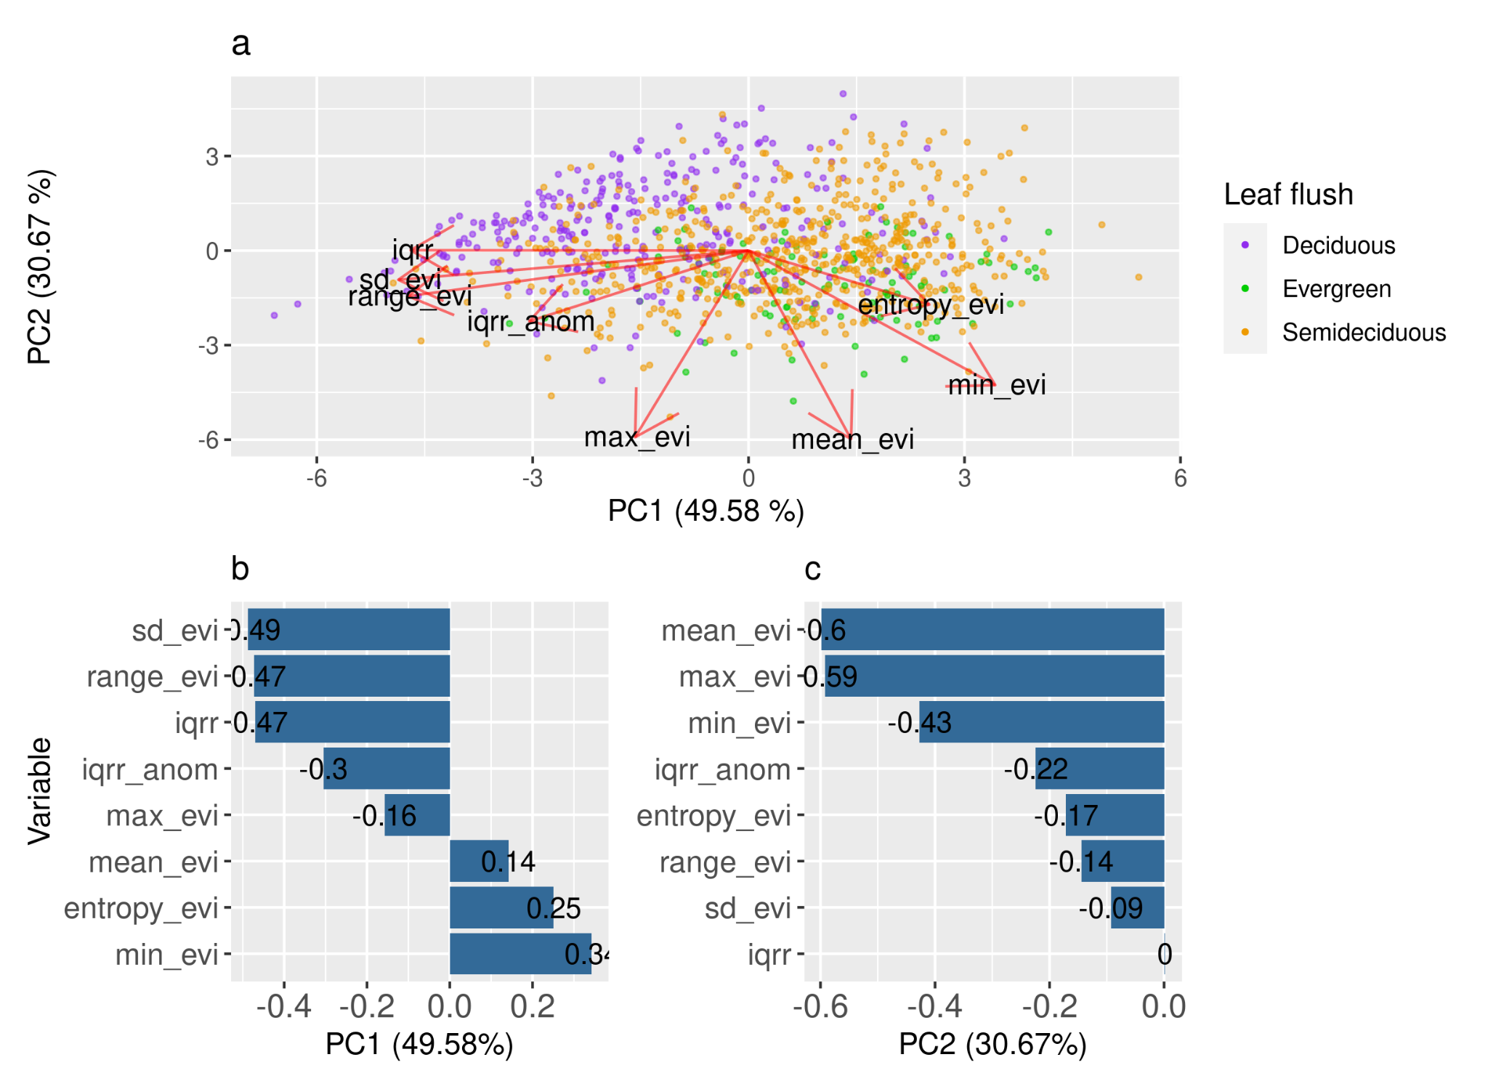

Figure 2: The panel (a) shows the biplot for the PCA performed to resume several metrics of greenness annual cycle that reflects phenological behavior (See methods). Panel (b) and (c) show the relationship between each variable and the first and second principal components, respectively.

On the other hand, the annual greenness cycle for evergreen communities exhibits higher entropy and lower standard deviation (Figure 2). This suggests that, despite being less variable, the greenness of evergreen vegetation follows a less predictive pattern compared to deciduous communities. This lack of rainfall-related predictability indicates that the greenness of evergreen communities is influenced not only by variations in rainfall throughout the seasons but may also be more dependent on other environmental variables such as light and soil-water availability. As expected, semideciduous communities fall between deciduous and evergreen communities (Figure 2), sharing functional responses amongst them. Semideciduous communities are recognized for their composition of both evergreen and deciduous species (Dexter et al., 2018). The presence of more evergreen (or deciduous) species within semideciduous communities may align their responses more closely with those of evergreen (or deciduous) communities.

|  |  |  |  |  |  |
| --- | --- | --- | --- | --- | --- |
| **Floristic-based pair** | **Estimate** | **SE** | **df** | **t ratio** | **P-value** |
| Deciduous-Evergreen | -2.467 | 0.196 | 979 | -12.563 | < 0.001 \* |
| Deciduous-Semideciduous | -2.031 | 0.125 | 979 | -16.128 | < 0.001 \* |
| Evergreen-Semideciduous | 0.436 | 0.182 | 979 | 2.389 | < 0.05 \* |

Table 1: Comparisons among leaf flush regimes regarding the first principal component derived from greenness annual cycle metrics.

#### 3.2.3.2 Clustering annual cycle behavior: three leaf flush regimes divided into two clusters

The overall accuracy of the random forest classification model was 0.686, with evergreen communities showing the highest balanced accuracy (0.82), followed by deciduous (0.8) and semideciduous (0.67) communities. We found that the most important variables to classify leaf flush regimes in accordance with the floristic-based classification are "min\_evi", "sd\_evi", "mean\_evi", "entropy\_evi", "iqrr", in addition to the mean monthly EVI2 for June, July, August, September, October, and November (SM1). Clusterization results in two clusters (SM2).

C-means clusterization allowed us to separate overall floristic-based deciduous (Group 1, greenness-based deciduous) and evergreen (Group 2, greenness-based evergreen) communities regarding metrics of the annual cycle of vegetation greenness, while semideciduous ones became well represented in the two groups most of them falling within the greenness-based evergreen group (67%) (Figure 3a, SM Table 2). However, despite being a minority, there are deciduous communities that behave like evergreens (20.54%). Evergreen communities prevail in Group 2, and only one plot in the Amazon biome (Pará state) was set in Group 1 (Figure 3a, b, SM Table 2). All the Amazonian communities are non-deciduous forests (66.67% evergreens and 33.33% semideciduous) (SM Table 2). In the Caatinga Biome, all communities are deciduous, with 12.33% classified as forests and 87.67% as savannas. Forests dominate group 2 (82.13%) with 17.86% communities belonging to group 1, and savannas dominate group 1 (82.4%). The Cerrado Biome also prevails in the evergreen group, however, Cerrado has more combinations of leaf flush regimes and vegetation types than the other biomes and also presents a relative balance of deciduous communities in the two groups (Figure 3; SM Table 2).

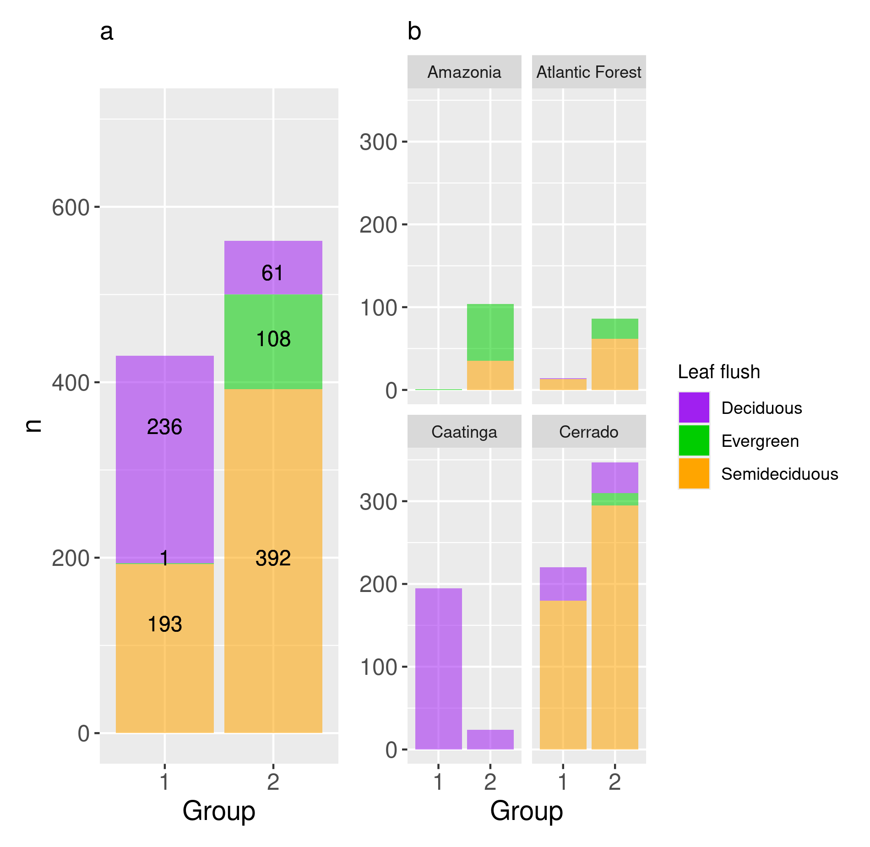

Figure 3: (a) Number of communities from each leaf flush regime classification based on species composition by group. (b) Distribution of leaf flush regimes by groups in four Brazilian tropical Biomes. Clustering was based on seasonal EVI2 metrics and reflects a distinct annual cycle of vegetation greenness.

The overall EVI2 mean of Group 1 is lower than that of Group 2 (t = -32.74, df = 824.29, p-value > 0.05). Oscillations in terms of standard deviation of EVI2 also differ between groups, where group 1 presents the highest variation (t = 16.463, df = 756.2, p-value < 0.001) as it is composed mostly of deciduous communities (Figure 3; Table 2). While group 1 presents similar mean EVI2, group 2 presents at least two types of responses: one primarily for evergreens and one for both deciduous and semideciduous communities (Figures 3-4). Communities with distinct leaf flush regimes have a distinct EVI2 behavior in group 2. Evergreens from group 2 have an increasing mean EVI2 from June to November with few oscillations, while deciduous and semideciduous communities decrease EVI2 and present higher oscillation than evergreens (Figure 4). Thus, these results agree with the random forest classification, which highlighted the importance of the mean monthly EVI2 from June to November to separate communities with distinct leaf phenology (SM1).

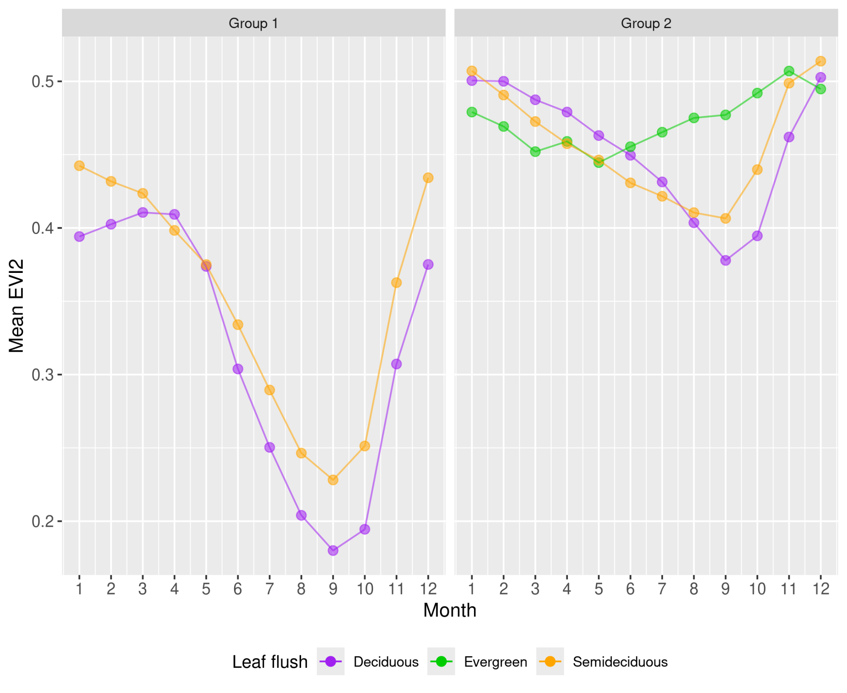

Figure 4: Mean monthly EVI2 for communities with distinct leaf flush regimes by group. Evergreens are represented by a single community in Group 1 (see SM Table 2) and we decided to exclude it.

#### 3.2.3.3 Coupling vegetation with rainfall: positive and negative correlations as contrasting responses

Deciduous, evergreen, and semideciduous communities have a distinct lag in months to the maximum response in terms of greenness to rainfall (Welch ANOVA statistic = 36.2, df = 2, p-value = 1.04e-14) (SM 3). The lag in months for the maximum coupling is similar between groups 1 and 2 (W = 113825, p-value = 0.106), however, they have distinct variance (F = 0.2568, num df = 429, denom df = 560, p-value < 2.2e-16). Biomes, except the Amazon Forest, presented a similar monthly lag associated with the maximum coupling (H = 41, df = 3, p < 0.05) (Table 2).

|  |  |  |
| --- | --- | --- |
| **Biome** | **Z** | **P-value** |
| Amazonia-Atlantic Forest | 4.32 | < 0.001 |
| Amazonia-Caatinga | 6.31 | < 0.001 |
| Amazonia-Cerrado | 5.32 | < 0.001 |
| Atlantic Forest-Caatinga | 1.2 | > 0.05 |
| Atlantic Forest-Cerrado | -0.36 | > 0.05 |
| Caatinga-Cerrado | -2.32 | > 0.05 |

Table 2: Comparisons of the lag in months to the maximum response to rainfall among biomes using the *post hoc* Dunn test.

We found at least three distinct types of maximum coupling to rainfall. The first is encapsulated into group 1, dominated by savannas, to which most of the deciduous communities belong (Figure 5). This group has predominantly a positive maximum coupling for both forests and savannas (Figure 5) classified as deciduous and semideciduous. Group 1 also presented the highest standard deviation in greenness and lower mean greenness. This means that those vegetation communities’ greenness is dependent on seasonal rainfall. The second and third types of responses belong to group 2, dominated by forests (Figure 5). Group 2 presents a higher greenness mean and a lower standard deviation. However, the difference between the second and third types of responses regards to the standard deviation of mean monthly greenness (Figure 4) and to the signal of the coupling (SM Table 3; Figure 4). Overall, structural vegetation types (i.e., forests and savannas) present distinct phenological dynamics (t = 11.7, df = 715.11, p-value < 0.001).

The maximum coupling is also distinct among leaf flush regimes (H = 225, df = 2, p-value < 0.001), vegetation types (W = 57629, p-value < 0.001), and Biomes (H = 252, df = 3, p-value < 0.001) (SM Table 3; Figure 4). Most evergreen communities (61.46%) presented negative maximum greenness-rainfall coupling, which means that trees increase greenness in months with lower (or even the absence of) rainfall. Most deciduous and semideciduous communities present positive coupling, meaning that the greenness decreases in months with low rainfall. Deciduous communities presented the lowest standard deviation (0.168) in the coupling, which may indicate a low diversity of strategies to deal with variations in rainfall. Evergreen communities presented the lowest (near zero) median and mean coupling. It does mean that the greenness pattern of those communities may be not (or are slightly) affected by variations in rainfall.

The intensity of the coupling (absolute values) is greater for deciduous communities than for both semideciduous and evergreens (SM Tables 3-4), meaning that vegetation greenness of deciduous communities is the most coupled with rainfall. Regarding comparisons among biomes, Caatinga presented the highest absolute maximum coupling followed by Cerrado, Atlantic Forest, and Amazonia (SM Table 4). In general, forests presented the lowest coupling compared to savannas (SM Table 3).

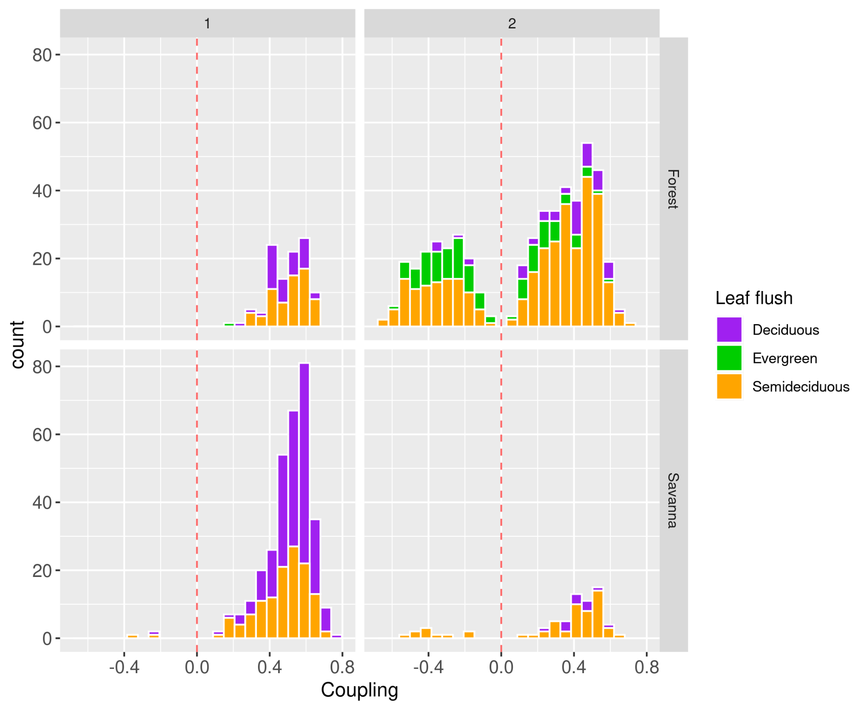

Figure 5: Distribution of the coupling for each leaf flush regime by group (columns) and vegetation type (rows).

Communities from group 1 occur mostly in the Cerrado and Caatinga Biomes spread along the axis northeast-southwest (Figure 6). Group 2 occurs in all Biomes, where overall communities with negative coupling are spread along the axis southeast-northwest (Figure 6). Communities with negative coupling dominate in group 2, while there are only two communities with negative coupling in group 1.

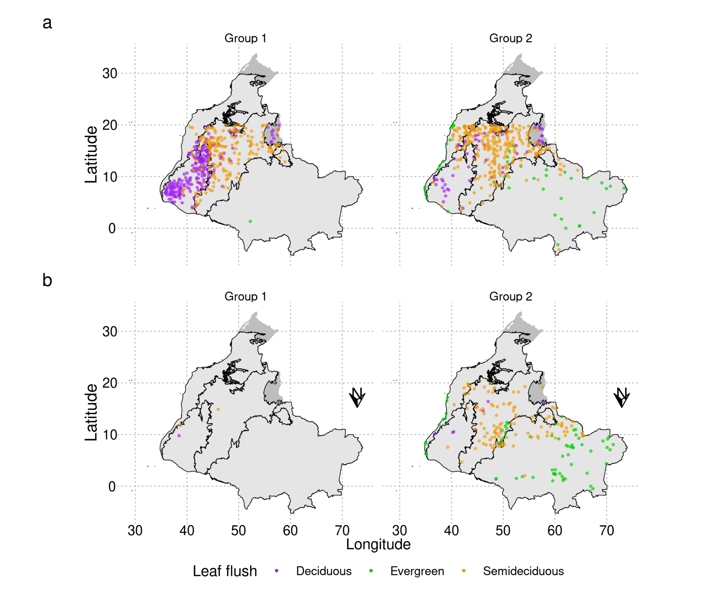

Figure 6: Brazilian map showing communities with positive (a) and negative (b) coupling by group (columns) and Leaf flush regime (colors; see the legend).

#### 3.2.3.4 Coupling vs climatic gradient: VPD, MSI and MAP as drivers of vegetation response to rainfall

Decreasing water stress (i.e. increasing MAP, decreasing MSI, and decreasing VPD) decreases the vegetation-rainfall coupling (i.e., the coupling approaches zero) (Figure 7; Table 3). Additionally, the relationship between large-scale environmental variables varies among Biomes (SM 5) and may play a crucial importance in ecosystem responses. For example, in the Amazon, VPD is more related to seasonality, while MAT drives VPD in the Cerrado and both MAT and seasonality are important drivers of Caatinga’s VPD (SM 5). The best explicative variable for vegetation coupling distribution is VPD, followed by MAP and MSI (see the AIC column in Table 3). However, only VPD and MAP presented both slopes and intercepts that were statistically significant (Table 3). The relationship between the coupling and VPD (Figure 7; SM 4a) for communities with negative coupling is more pronounced (slope -0.4; Table 3) than for communities with positive coupling (slope = 0.3; Table 3), while the best explicative variable for the negative coupling is the MSI (-0.7). Despite its significance, the slope of communities with negative and positive coupling along the log MAP gradient does not capture data trends (SM 4d) and shows little effect (i.e., near-zero slopes mean little effect) (Table 3). It implies that communities’ responses may be detached from the MAP once the model is not visually accurate. With significant slopes, MAT slightly increases the coupling, but the effect is small compared with VPD and MSI (Figure 7; SM 4; Table 3).

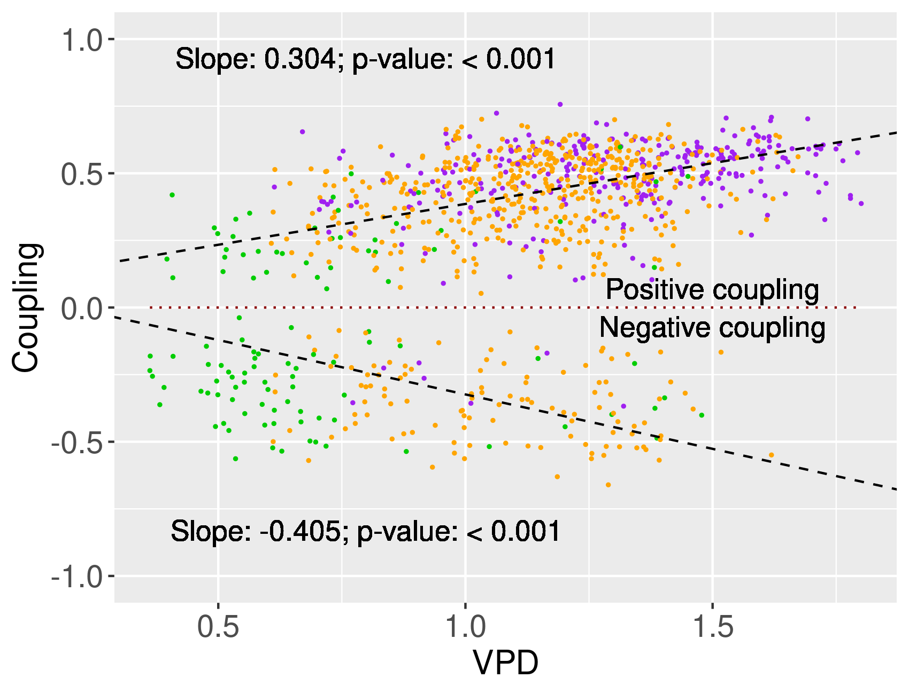

Figure 7: Relationship of the coupling between EVI2 and rainfall with VPD. Dashed black lines depict predicted values from statistical models describing the effect of VPD on negative (bottom line) and positive (top line) coupling.

|  |  |  |  |  |  |
| --- | --- | --- | --- | --- | --- |
| **Explicative variable** | **Estimate** | **Std error** | **Statistic** | **p-value** | **AIC** |
| **MAP** |  |  |  |  | -1085.73 |
| Intercept | 0.901 | 0.08 | 11.218 | < 0.001 |  |
| MAP:Neg | -0.167 | 0.011 | -15.31 | < 0.001 |  |
| MAP:Pos | -0.064 | 0.012 | -5.583 | < 0.001 |  |
| **MSI** |  |  |  |  | -1077 |
| Intercept | 0.007 | 0.027 | 0.248 | 0.8 |  |
| MSI:Neg | -0.7 | 0.056 | -12.384 | < 0.001 |  |
| MSI:Pos | 0.779 | 0.047 | 16.408 | < 0.001 |  |
| **MAT** |  |  |  |  | -1061.85 |
| Intercept | 0.117 | 0.061 | 1.919 | 0.055 |  |
| MAT:Neg | -0.018 | 0.002 | -7.36 | < 0.001 |  |
| MAT:Pos | 0.013 | 0.002 | 5.432 | < 0.001 |  |
| **VPD** |  |  |  |  | -1114.66 |
| Intercept | 0.082 | 0.019 | 4.282 | < 0.001 |  |
| VPD:Neg | -0.405 | 0.02 | -19.908 | < 0.001 |  |
| VPD:Pos | 0.304 | 0.015 | 19.76 | < 0.001 |  |

Table 3: Model parameters to test the performance of mean climatic variables in explaining vegetation response in terms of greenness to rainfall (i.e. coupling). AIC was used to select the best model.

The variance in vegetation-rainfall coupling is the lowest for both MAP extremes, with the highest variance for communities settled in regions with intermediate MAP (Figure 8a, Table 4). There is an abrupt change in the signal of the coupling when crossing from both sides of the intermediate MAP interval (Figure 8a). Evergreen communities with positive coupling predominate in the lowest extreme interval of MAP where evergreens are found (Figure 8b). With increasing MAP, the coupling becomes more negative for evergreens. Overall semideciduous communities have negative coupling in the highest extreme of the MAP interval where they are found (Figure 8b). Deciduous communities present a lower variance that increases with increasing MAP intervals (Figure 8b). Thus, vegetation responses to rainfall are more variable and diverse in regions with intermediate MAP, possibly indicating a wide range of strategies to deal with rainfall seasonality.

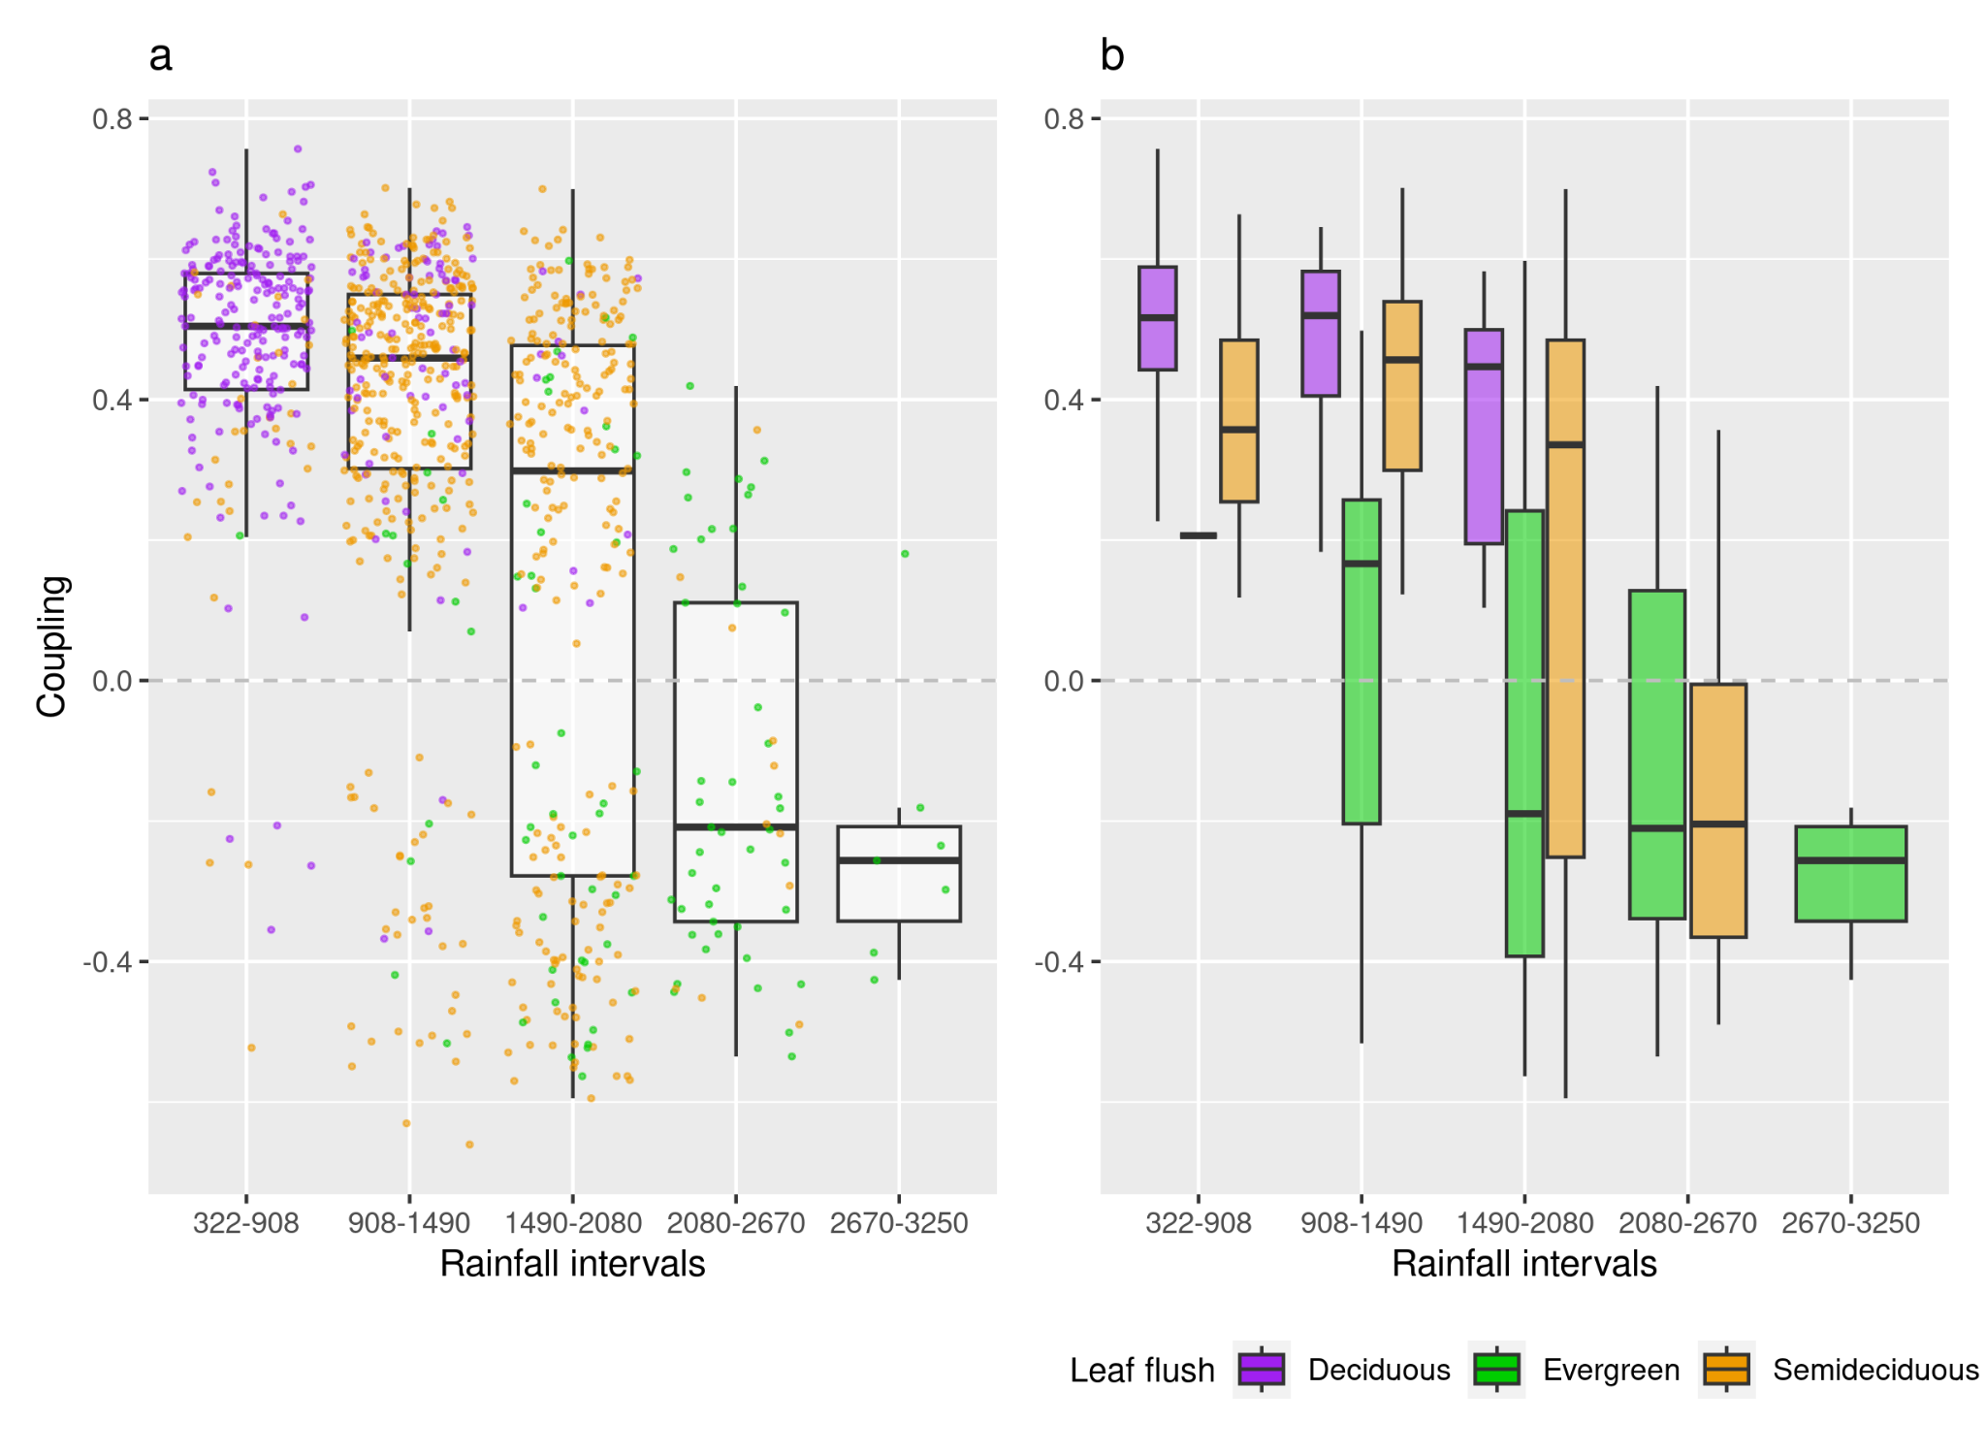

Figure 8: Distribution of coupling by rainfall (MAP) intervals for the distinct leaf flush regimes. (a) Boxplots for all plots with points representing values for each leaf flush regime classification (see the legend); (b) Boxplots separated by leaf flush regimes.

|  |  |  |  |
| --- | --- | --- | --- |
| MAP interval | n | var coupling | Mean MAP |
| 322-908 | 242 | 0.033 | 696.07 |
| 908-1490 | 411 | 0.074 | 1229.59 |
| 1490-2080 | 274 | 0.153 | 1699.82 |
| 2080-2670 | 57 | 0.071 | 2327.03 |
| 2670-3250 | 7 | 0.0398 | 2911.71 |

Table 4: Variance of the coupling (var coupling) between greenness and rainfall in a gradient of MAP intervals (mm/year). The column MAP interval indicates the interval between the minimum and maximum MAP, n indicates the number of sample points used in the analysis, and Mean MAP is the mean MAP for the sample points inside each MAP interval.

### 3.2.4 Discussion

Our results show that vegetation phenology is heterogeneous within floristic-based leaf flush classes and differs among biomes depending on large-scale climatic regimes (mean annual VPD, MAP, and MSI) (Chen et al., 2020). We found that the stability pattern of the greenness dynamics of communities (Figure 4) is similar to the one presented by Kumar et al. (2022), in which evergreen forests annual cycle is more stable than deciduous ones. However, differences among communities within the same leaf flush regime and biomes, e.g. distinct physiology within deciduous species (de Souza et al., 2020), may challenge phenological classification of vegetation types. We discuss such heterogeneities and the role of large-scale climatic conditions driving vegetation-rainfall coupling. Understanding vegetation responses to seasonal rainfall at the ecosystem level from satellite-based measurements is crucial to upscaling from fine-scale processes to broader scales, interacting with climate and biogeochemistry cycles.

#### 3.2.4.1 Vegetation-response heterogeneities within leaf flush regime groups

The floristic-based leaf flush regime classification does not fully represent the diversity of phenological dynamics in terms of greenness for the sampled communities (Souza et al., 2020). Deciduous and semideciduous communities belong to both groups 1 and 2, which have the annual cycle features expected of the deciduous and evergreen dynamics respectively. Response diversity within the same leaf flush regime group may result from trait variability within species (Lepš et al., 2011). Leaf trait variation was reported to be higher between than within species, while also displaying variability between individuals within a population (Hulshof & Swenson, 2010). In this sense, variability in traits within the same species can impact the patterns of ecosystem dynamics (Albert et al., 2012). Vegetation phenology and individual growth within the same species can also be influenced by soil characteristics and access to the water table (Cardoso et al., 2012; Luo et al., 2021). Additionally, the composition of semideciduous communities is a blend of dry and evergreen species (Dexter et al., 2018), which can exhibit deciduous (group 1) or evergreen (group 2) dynamics depending on environmental conditions (Oliveira et al., 2021). For example, evergreen and deciduous species may present similar stomatal regulation in seasonally dry forests from the Caatinga biome; however, evergreen species are only sensitive to soil drought, while deciduous species are sensitive to both soil and atmospheric drought (Souza et al., 2020). Furthermore, tropical deciduous forest species may present distinct strategies (e.g., avoidance, and tolerance) that influence plant hydraulic traits (Medeiros et al., 2024) and biomass accumulation (Chaturvedi et al., 2021). Thus, incorporating intraspecific variation may improve the mechanistic understanding of ecosystem function in response to environmental change (Jung et al., 2010).

#### 3.2.4.2 Vegetation-response dependence on large-scale drivers

With global changes, environmental conditions are becoming skewed by increasing precipitation extremes, threatening several species in areas subjected to seasonal drought, imposing filters that can be overcomed only by species with specific characteristics and functioning. Loss of species locally forced by more extreme conditions may disrupt ecosystem processes and lead to a collapse through the imbalance of feedbacks at play (Flores & Staal, 2022). Such changes force vegetation to its limits of operation under extreme drought conditions, promoting instability in alternative vegetation states and causing shifts in their distribution (Anadón, Sala, and Maestre, 2014). This process would lead to the homogenization of biomes in terms of vegetation types as well as species turnover, which would affect ecosystem functions and services (Tilman, 1999, Tilman, Isbel and Cowles, 2014; IPBES, 1999). For example, changes in vegetation distribution may negatively affect carbon sink (Vieilledent et al., 2016) and also cause ecological and economic losses (Baumbach et al., 2023).

Evolutionary history is strongly linked with vegetation distribution and functioning (Cavender-Bares et al., 2009; Pennington, Lavin, Oliveira-Filho, 2009; Coelho de Souza et al., 2016; Dick and Pennington, 2019). For example, local edaphic and climatic characteristics drive heterogeneities in vegetation functioning (Chen et al., 2020; Lira-Martins et al., 2022) that evolve over a geological time scale in which biological evolution occurs. However, the temporal scale and processes are particular for each tropical biome (Hughes et al, 2013), as demonstrated by our results for the annual cycle of vegetation greenness and ecosystems responses to rainfall (Table 2; SM Tables 1,4). These variations may result from eco-evolutionary feedbacks, wherein organisms can alter their environment, and environmental changes may influence the species' role and the evolutionary process (Post and Palkovacs, 2009). Thus, the heterogeneity in the functioning of communities may be driven by a combination of specific climate regimes (Alberton et al., 2023) and soil characteristics (Oliveira et al., 2021) and further biotic interactions and phenotypes that are all particular to each site.

We found that the coupling between greenness and rainfall decreases with water stress (decreasing MAP; increasing VPD and MSI). Accordingly, in the Amazon and areas with higher precipitation in the Caatinga Biome, vegetation is reported to have a lower relationship between vegetation index and precipitation (Santos & Negri, 1997). Additionally, similar to the presented results, ecosystems from arid and semi-arid environments are more coupled with precipitation in China, while overall forests show a non-significant or even a negative coupling (Shen et al., 2020). At the landscape scale, such responses were observed to be influenced by soil attributes such as nutrient content and water availability (Cure et al., 2023). In this study, evergreen communities (overall from Amazônia) exhibited a negative correlation with rainfall, whereas deciduous ones (overall from Caatinga and Cerrado) showed a positive correlation. The negative greenness-rainfall coupling may be explained by perennial access to groundwater (Cure et al., 2023), and in this case, greenness may respond to increased sunlight during the dry season, as found in the Amazon (Huete et al., 2006; Saleska et al., 2007), rather than to rainfall (Restrepo-Coupe et al., 2013). Another explanation lies in the fact that young trees and leaves possess physiological traits related to acquisitive strategies and exhibit higher net photosynthetic capacity and respiration compared to mature trees and leaves (Joshi et al., 2024). Thus, despite the fact that soil characteristics, light availability, vegetation ontogenetic stage, and periods of leaf flushing potentially enhance the understanding of vegetation responses to seasonal rainfall and consequently improve vegetation model performance (Caldararu, Purves & Smith, 2016; Wu et al., 2016; Albert et al., 2018), the coupling metric may simplify models, emphasizing the efficacy of simpler models, because it can also capture the effect of several environmental variables.

Low MAP and high VPD may select species with abilities to support periods of water scarcity, such as those provided by slow growth strategies. The same occurs on the opposite side of conditions, in which rainfall is higher and evenly distributed throughout the year and the dominant vegetation presents a high growth rate at the cost of hydraulic safety (Oliveira et al., 2021). The upward trend in the coupling variance at the mid-MAP interval may indicate a transition of responses (Scheffer et al., 2015) from low MAP, where vegetation greenness is primarily positively related to rainfall, to high MAP, where vegetation displays as dominant behavior an opposite negative greenness response (Figure 8a). From this point of view, the highest variance in the intermediate MAP regime may indicate higher instability and, thus, lower resilience of vegetation states (i.e., here defined by the coupling metric) (Scheffer et al., 2015). However, natural seasonal variability may shadow the detection of early warning signals (Carpenter and Brock, 2010). For example, the high variance in responses may be driven by the highest diversity of species, which can enhance drought resistance (Liu et al., 2022) in non-equilibrium states following the intermediate disturbance hypothesis (Connell, 1978). Accordingly, we found that communities from distinct leaf flush regimes exhibited distinct patterns of seasonal greenness behavior in intermediate MAP and seasonality, particularly within the Cerrado Biome. This variability in responses potentially reflects a wide range of adaptive strategies, contributing to higher resilience to environmental changes (Mazzochini et al., 2024; Girardello et al., 2024).

#### 3.2.4.3 Bridging scales: upscaling ecosystem dynamics

Despite the development of several upscaling techniques (Markham et al., 2023), upscaling ecosystem properties is recognized by underestimating the real complexity of environments and their emergences (Ge et al., 2019; Song et al., 2024). Another reason is that mismatching ecological patterns used to occur across scales (Wiens, 1989; Ma et al., 2023). For example, the trade-offs in vegetation functional traits vary between local and global scales, with a much weaker correlation between traits occurring on the local scale (Messier et al., 2017). Additionally, generalized representations of vegetation structure (e.g., Hirota et al., 2011) and functioning (Yan et al., 2024) at global scales do not consider local scale heterogeneities in vegetation distribution and environmental conditions (Abdi et al., 2022). Thus, including in situ data is accepted to be crucial for enhancing the modeling and upscaling of ecosystem carbon fluxes (Schimel et al., 2014; Virkkala et al., 2021).

However, the scarcity of such data poses a significant challenge for researchers. For example, there is a lack of data on fine-scale environmental variables, which are essential for integrating analysis with remote sensing data. It challenges the understanding of the effect of fine-scale environmental factors on vegetation distribution and functioning on broader scales. In this sense, it is challenging to represent understudied areas due to the lack of biological and environmental data. Furthermore, another limitation is that time series of satellite-derived products at fine scales (10-30 m; e.g. Sentinel-2 and Landsat 8, respectively) are often contaminated by clouds, primarily at higher precipitation levels in the Amazon biome and in the Cerrado biome during the wet season, which challenges the capture of vegetation seasonal dynamics for longer time-scales. A possible solution lies in the use of radar derived products that may deal with cloud cover (Mitchard et al., 2012).

Targeting the understanding of distinct vegetation phenological types, here, we went ahead with our previous study on the landscape-scale response of vegetation to seasonal rainfall (Cure et al., 2023) by upscaling the analysis to the Brazilian tropical biomes, including large-scale climatic variables. We have based our approach on single values of remotely sensed data on monthly rainfall and a vegetation index (EVI2), and species-based phenological types (i.e. evergreen, deciduous, and semideciduous) to understand the leaf phenological pattern of Brazilian tropical vegetation communities and its large-scale drivers. Our results synthesize distinct types of responses between and within forests and savannas classified as evergreen, deciduous, and semideciduous across tropical Brazilian biomes. Positive coupling, lower greenness mean, and higher greenness variation (group 1) dominate in communities classified as savannas, while forest responses are more variable (i.e. both positive and negative coupling and low and higher greenness mean and variation) belonging to both groups. The VPD is the primary factor influencing the response of tropical vegetation in the studied plots, however, the variation in VPD depends on different variables across different biomes. For example, the Amazon and the Atlantic Forest experience VPD dependence primarily on rainfall seasonality, while in the Cerrado and the Caatinga, it is more influenced by temperature (SM 5). Thus, a combination of factors may be considered in the understanding of seasonal responses of distinct vegetation types in different biomes (Girardello et al., 2024).

Upscaling vegetation types' responses in terms of greenness to rainfall seasonality is key to improving vegetation models' performance and thus advancing the discussion on vegetation distribution and management in the face of climatic change. The study results may be spatially and temporally upscaled by applying it in places where ground-based data are unavailable and by combining it with future climatic projections. Our approach may help modelers to achieve ecosystem phenological responses in locals without ground-based data on species composition and vegetation type and also analyze local or regional data in gradients of large-scale environmental variables, such as MAP and VPD. The coupling metric may be easily integrated into vegetation models as a reliable functional variable to account for vegetation response and dynamics.

### References

Abdi, A. M., Brandt, M., Abel, C., & Fensholt, R. (2022). Satellite Remote Sensing of Savannas: Current Status and Emerging Opportunities. *Journal of Remote Sensing*, *2022*. <https://doi.org/10.34133/2022/9835284>

Allen, R., Pereira, L., Raes, D., & Smith, M. (1998). Crop Evapotranspiration. Guidelines for Computing Crop Water Requirements. In *FAO Irrigation and Drainage Paper* (Vol. 56).

Albert, C.H., de Bello, F., Boulangeat, I., Pellet, G., Lavorel, S. and Thuiller, W. (2012), On the importance of intraspecific variability for the quantification of functional diversity. *Oikos*, 121: 116-126. <https://doi.org/10.1111/j.1600-0706.2011.19672.x>

Alberton, B., Martin, T. C. M., da Rocha, H. R., Richardson, A. D., Moura, M. S. B., Torres, R. S., & Morellato, L. P. C. (2023). Relationship between tropical leaf phenology and ecosystem productivity using phenocameras. *Frontiers in Environmental Science*, *11*. <https://doi.org/10.3389/fenvs.2023.1223219>

Anadón, J.D., Sala, O.E. and Maestre, F.T. (2014). Climate change will increase savannas at the expense of forests and treeless vegetation in tropical and subtropical Americas. *Journal of Ecology*, 102: 1363-1373. <https://doi.org/10.1111/1365-2745.12325>

Assis, L. F. F. G.; Ferreira, K. R.; Vinhas, L.; Maurano, L.; Almeida, C.; Carvalho, A.; Rodrigues, J.; Maciel, A.; Camargo, C. (2019). TerraBrasilis: A Spatial Data Analytics Infrastructure for Large-Scale Thematic Mapping. *ISPRS International Journal of Geo-Information*. 8, 513.<https://doi.org/10.3390/ijgi8110513>

Baumbach, L., Hickler, T., Yousefpour, R. et al. (2023). High economic costs of reduced carbon sinks and declining biome stability in Central American forests. *Nat Commun* 14, 2043. <https://doi.org/10.1038/s41467-023-37796-z>

Biudes, M. S., Vourlitis, G. L., Velasque, M. C. S., Machado, N. G., Danelichen, V. H. D. M., Pavão, V. M., Arruda, P. H. Z., & Nogueira, J. D. S. (2021). Gross primary productivity of Brazilian Savanna (Cerrado) estimated by different remote sensing-based models. *Agricultural and Forest Meteorology*, *307*, 108456. <https://doi.org/10.1016/j.agrformet.2021.108456>

Bolker, B. and Robinson, D. (2022). \_broom.mixed: Tidying Methods for Mixed Models\_. R package version 0.2.9.4, [https://CRAN.R-project.org/package=broom.mixed](https://cran.r-project.org/package=broom.mixed)

Breiman, L. Random Forests. *Machine Learning* **45**, 5–32 (2001). <https://doi.org/10.1023/A:1010933404324>

Caldararu, S., Purves, D. W., & Smith, M. J. (2016). The effect of using the plant functional type paradigm on a data-constrained global phenology model. *Biogeosciences*, *13*(4), 925–941. <https://doi.org/10.5194/bg-13-925-2016>

Cardoso, F. C. G., Marques, R., Botosso, P. C., & Marques, M. C. M. (2012). Stem growth and phenology of two tropical trees in contrasting soil conditions. *Plant and Soil*. 354, 269-281 <https://doi.org/10.1007/s11104-011-1063-9>

Carpenter, S. R., & Brock, W. A. (2010). Early warnings of regime shifts in spatial dynamics using the discrete Fourier transform. *Ecosphere*, *1*(5), 1-15. <https://doi.org/10.1890/ES10-00016.1>

Cavender-Bares, J., Kozak, K.H., Fine, P.V.A. and Kembel, S.W. (2009), The merging of community ecology and phylogenetic biology. *Ecology Letters*, 12: 693-715.<https://doi.org/10.1111/j.1461-0248.2009.01314.x>

Chaturvedi, R. K., Tripathi, A., Raghubanshi, A. S., & Singh, J. S. (2021). Functional traits indicate a continuum of tree drought strategies across a soil water availability gradient in a tropical dry forest. Forest Ecology and Management, 482, 118740. <https://doi.org/https://doi.org/10.1016/j.foreco.2020.118740>

Coelho de Souza, F., Dexter, K. G., Phillips, O. L., Brienen, R. J. W., Chave, J., Galbraith, D. R., … Baker, T. R. (2016). Evolutionary heritage influences Amazon tree ecology. *Proceedings of the Royal Society B: Biological Sciences*, *283*(1844). <https://doi.org/10.1098/rspb.2016.1587>

Connell, J. H. (1978). Diversity in Tropical Rain Forests and Coral Reefs. *Science.* 199, 1302-1310. DOI: [10.1126/science.199.4335.1302](https://doi-org.ez46.periodicos.capes.gov.br/10.1126/science.199.4335.1302)

Cure, M. B., Flores, B. M., Mattos, C. R. C., Oliveira, R. S., & Hirota, M. (2023). Vegetation-rainfall coupling as an indicator of ecosystem state in a heterogeneous landscape. *Ecological Indicators*, *157*, 111268. <https://doi.org/https://doi.org/10.1016/j.ecolind.2023.111268>

Dexter KG, Pennington RT, Oliveira-Filho AT, Bueno ML, Silva de Miranda PL and Neves DM (2018). Inserting Tropical Dry Forests Into the Discussion on Biome Transitions in the Tropics. *Frontiers in Ecology and Evolution* 6:104. <https://doi.org/10.3389/fevo.2018.00104>

Dick, C. W., & Pennington, R. T. (2019). History and Geography of Neotropical Tree Diversity. *Annu. Rev. Ecol. Evol. Syst.*, 50:279–301. <https://doi.org/10.1146/annurev-ecolsys-110617>

Dobson, A. et al.(2022). Savannas are vital but overlooked carbon sinks. *Science* 375, 6579, p. 392. <https://doi.org/10.1126/science.abn4482>

Dronova, I., & Taddeo, S. (2022). Remote sensing of phenology: Towards the comprehensive indicators of plant community dynamics from species to regional scales. *Journal of Ecology*, *110*(7), 1460-1484. <https://doi.org/10.1111/1365-2745.13897>

Fang, H., Sha, M., Xie, Y., Lin, W., Qiu, D., Tu, J., Tan, X., Li, X., & Sha, Z. (2023) Shifted Global Vegetation Phenology in Response to Climate Changes and Its Feedback on Vegetation Carbon Uptake. *Remote Sensing*, *15*(9), 2288. <https://doi.org/10.3390/rs15092288>

Feng, Y., Su, H., Tang, Z., Wang, S., Zhao, X., Zhang, H., Ji, C., Zhu, J., Xie, P., & Fang, J. (2021). Reduced resilience of terrestrial ecosystems locally is not reflected on a global scale. *Communications Earth & Environment*, *2*(1), 1-11. <https://doi.org/10.1038/s43247-021-00163-1>

Funk, C., Peterson, P., Landsfeld, M., Pedreros, D., Verdin, J., Shukla, S., Husak, G., Rowland, J., Harrison, L., Hoell, A., & Michaelsen, J. (2015). The climate hazards infrared precipitation with stations - a new environmental record for monitoring extremes. *Scientific Data*, *2*(150066). <https://doi.org/https://doi.org/10.1038/sdata.2015.66>

Gao, X., McGregor, I. R., Gray, J. M., Friedl, M. A., & Moon, M. (2023). Observations of Satellite Land Surface Phenology Indicate That Maximum Leaf Greenness Is More Associated With Global Vegetation Productivity Than Growing Season Length. *Global Biogeochemical Cycles*, *37*(3), e2022GB007462. <https://doi.org/10.1029/2022GB007462>

Ge, Y., Jin, Y., Stein, A., Chen, Y., Wang, J., Wang, J., Cheng, Q., Bai, H., Liu, M., & Atkinson, P. M. (2019). Principles and methods of scaling geospatial Earth science data. *Earth-Science Reviews*, 197, 102897. <https://doi.org/10.1016/J.EARSCIREV.2019.102897>

Gegzna V (2020). \_biostat: Routines for Basic (Bio)Statistics\_. R package version 0.0.20, <https://github.com/gegznav/biostat/>, <https://gegznav.github.io/biostat/>

Grossiord, C., Buckley, T. N., Cernusak, L. A., Novick, K. A., Poulter, B., W. Siegwolf, R. T., Sperry, J. S., & McDowell, N. G. (2020). Plant responses to rising vapor pressure deficit. *New Phytologist*, *226*(6), 1550-1566. <https://doi.org/10.1111/nph.16485>

Hausser J, Strimmer K (2021). \_entropy: Estimation of Entropy, Mutual Information and Related Quantities\_. R package version 1.3.1, [https://CRAN.R-project.org/package=entropy](https://cran.r-project.org/package=entropy)

Huete, A., Didan, K., Miura, T., Rodriguez, E., Gao, X., & Ferreira, L. (2002). Overview of the radiometric and biophysical performance of the MODIS vegetation indices. *Remote Sensing of Environment*, *83*(1-2), 195-213. <https://doi.org/10.1016/S0034-4257(02)00096-2>

Hughes, C. E., Pennington, R. T., & Antonelli, A. (2013). Neotropical Plant Evolution: Assembling the Big Picture. *Botanical Journal of the Linnean Society* (Vol. 171). <https://academic.oup.com/botlinnean/article/171/1/1/2557401>

Hulshof, C. M., & Swenson, N. G. (2010). Variation in leaf functional trait values within and across individuals and species: an example from a Costa Rican dry forest. *Functional Ecology*. 24 (1). 217-223. <https://doi.org/10.1111/j.1365-2435.2009.01614>

IPBES (2019): Global assessment report on biodiversity and ecosystem services of the Intergovernmental Science-Policy Platform on Biodiversity and Ecosystem Services. E. S. Brondizio, J. Settele, S. Díaz, and H. T. Ngo (editors). IPBES secretariat, Bonn, Germany. 1148 pages.<https://doi.org/10.5281/zenodo.3831673>

Jiang, Z., Huete, A. R., Didan, K., & Miura, T. (2008). Development of a two-band enhanced vegetation index without a blue band. *Remote Sensing of Environment*, *112*(10), 3833-3845. <https://doi.org/10.1016/j.rse.2008.06.006>

Joshi, K., R., Mishra, A., Gupta, R., & Chandra Garkoti, S. (2024). Leaf and tree age-related changes in leaf ecophysiological traits, nutrient, and adaptive strategies of Alnus nepalensis in the central Himalaya. *Journal of Biosciences*, 49(24). <https://doi.org/10.1007/s12038-023-00385-9>

Jung, V., Violle, C., Dric Mondy, C., Hoffmann, L., & Muller, S. (2010). Intraspecific variability and trait-based community assembly. *Journal of Ecology*, 98, 1134–1140. <https://doi.org/10.1111/j.1365-2745.2010.01687.x>

Kassambara A, Mundt F (2020). \_factoextra: Extract and Visualize the Results of Multivariate Data Analyses\_. R package version 1.0.7, [https://CRAN.R-project.org/package=factoextra](https://cran.r-project.org/package=factoextra)

Kassambara A (2023). \_rstatix: Pipe-Friendly Framework for Basic Statistical Tests\_. R package version 0.7.2, [https://CRAN.R-project.org/package=rstatix](https://cran.r-project.org/package=rstatix)

Kuhn M (2021). \_caret: Classification and Regression Training\_. R package version 6.0-90, [https://CRAN.R-project.org/package=caret](https://cran.r-project.org/package=caret)

Kumar, M., Phukon, S. N., Paygude, A. C., Tyagi, K., & Singh, H. (2022). Mapping Phenological Functional Types (PhFT) in the Indian Eastern Himalayas using machine learning algorithm in Google Earth Engine. *Computers & Geosciences*, *158*, 104982. <https://doi.org/10.1016/j.cageo.2021.104982>

Lenth R (2023). \_emmeans: Estimated Marginal Means, aka Least-Squares Means\_. R package version 1.9.0, [https://CRAN.R-project.org/package=emmeans](https://cran.r-project.org/package=emmeans)

Lepš, J., de Bello, F., Šmilauer, P. & Doležal, J. (2011), Community trait response to environment: disentangling species turnover vs intraspecific trait variability effects. *Ecography*, 34: 856-863.<https://doi.org/10.1111/j.1600-0587.2010.06904.x>

Li, M. & Qu, J. J. (2013). Satellite applications for detecting vegetation phenology. *Satellite-Based Applications on Climate Change*, 263-276. <https://doi.org/10.1007/978-94-007-5872-8_17>

Liaw, A. & Wiener, M. (2002). Classification and Regression by randomForest. R News 2(3), 18--22. [https://CRAN.R-project.org/doc/Rnews/](https://cran.r-project.org/doc/Rnews/)

Lira-Martins, D., Nascimento, D.L., Abrahão, A. *et al.* Soil properties and geomorphic processes influence vegetation composition, structure, and function in the Cerrado Domain. *Plant Soil*, 476, 549–588 (2022). <https://doi.org/10.1007/s11104-022-05517-y>

Liu, D., Wang, T., Peñuelas, J., & Piao, S. (2022). Drought resistance enhanced by tree species diversity in global forests. *Nature Geoscience*, *15*(10), 800-804. <https://doi.org/10.1038/s41561-022-01026-w>

Luo, M., Meng, F., Sa, C., Duan, Y., Bao, Y., Liu, T., & de Maeyer, P. (2021). Response of vegetation phenology to soil moisture dynamics in the Mongolian Plateau. *CATENA*, 206, 105505. <https://doi.org/10.1016/J.CATENA.2021.105505>

Ma, L., Yang, L., Chang, Q., Wang, S., Guan, C., Chen, N., & Zhao, C. (2023). Alternative tree-cover states of dryland ecosystems: Inconsistencies between global and continental scales. *Agricultural and Forest Meteorology*, *337*, 109497. <https://doi.org/10.1016/j.agrformet.2023.109497>

Markham, C. G. (1970). Seasonality of precipitation in the United States. *Annals of the Association of American Geographers*, *60*(3), 593–597. <https://doi.org/10.1111/J.1467-8306.1970.TB00743.X>

Markham, K., Frazier, A. E., Singh, K. K., Madden (2023). A review of methods for scaling remotely sensed data for spatial pattern analysis. *Landscape Ecology*, 38, 619–635. <https://doi.org/10.1007/s10980-022-01449-1>

Mattos, C. R., Hirota, M., Oliveira, R. S., Flores, B. M., Pokhrel, Y., & Fan, Y. (2023a). Double stress of waterlogging and drought drives forest–savanna coexistence. *Proceedings of the National Academy of Sciences*, *120*(33), e2301255120. <https://doi.org/10.1073/pnas.2301255120>

Mattos, C. R. C., Mazzochini, G. G., Rius, B. F., Penha, D., Giacomin, L. L., Flores, B. M., Silva, M. C., Xavier, R. O., Nehemy, M. F., Petroni, A. R., Silva, J. S. G. M., Schlickmann, M. B., Rocha, M., Rodrigues, G., Costa, S. S., Barros, F. v, Tavares, J. v, Furtado, M. N., Verona, L. S., … Hirota, M. (2023b). Rainfall and topographic position determine tree embolism resistance in Amazônia and Cerrado sites. *Environmental Research Letters*, *18*(11), 114009. <https://doi.org/10.1088/1748-9326/ad0064>

Mazzochini, G. G., Rowland, L., Lira-Martins, D., Barros, F. d. V., Flores, B. M., Hirota, M., Pennington, R. T., & Oliveira, R. S. (2024). Spectral asynchrony as a measure of ecosystem response diversity. *Global Change Biology*, 30, e17174.<https://doi.org/10.1111/gcb.17174>

McFadden, I. R., Sandel, B., Tsirogiannis, C., Morueta-Holme, N., Svenning, C., Enquist, B. J., & Kraft, J. B. (2019). Temperature shapes opposing latitudinal gradients of plant taxonomic and phylogenetic β diversity. *Ecology Letters*, *22*(7), 1126-1135. <https://doi.org/10.1111/ele.13269>

Medeiros, M., Wright, C. L., de Lima, A. L. A., da Silva Brito, N. D., Souza, R., Silva, J. R. I., & Souza, E. (2024). Divergent hydraulic strategies of two deciduous tree species to deal with drought in the Brazilian semi-arid region. *Trees*. <https://doi.org/10.1007/s00468-024-02506-9>

Meyer D, Dimitriadou E, Hornik K, Weingessel A, & Leisch F (2023). \_e1071: Misc Functions of the Department of Statistics, Probability Theory Group (Formerly: E1071), TU Wien\_. R package version 1.7-14, [https://CRAN.R-project.org/package=e1071](https://cran.r-project.org/package=e1071)

Middleby, K. B., Cheesman, A. W., Cernusak, L. A., & Middleby, K. (2024). Impacts of elevated temperature and vapour pressure deficit on leaf gas exchange and plant growth across six tropical rainforest tree species. *New Phytologist*. <https://doi.org/10.1111/nph.19822>

Migliavacca, M., Sonnentag, O., Keenan, T. F., Cescatti, A., O’Keefe, J., & Richardson, A. D. (2012). On the uncertainty of phenological responses to climate change, and implications for a terrestrial biosphere model. *Biogeosciences*, 9(6). <https://doi.org/10.5194/bg-9-2063-2012>

Mitchard, E. T. A., Saatchi, S. S., White, L. J. T., Abernethy, K. A., Jeffery, K. J., Lewis, S. L., Collins, M., Lefsky, M. A., Leal, M. E., Woodhouse, I. H., & Meir, P. (2012). Mapping tropical forest biomass with radar and spaceborne LiDAR in Lopé National Park, Gabon: overcoming problems of high biomass and persistent cloud. *Biogeosciences*, *9*(1), 179–191. <https://doi.org/10.5194/bg-9-179-2012>

Newbold, T., Oppenheimer, P., Etard, A. et al. (2020). Tropical and Mediterranean biodiversity is disproportionately sensitive to land-use and climate change. *Nature Ecology and Evolution*, 4, 1630-1638. <https://doi.org/10.1038/s41559-020-01303-0>

Ogle DH, Doll JC, Wheeler AP, Dinno A (2023). \_FSA: Simple Fisheries Stock Assessment Methods\_. R package version 0.9.5, [https://CRAN.R-project.org/package=FSA](https://cran.r-project.org/package=FSA)

Oksanen, J., Simpson, G., Blanchet, F., Kindt, R., Legendre, P., Minchin, P., O'Hara, R., Solymos, P., Stevens, M., Szoecs, E., Wagner, H., Barbour, M., Bedward, M., Bolker, B., Borcard, D., Carvalho, G., Chirico, M., De Caceres, M., Durand, S., Evangelista, H., FitzJohn, R., Friendly, M., Furneaux, B., Hannigan, G., Hill, M., Lahti, L., McGlinn, D., Ouellette, M., Ribeiro, Cunha, E., Smith, T., Stier, A., Ter Braak, and C., Weedon, J. (2022). \_vegan: Community Ecology Package\_. R package version 2.6-4, [https://CRAN.R-project.org/package=vegan](https://cran.r-project.org/package=vegan)

Oliveira-Filho, A.T. 2017.NeoTropTree: Tree flora of the Neotropical Region: A database involving biogeography, diversity and conservation. Universidade Federal de Minas Gerais. ([http://www.neotroptree,info](about:blank))

Pennington, R. T., Lavin, M., & Oliveira-Filho, A. (2009). Woody Plant Diversity, Evolution, and Ecology in the Tropics: Perspectives from Seasonally Dry Tropical Forests. *Annual Review of Ecology, Evolution, and Systematics.* 40, 437-457. <https://doi.org/10.1146/annurev.ecolsys.110308.120327>

Post, D. M., & Palkovacs, E. P. (2009). Eco-evolutionary feedbacks in community and ecosystem ecology: interactions between the ecological theater and the evolutionary play. Philosophical Transactions of the Royal Society B, 364, 1629–1640. <https://doi.org/10.1098/rstb.2009.0012>

R Core Team (2023). \_R: A Language and Environment for Statistical Computing\_. R Foundation for Statistical Computing, Vienna, Austria. [https://www.R-project.org/](https://www.r-project.org/)

Restrepo-Coupe, N., Da Rocha, H. R., Hutyra, L. R., Da Araujo, A. C., Borma, L. S., Christoffersen, B., Cabral, O. M., De Camargo, P. B., Cardoso, F. L., Da Costa, A. C. L., Fitzjarrald, D. R., Goulden, M. L., Kruijt, B., Maia, J. M., Malhi, Y. S., Manzi, A. O., Miller, S. D., Nobre, A. D., Von Randow, C., . . . Saleska, S. R. (2013). What drives the seasonality of photosynthesis across the Amazon basin? A cross-site analysis of eddy flux tower measurements from the Brasil flux network. *Agricultural and Forest Meteorology*, *182-183*, 128-144. <https://doi.org/10.1016/j.agrformet.2013.04.031>

Restrepo‐Coupe, Natalia, Naomi M. Levine, Bradley O. Christoffersen, Loren P. Albert, Jin Wu, Marcos H. Costa, David Galbraith, Hewlley Imbuzeiro, Giordane Martins, Alessandro C. Araujo, Yadvinder S. Malhi, Xubin Zeng, Paul Moorcroft, and Scott R. Saleska. (2017). Do Dynamic Global Vegetation Models Capture the Seasonality of Carbon Fluxes in the Amazon Basin? A Data‐model Intercomparison. *Global Change Biology* 23.1: 191-208. Web

Ryan, J. A., Ulrich, J. M. (2020). \_quantmod: Quantitative FinancialModelling Framework\_. R package version 0.4.18, [https://CRAN.R-project.org/package=quantmod](https://cran.r-project.org/package=quantmod)

Saleska, S. R., Didan, K., Huete, A. R., & Rocha, H. R. (2007). Amazon Forests Green-Up During 2005 Drought. *Science*, 318, 612. <https://doi.org/10.1126/science.1146663>

Scheffer, Marten; Carpenter, Stephen R.; Dakos, Vasilis; van Nes, Egbert (2015). Generic Indicators of Ecological Resilience: Inferring the Chance of a Critical Transition. *Annual Review of Ecology, Evolution, and Systematics,* 46(1), <https://doi.org/10.1146/annurev-ecolsys-112414-054242>

Schimel, D., Pavlick, R., Fisher, J.B., Asner, G.P., Saatchi, S., Townsend, P., Miller, C., Frankenberg, C., Hibbard, K. and Cox, P. (2015), Observing terrestrial ecosystems and the carbon cycle from space. Glob Change Biol, 21: 1762-1776.<https://doi.org/10.1111/gcb.12822>

Skelton, R. P., West, A. G., & Dawson, T. E. (2015). Predicting plant vulnerability to drought in biodiverse regions using functional traits. *PNAS*, 112(18), 5744–5749. <https://doi.org/10.1073/pnas.1503376112>

Sobrado, M. A. (1991). Cost-Benefit Relationships in Deciduous and Evergreen Leaves of Tropical Dry Forest Species. *Functional Ecology*, 5(5), 608. <https://doi.org/10.2307/2389479>

Song, G., Wang, J., Zhao, Y., Yang, D., Lee, C. K., Guo, Z., Detto, M., Alberton, B., Morellato, P., Nelson, B., & Wu, J. (2024). Scale matters: Spatial resolution impacts tropical leaf phenology characterized by multi-source satellite remote sensing with an ecological-constrained deep learning model. *Remote Sensing of Environment*, *304*, 114027. <https://doi.org/10.1016/j.rse.2024.114027>

de Souza, B.C., Carvalho, E.C.D., Oliveira, R.S., de Araújo, F.S., de Lima, A.L.A., Rodal, M.J.N. (2020). Drought response strategies of deciduous and evergreen woody species in a seasonally dry neotropical forest. *Oecologia* 194, 221–236.<https://doi.org/10.1007/s00442-020-04760-3>

Tang, J., Körner, C., Muraoka, H., Piao, S., Shen, M., Thackeray, S. J., & Yang, X. (2016). Emerging opportunities and challenges in phenology: A review. *Ecosphere*, *7*(8), e01436. <https://doi.org/10.1002/ecs2.1436>

Tilman, D. (1999). The Ecological Consequences of Changes in Biodiversity: A Search for General Principles. *Ecology*, 80(5), 1455. <https://doi.org/10.2307/176540>

Tilman, D., Isbell, F., & Cowles, J. M. (2014). Biodiversity and Ecosystem Functioning. *Annual Review of Ecology, Evolution, and Systematics*, 45(1), 471–493. <https://doi.org/10.1146/annurev-ecolsys-120213-091917>

Veenendaal, E. M., Torello-Raventos, M., Feldpausch, T. R., Domingues, T. F., Gerard, F., Schrodt, F., Saiz, G., Quesada, C. A., Djagbletey, G., Ford, A., Kemp, J., Marimon, B. S., Marimon-Junior, B. H., Lenza, E., Ratter, J. A., Maracahipes, L., Sasaki, D., Sonké, B., Zapfack, L., … Lloyd, J. (2015). Structural, physiognomic and above-ground biomass variation in savanna-forest transition zones on three continents - how different are co-occurring savanna and forest formations? *Biogeosciences*, *12*, 2927–2951. <https://doi.org/10.5194/bg-12-2927-2015>

Vieilledent, G., Gardi, O., Grinand, C., Burren, C., Andriamanjato, M., Camara, C., Gardner, C.J., Glass, L., Rasolohery, A., Rakoto Ratsimba, H., Gond, V. and Rakotoarijaona, J.-R. (2016), Bioclimatic envelope models predict a decrease in tropical forest carbon stocks with climate change in Madagascar. J Ecol, 104: 703-715. <https://doi.org/10.1111/1365-2745.12548>

Violle, C., Jiang, L. (2009). Towards a trait-based quantification of species niche, *Journal of Plant Ecology*, Volume 2, Issue 2, Pages 87–93,<https://doi.org/10.1093/jpe/rtp007>

Virkkala, A.-M., Aalto, J., Rogers, B.M., Tagesson, T., Treat, C.C., Natali, S.M., Watts, J.D., Potter, S., Lehtonen, A., Mauritz, M., Schuur, E.A.G., Kochendorfer, J., Zona, D., Oechel, W., Kobayashi, H., Humphreys, E., Goeckede, M., Iwata, H., Lafleur, P.M., Euskirchen, E.S., Bokhorst, S., Marushchak, M., Martikainen, P.J., Elberling, B., Voigt, C., Biasi, C., Sonnentag, O., Parmentier, F.-J.W., Ueyama, M., Celis, G., St.Louis, V.L., Emmerton, C.A., Peichl, M., Chi, J., Järveoja, J., Nilsson, M.B., Oberbauer, S.F., Torn, M.S., Park, S.-J., Dolman, H., Mammarella, I., Chae, N., Poyatos, R., López-Blanco, E., Christensen, T.R., Kwon, M.J., Sachs, T., Holl, D. and Luoto, M. (2021), Statistical upscaling of ecosystem CO2 fluxes across the terrestrial tundra and boreal domain: Regional patterns and uncertainties. Glob. Change Biol., 27: 4040-4059.<https://doi.org/10.1111/gcb.15659>

Wiens, J. A. (1989). Spatial Scaling in Ecology. *Functional Ecology*, Vol. 3, No. 4. , pp. 385-397. <https://www.jstor.org/stable/2389612?seq=1>

Wu, D., Zhao, X., Liang, S., Zhou, T., Huang, K., Tang, B. and Zhao, W. (2015), Time-lag effects of global vegetation responses to climate change. *Glob Change Biol*, 21: 3520-3531.<https://doi.org/10.1111/gcb.12945>

Wu, J., Albert, L. P., Lopes, A., Restrepo-Coupe, N., Hayek, M., Wiedemann, K. T., Guan, K., Stark, S. C., Christoffersen, B., Prohaska, N., Tavares, J. v., Marostica, S., Kobayashi, H., Ferreira, M. L., Campos, K. S., Silva, R. da, Brando, P. M., Dye, D. G., Huxman, T. E., … Saleska, S. R. (2016). Leaf development and demography explain photosynthetic seasonality in Amazon evergreen forests. Science, 351(6276), 972–976. <https://doi.org/10.1126/science.aad5068>

Yan, Y., Piao, S., Hammond, W. M., Chen, A., Hong, S., Xu, H., Munson, S. M., Myneni, R. B., & Allen, C. D. (2024). Climate-induced tree-mortality pulses are obscured by broad-scale and long-term greening. *Nature Ecology & Evolution*, 1-12. <https://doi.org/10.1038/s41559-024-02372-1>

Zeileis, A. and Grothendieck, G. (2005). zoo: S3 Infrastructure for Regular and Irregular Time Series. Journal of Statistical Software, 14(6), 1-27. <http://doi.org/10.18637/jss.v014.i06>

Supplementary Materials

**SM1**: Importance of variables (i.e., the statistical descriptors of the greenness annual cycle), according to the Gini index obtained by a random forest model to classify distinct leaf flush regimes based on species composition.

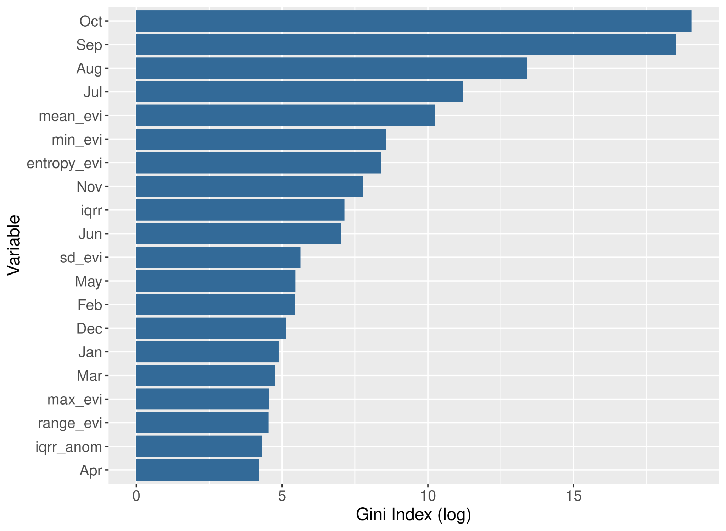

**SM2**: Optimal number of clusters using the average silhouette width.

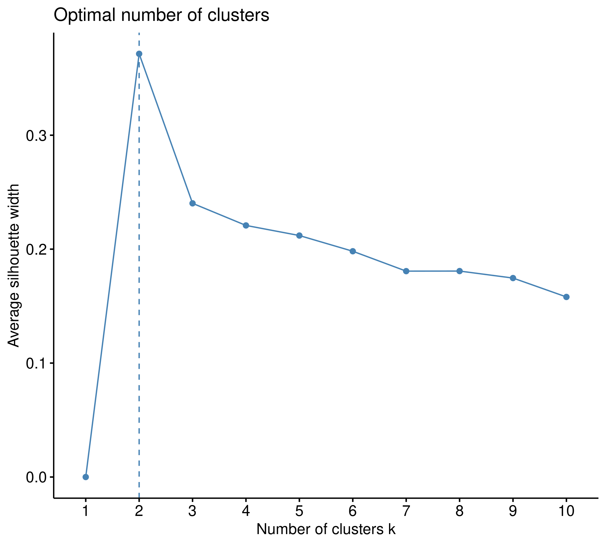

**SM 3:** Coupling with respective lag in months to the maximum response of the sampled communities belonging to distinct leaf flush regime classifications by group.

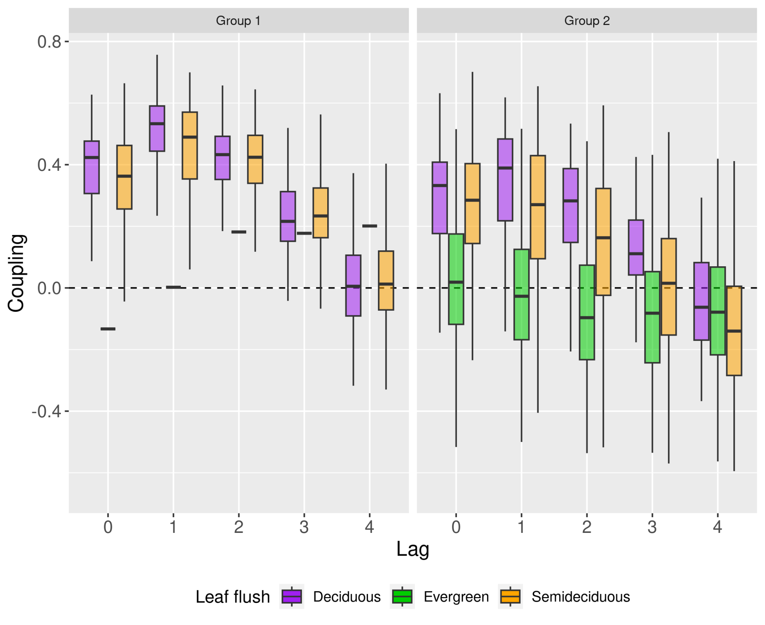

**SM 4:** Relationship of the coupling between EVI2 and rainfall with VPD (a), MSI (b), MAT (c), and logarithmized MAP (d). Black lines depict predicted values from statistical models describing the effect of each variable (a-d) on negative (bottom line) and positive (top line) coupling.

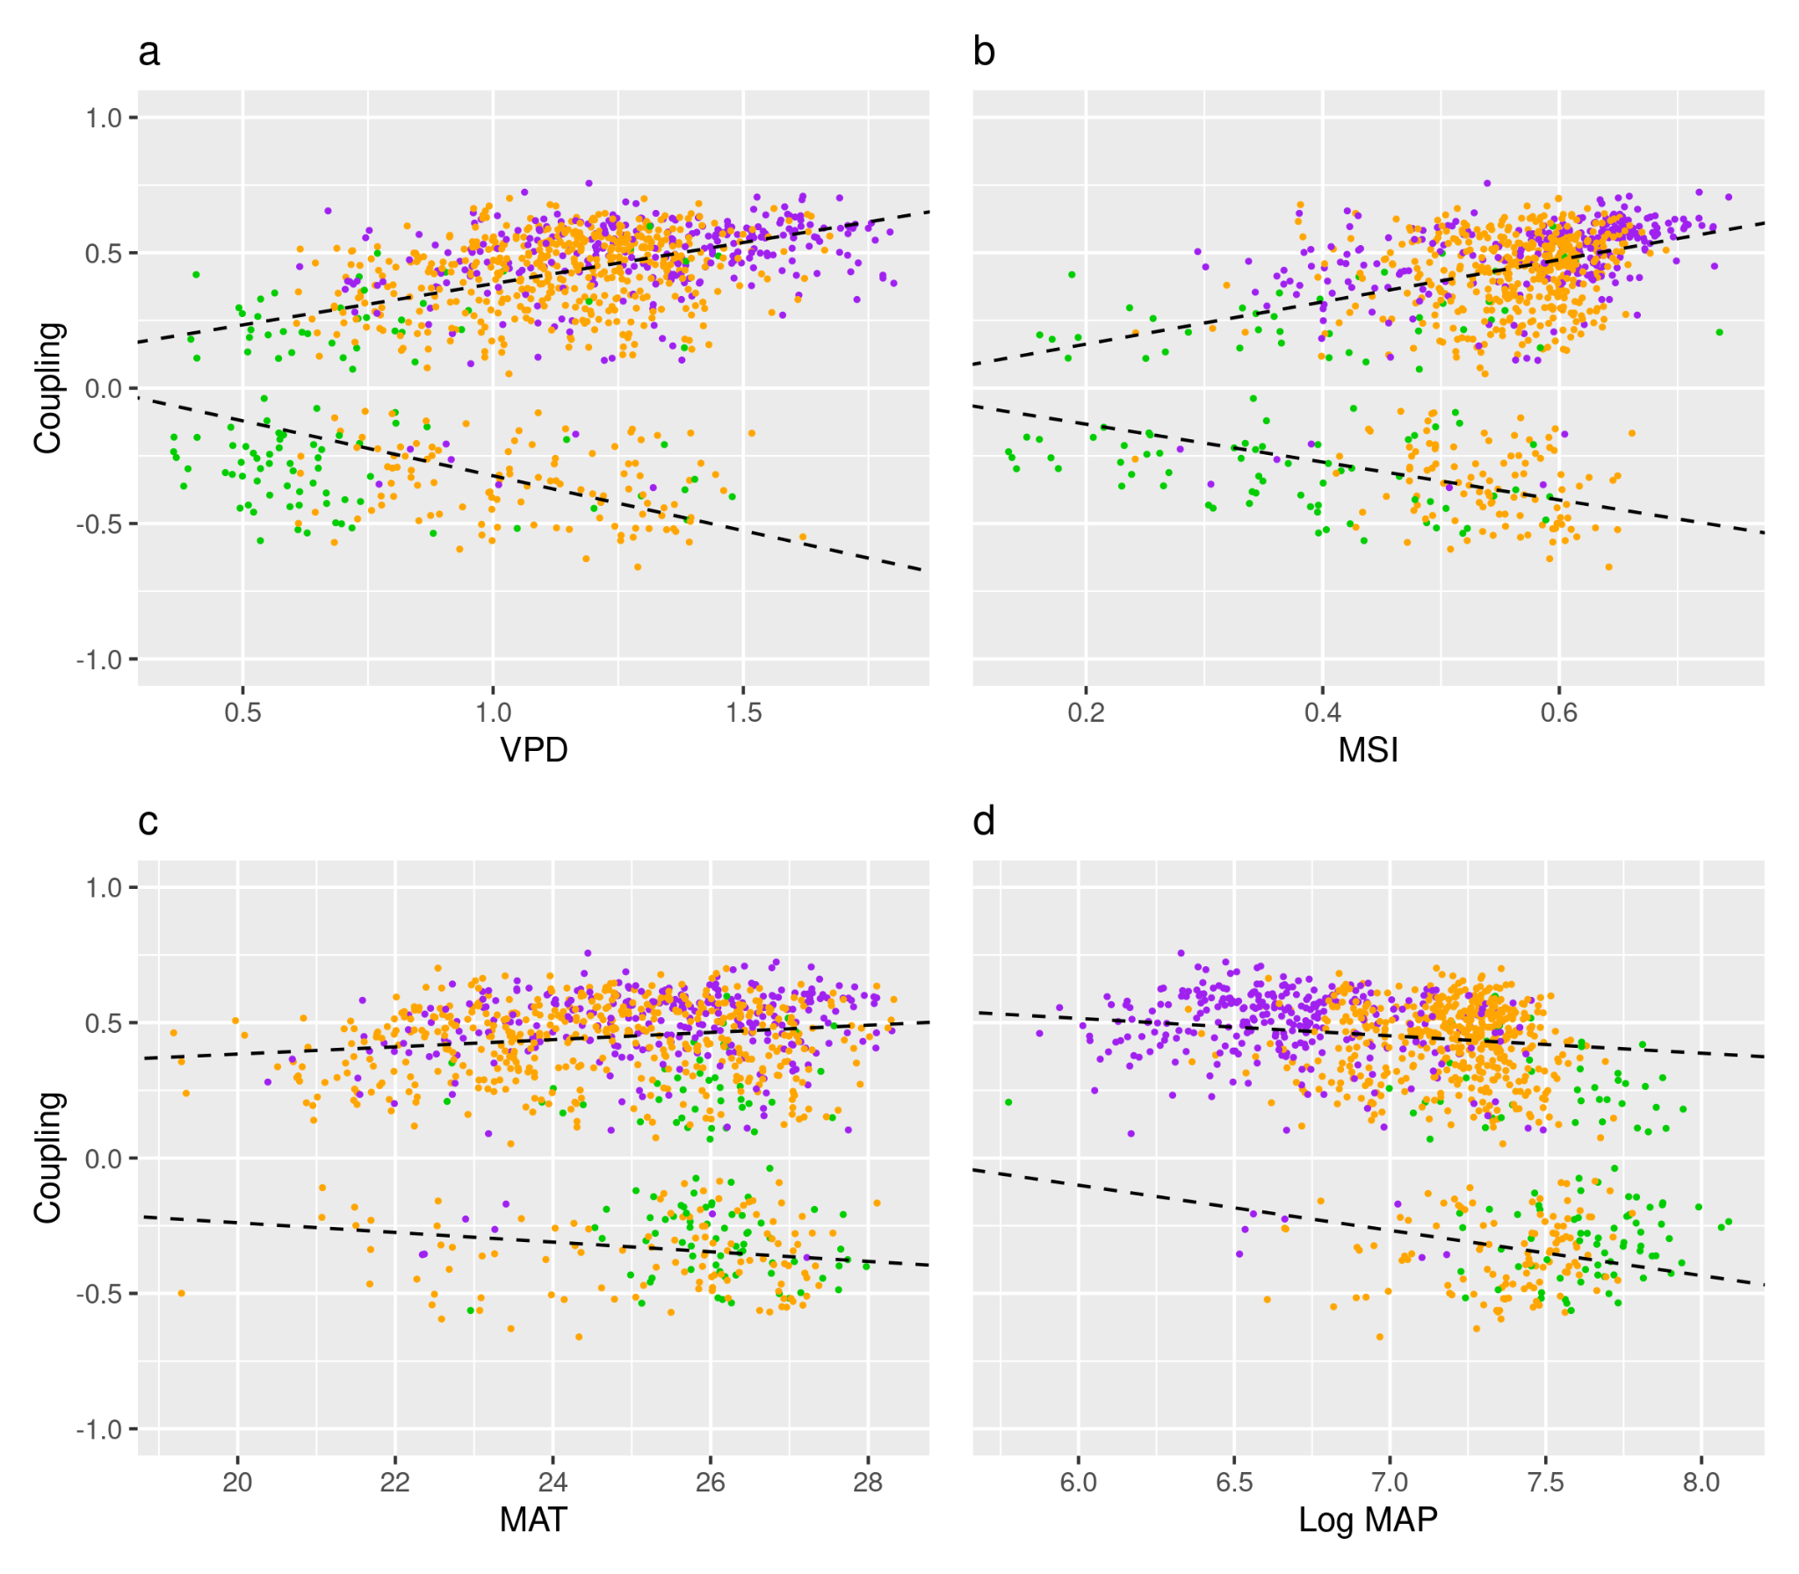

**SM 5:** Bidimensional environmental space of plots colored by Brazilian tropical biomes and its corresponding correlation between pairs of variables for each biome.

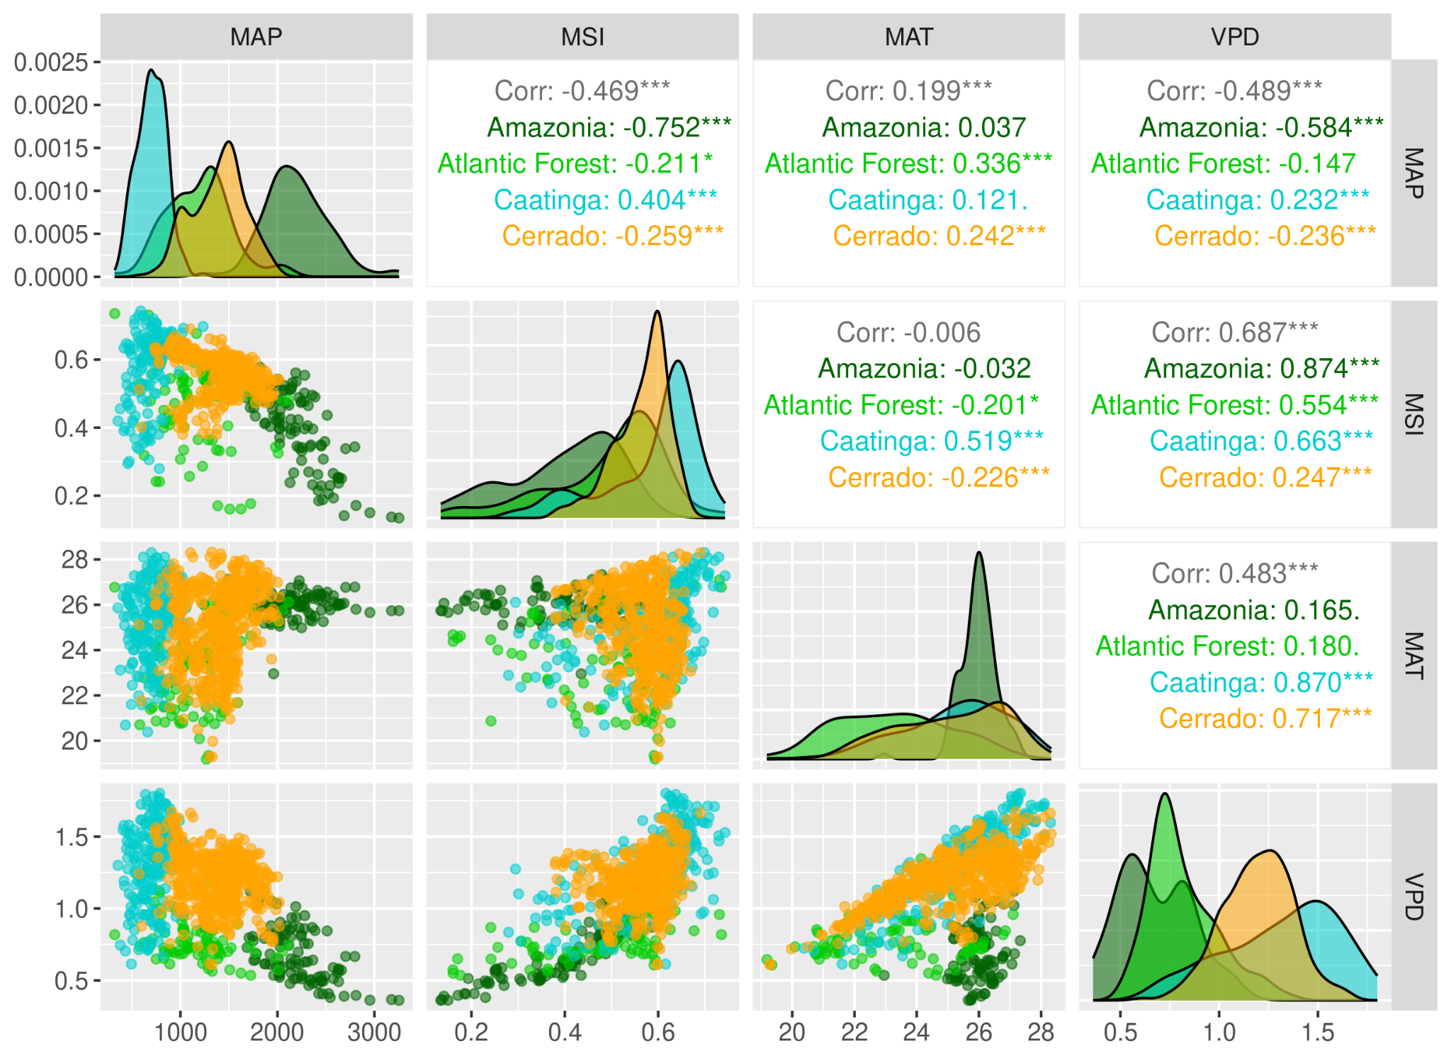

**SM Table 1:** Comparisons among biomes regarding the first principal component derived from greenness annual cycle metrics.

|  |  |  |  |  |  |
| --- | --- | --- | --- | --- | --- |
| Floristic-based pair | Estimate | SE | df | t ratio | P-value |
| Amazonia-Atlantic Forest | 0.864 | 0.249 | 978 | 3.464 | < 0.01 \* |
| Amazonia-Caatinga | 2.838 | 0.212 | 978 | 13.343 | < 0.001 \* |
| Amazonia-Cerrado | 0.778 | 0.19 | 978 | 4.09 | < 0.001 \* |
| Atlantic Forest-Caatinga | 1.973 | 0.215 | 978 | 9.156 | < 0.001 \* |
| Atlantic Forest-Cerrado | -0.086 | 0.193 | 978 | -0.447 | > 0.05 |
| Caatinga-Cerrado | -2.06 | 0.142 | 978 | -14.439 | < 0.001 \* |

**SM Table 2:** Counts of communities of each vegetation type and leaf flush regime in each Biome by group.

|  |  |  |  |  |
| --- | --- | --- | --- | --- |
| **Domain** | **Leaf flush** | **Vegetation** | **Group** | **n** |
| Amazonia | Evergreen | Forest | 1 | 1 |
| Amazonia | Evergreen | Forest | 2 | 69 |
| Amazonia | Semideciduous | Forest | 2 | 35 |
| Atlantic Forest | Deciduous | Savanna | 1 | 1 |
| Atlantic Forest | Evergreen | Forest | 2 | 24 |
| Atlantic Forest | Semideciduous | Forest | 1 | 9 |
| Atlantic Forest | Semideciduous | Forest | 2 | 59 |
| Atlantic Forest | Semideciduous | Savanna | 1 | 4 |
| Atlantic Forest | Semideciduous | Savanna | 2 | 3 |
| Caatinga | Deciduous | Forest | 1 | 13 |
| Caatinga | Deciduous | Forest | 2 | 14 |
| Caatinga | Deciduous | Savanna | 1 | 182 |
| Caatinga | Deciduous | Savanna | 2 | 10 |
| Cerrado | Deciduous | Forest | 1 | 28 |
| Cerrado | Deciduous | Forest | 2 | 35 |
| Cerrado | Deciduous | Savanna | 1 | 12 |
| Cerrado | Deciduous | Savanna | 2 | 2 |
| Cerrado | Evergreen | Forest | 2 | 15 |
| Cerrado | Semideciduous | Forest | 1 | 56 |
| Cerrado | Semideciduous | Forest | 2 | 241 |
| Cerrado | Semideciduous | Savanna | 1 | 124 |
| Cerrado | Semideciduous | Savanna | 2 | 54 |

**SM Table 3**: Descriptive statistics for the maximum coupling between greenness and precipitation for distinct groups of vegetation types, leaf flush regimes and Biomes.

|  |  |  |  |  |  |  |  |  |
| --- | --- | --- | --- | --- | --- | --- | --- | --- |
| **GROUP** | **n** | **mean** | **sd** | **min** | **Q1** | **median** | **Q3** | **max** |
| **Vegetation types** | - | - | - | - | - | - | - | - |
| Forest | 599 | 0.191 | 0.367 | -0.661 | -0.178 | 0.329 | 0.479 | 0.701 |
| Savannas | 392 | 0.468 | 0.193 | -0.519 | 0.420 | 0.513 | 0.578 | 0.757 |
| **Leaf flush** | - | - | - | - | - | - | - | - |
| Deciduous | 297 | 0.481 | 0.168 | -0.368 | 0.424 | 0.517 | 0.583 | 0.757 |
| Evergreen | 109 | -0.088 | 0.313 | -0.563 | -0.343 | -0.189 | 0.206 | 0.598 |
| Semideciduous | 585 | 0.282 | 0.341 | -0.661 | 0.206 | 0.408 | 0.523 | 0.701 |
| **Biome** | - | - | - | - | - | - | - | - |
| Amazônia | 105 | -0.137 | 0.294 | -0.57 | -0.359 | -0.235 | 0.134 | 0.468 |
| Atlantic Forest | 100 | 0.225 | 0.296 | -0.542 | 0.169 | 0.292 | 0.451 | 0.631 |
| Caatinga | 219 | 0.499 | 0.151 | -0.355 | 0.445 | 0.535 | 0.591 | 0.757 |
| Cerrado | 567 | 0.318 | 0.329 | -0.661 | 0.255 | 0.441 | 0.536 | 0.701 |

**SM Table 4**: Statistics and p-values for each hypothesis tested (column H1 in the table) regarding the intensity of the coupling using the Wilcoxon rank sum test with continuity correction. Shaded rows for leaf flush regime and white rows for biomes. \* depicts significant results and rejection of the null hypothesis.

|  |  |  |
| --- | --- | --- |
| **H1** | **statistic** | **p.value** |
| Deciduous > Evergreen | 27782 | < 0.001\* |
| Evergreen > Semideciduous | 16594 | > 0.05 |
| Deciduous > Semideciduous | 114468 | < 0.001\* |
| Atlantic Forest > Caatinga | 4188 | > 0.05 |
| Amazonia > Caatinga | 2590 | > 0.05 |
| Caatinga > Cerrado | 81818 | < 0.001\* |
| Amazonia > Atlantic Forest | 4298 | > 0.05 |
| Atlantic Forest > Cerrado | 18058 | > 0.05 |
| Amazonia > Cerrado | 13596 | > 0.05 |

# **4 CONCLUSÃO**

Nossos resultados mostram que diferentes tipos de vegetação (i.e. florestas e savanas) submetidos ao mesmo regime de precipitação apresentam funcionamento diferente, determinado parcialmente pelas condições ambientais locais, tais como disponibilidade de água e nutrientes no solo (Capítulo I; CURE et al., 2023). Dessa forma, embora os tipos de vegetação difiram no seu funcionamento e estejam submetidos ao mesmo regime de precipitação, eles não podem ser considerados estados alternativos. Essa afirmação parte do pressuposto de que não existem feedbacks entre o solo e a vegetação. Isso pode ser verdade no caso das matas secas, onde o embasamento rochoso calcário, que com frequência aflora na superfície, contribui para a elevada fertilidade do solo (LIRA-MARTINS et al., 2022) (em relação às outras fisionomias vegetais) que favorece o crescimento rápido e a estratégia de evitar os efeitos da seca, neste caso, através da deciduidade (OLIVEIRA et al., 2021).

Além disso, variáveis estruturais não são a melhor alternativa para diferenciar tipos de vegetação abertos (savanas) e fechados (florestas) (SCOGINGS, 2023). Neste sentido, a ideia de que a estrutura da vegetação está relacionada ao seu funcionamento (XU et al., 2018) não condiz com nossos achados, pois mostramos que as matas de galeria e as matas secas possuem estrutura similar, porém com respostas opostas à variação sazonal da chuva (Capítulo I; CURE et al., 2023). Isso revela que métricas simples, como cobertura do dossel e a média de índices de vegetação, também não refletem as diferenças funcionais entre as fisionomias vegetais florestais. A diferença aparece na variação intra-anual do verdor foliar e nas tendências deste verdor durante a estação seca.

Em escala mais ampla, que abrange os biomas tropicais brasileiros, diferentes tipos de vegetação estão submetidos a diferentes regimes de precipitação (HIROTA et al., 2011; CIEMER et al., 2019). Da mesma forma, o regime de chuvas também pode estar relacionado com diferenças no funcionamento hidráulico da vegetação (BARROS et al., 2019; VARGAS et al., 2022), assim como na sua resiliência (CIEMER et al., 2019). Mostramos que há grande heterogeneidade nas respostas em termos de verdor foliar à sazonalidade da chuva (Capítulo II). Esta heterogeneidade depende parcialmente do Bioma em que a comunidade vegetal está, provavelmente relacionada aos processos eco-evolutivos promovidos pela particularidade das combinações das características climáticas, biogeográficas (Capítulo II, Figure 9) e edáficas de cada bioma.

A frequência de ocorrência dos tipos de vegetação na região tropical brasileira pode ser um indicador do quanto a vegetação é estável (ou resiliente) nas condições dadas (SCHEFFER et al., 2015; e.g., HIROTA et al., 2011), pois sua dominância pode refletir uma vantagem adaptativa. Com mudanças nos regimes de precipitação e temperatura, as espécies com características que conferem pouca eficiência no uso da água e que possuem crescimento rápido, concentradas principalmente nas regiões mais úmidas, podem ser trocadas por aquelas que crescem mais lentamente, porém que têm uma margem de segurança hidráulica mais robusta. Além disso, a persistência dos tipos de vegetação na paisagem está relacionada com a frequência e intensidade das perturbações sofridas pela vegetação, assim como com a sua tendência ao longo do tempo (CONNELL, 1978; SOUZA, 1984).

Variações ambientais sazonais afetam a variação do ecossistema (i.e. fenologia) e também podem interferir na identificação de sinais prévios de transição nos ecossistemas (CARPENTER & BROCK, 2010). Por exemplo, Smith e Boers (2023) mostram que em locais com maior índice de aridez, a vegetação possui menor resiliência, devido à maior variação e autocorrelação do índice de vegetação e da taxa de retorno frente às perturbações (SCHEFFER et al., 2015). Por outro lado, Ciemer e seus colegas (2019) destacam que a maior variabilidade climática, que no Brasil particularmente ocorre em regiões mais áridas como o Cerrado e a Caatinga, conferem à vegetação maior resiliência a mudanças na precipitação. Maior ou menor variabilidade, assim como de taxa de retorno, podem estar relacionados com a estratégia de crescimento, ligado à disponibilidade e eficiência na utilização dos recursos e à forma como as plantas lidam com períodos de seca (OLIVEIRA et al., 2021). Por exemplo, apesar das diferenças no sinal do acoplamento (Capítulo I, Fig. 3), tanto as savanas quanto as florestas de galeria apresentaram novos brotos durante a estação seca (Capítulo I, Fig. S12). Sendo assim, uma maior variação no verdor foliar pode indicar apenas uma estratégia diferente de resposta às perturbações, ou também pode refletir maior flexibilidade, e não necessariamente a perda de resiliência, contanto que não mude a média da variável de estado analisada a médio e longo prazo.

Ademais, a questão de escala tem importância central na abordagem de questões ecológicas, uma vez que as propriedades emergentes de um sistema não podem ser encontradas nos elementos que compõem este sistema e vice-versa. O comportamento dos ecossistemas em uma escala de paisagem, por exemplo, não reflete, necessariamente, o comportamento das árvores que compõem este ecossistema e nem das folhas individuais que fazem parte das árvores. Entretanto, sistemas em diferentes escalas interagem entre si e se retroalimentam. Sendo assim, sugerimos que estudos futuros relacionem diferentes escalas de análise e considerem variáveis ambientais em diferentes escalas espaciais e temporais.

Concluímos que o uso de variáveis de estado funcionais revelou os diferentes estados funcionais da vegetação tropical brasileira, não necessariamente alternativos, mas dependentes das condições ambientais locais na escala da paisagem e do bioma na escala continental. Entretanto, para contribuir de forma mais robusta com a discussão sobre a existência de estados alternativos funcionais, é necessário explorar com maior profundidade os feedbacks entre a vegetação e as condições ambientais nessas diferentes escalas. Nossos resultados destacam a importância de considerar a heterogeneidade espacial e a temporal da vegetação, bem como a interação entre fatores bióticos e abióticos, para compreender a resiliência da vegetação tropical em um contexto de mudanças ambientais. Essa abordagem integrada pode lançar luz sobre os mecanismos que sustentam a estabilidade ou promovem transições entre estados funcionais da vegetação, contribuindo assim para o manejo e conservação desses ecossistemas complexos.

**REFERÊNCIAS**

Barros, F. de v., Bittencourt, P. R. L., Brum, M., Restrepo-Coupe, N., Pereira, L., Teodoro, G. S., Saleska, S. R., Borma, L. S., Christoffersen, B. O., Penha, D., Alves, L. F., Lima, A. J. N., Carneiro, V. M. C., Gentine, P., Lee, J. E., Aragão, L. E. O. C., Ivanov, V., Leal, L. S. M., Araujo, A. C., & Oliveira, R. S. (2019). Hydraulic traits explain differential responses of Amazonian forests to the 2015 El Niño-induced drought. *New Phytologist*, *223*(3), 1253–1266. <https://doi.org/10.1111/nph.15909>

Carpenter, S. R., & Brock, W. A. (2010). Early warnings of regime shifts in spatial dynamics using the discrete Fourier transform. *Ecosphere*, *1*(5), 1-15. <https://doi.org/10.1890/ES10-00016.1>

Ciemer, C., Boers, N., Hirota, M., Kurths, J., Müller-Hansen, F., Oliveira, R. S., & Winkelmann, R. (2019). Higher resilience to climatic disturbances in tropical vegetation exposed to more variable rainfall. *Nature Geoscience*, *12*(3), 174–179. <https://doi.org/10.1038/s41561-019-0312-z>

Connell, J. H. (1978). Diversity in Tropical Rain Forests and Coral Reefs. *Science*. <https://doi.org/1302>

Cure, M. B., Flores, B. M., Mattos, C. R. C., Oliveira, R. S., & Hirota, M. (2023). Vegetation-rainfall coupling as an indicator of ecosystem state in a heterogeneous landscape. *Ecological Indicators*, *157*, 111268. <https://doi.org/https://doi.org/10.1016/j.ecolind.2023.111268>

Hirota, M., Holmgren, M., van Nes, E. H., & Scheffer, M. (2011). Global resilience of tropical forest and savanna to critical transitions. *Science*, *334*(6053), 232–235. <https://doi.org/10.1126/science.1210657>

Lira-Martins, D., Luciano Nascimento, D., Abrahão, A., de Britto Costa, P., D, A. M., Valézio, E., Rowland, L., Oliveira, R. S., Lira-Martins, D., de Britto Costa, P., Oliveira, R. S., Nascimento, D. L., Abrahão, A., Valézio, E., & Rowland, L. (2022). Soil properties and geomorphic processes influence vegetation composition, structure, and function in the Cerrado Domain. *Plant and Soil 2022*, 1–40. <https://doi.org/10.1007/S11104-022-05517-Y>

Oliveira, R. S., Eller, C. B., Barros, F. de v., Hirota, M., Brum, M., & Bittencourt, P. (2021). Linking plant hydraulics and the fast‐slow continuum to understand resilience to drought in tropical ecosystems. *New Phytologist*. <https://doi.org/10.1111/nph.17266>

Scogings, P. F. (2023). Perspective: Monitoring global forests using only structural metrics – problems and solutions from a savanna viewpoint. *Forest Ecology and Management*, *546*, 121381. <https://doi.org/10.1016/J.FORECO.2023.121381>

Scheffer, M., Carpenter, S. R., Dakos, V., & van Nes, E. (2015). Generic indicators of ecological resilience: inferring the chance of a critical transition. *Annual Review of Ecology, Evolution, and Systematics*, *46*, 145–167. <https://doi.org/10.1146/annurev-ecolsys-112414-054242>

Vargas, G., G. V., Kunert, N., Hammond, W. M., Berry, Z. C., Werden, L. K., Smith-Martin, C. M., Wolfe, B. T., Toro, L., Mondragón-Botero, A., Pinto-Ledezma, J. N., Schwartz, N. B., Uriarte, M., Sack, L., Anderson-Teixeira, K. J., & Powers, J. S. (2022). Leaf habit affects the distribution of drought sensitivity but not water transport efficiency in the tropics. *Ecology Letters*, *25*(12), 2637-2650. <https://doi.org/10.1111/ele.14128>

Wang, J., Wen, X., Lyu, S., & Guo, Q. (2021). Soil properties mediate ecosystem intrinsic water use efficiency and stomatal conductance via taxonomic diversity and leaf economic spectrum. *Science of The Total Environment*, *783*, 146968. <https://doi.org/10.1016/j.scitotenv.2021.146968>

Xu, P., Zhou, T., Yi, C., Fang, W., Hendrey, G., & Zhao, X. (2018). Forest drought resistance distinguished by canopy height. *Environmental Research Letters*, *13*. <https://doi.org/10.1088/1748-9326/AACADD>